Our Class: Educational resources on children’s friendships
2nd Edition


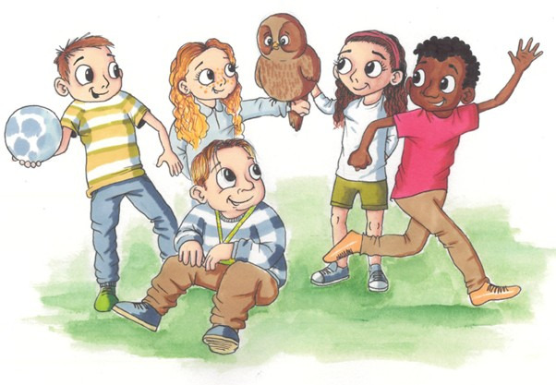

Introduction to the ‘Our Class’ resources

Welcome to ‘Our Class’ and thank you for downloading the resource pack. In this section we will explain the purpose of the resources and provide some suggestions for how they can be used.
This resource contains a package of materials for teaching Key Stage 2 primary school pupils about friendships, as part of a broader Personal, Social, Health and Economic Education (PSHE) curriculum. Within it there are lesson plans, guidance materials and learning resources for educators. The topics covered map directly onto the statutory requirements of the Relationships Education curriculum in England, under the ‘Caring Friendships’ unit.
The materials have been designed by psychology researchers specialising in children’s peer relationships and social development and are informed by research on the quality of children’s friendships in primary school. They have been reviewed and edited based on feedback from classroom teachers, teacher educators, and specialists in PSHE. They are designed to be user-friendly for educational practitioners – providing an ‘off-the-shelf’ resource that can be delivered as a scheme of work, whilst also allowing flexibility for stand-alone sessions based on need, and adaptation/personalisation of plans through personal choice.
These materials have been awarded the PSHE Association Quality Mark, showing that they meet best practice principles for safe and effective PSHE education.
This is the second edition of ‘Our Class’. Since the first edition (launched in 2023), we have used feedback from educators and advisers to update and improve the resources. The main changes are:
- Shortened stories – to allow more time for discussion and activities
- Alignment to the revised statutory Relationships Education (Department for Education, 2025)
- Links to the PSHE Association Programme of Study (updated 2026)
- ‘At a glance’ lesson overviews, to help teachers with planning
- Some updated illustrations, and more engaging videos to support in-class presentation of the materials
- Refreshed resource list, for further information and guidance

What this resource contains: Contents
Contents
Introduction to the ‘Our Class’ resources 2
What this resource contains: Contents 3
Who this resource is aimed at 5
Learning outcomes 5
How to use this resource 5
Accompanying materials 7
Alignment with the statutory Relationship Education curriculum 7
Climate for learning 10
Hints and tips 10
Further resources 11
About the authors 12
Lesson 1: Co-constructing ground rules & meeting ‘Our Class’ 14
Lesson 1 Overview: At a glance 14
Lesson 1 Session Plan 14
Story 1: Welcome to Our Class 20
Resource 1a 23
Baseline activities 23
Resource 1b 24
Our Class Agreement 24
Lesson 2: Friendships Change (Tommy’s story) 25
Lesson 2 Overview: At a glance 25
Lesson 2 Session Plan 25
Story 2: Tommy’s story 33
Resource 2a 42
Activity Sheet (Tommy’s story): Pathways to Friendship 42
Resource 2b 43
Pathways to Friendship – support for the activity 43
Resource 2c 44
Activity Sheet (Tommy’s story): What happens next? 44
Resource 2d 45
Activity Sheet (Tommy’s story): Further learning 45
Lesson 3: When should you keep a secret and what makes a good friendship? (Halina’s story) 46
Lesson 3 Overview: At a glance 46
Lesson 3: Session plan 46
Story 3: Halina’s story 54
Resource 3a 63
When is a Secret, secret? Secret Agent Game 63
Resource 3b 65
Activity sheet: Heads, hearts, hands 65
Resource 3c 66
Further learning worksheet 66
Lesson 4: Making new friendships (Ruby’s story) 67
Lesson 4 Overview: At a glance 67
Lesson 4: Session Plan 67
Story 4: Ruby’s story 75
Resource 4a 85
Feeling lonely and making friends 85
Resource 4b 86
Activity sheet: What would Ope say? 86
Lesson 5: Recognising healthy and unhealthy friendships, and handling tricky situations (Benson’s story) 87
Lesson 5 Overview: At a glance 87
Lesson 5: Session Plan 88
Story 5: Benson’s story 96
Resource 5a 105
Pause, rewind and replay 105
Resource 5b 107
What if? Scenario Cards 107
Optional Extension Activities 110
Resource 6c 112
My social circle 112

Who this resource is aimed at
The materials in this resource are designed to be delivered by teachers, support staff and/or colleagues who are involved in delivering Personal, Social, Health and Economic Education (PSHE) in primary education. This resource could also support those who may be delivering targeted interventions (such as ELSAs, Education Mental Health Practitioners, Mental Health Champions etc.) to pupils with identified needs in peer relationships, social skills, and/or prosocial behaviour.
The learning activities and resources are designed for use with pupils in Key Stage 2 (aged 7-11 years). They may be particularly relevant to lower Key Stage 2 (Years 3 and 4), although there is scope for flexibility here based on professional judgement. The year group of the class featured in the story can be changed by practitioners to make it directly applicable to the year group they are working with.

Learning outcomes
The overarching aim of this resource is to help pupils understand the nature of friendships and explore, in a supported capacity, how they can manage their peer relationships in a positive way. Through examining a series of stories featuring fictional characters who encounter various challenges with their friendships, pupils will have the opportunity to discuss healthy and unhealthy friendships and consider how difficulties can be handled and resolved.
On completion of this unit of work, pupils should be able to:
- identify the characteristics and importance of caring friendships.
- use strategies to manage difficult situations they may encounter within their friendships.

How to use this resource
The resources can be used as a 5-to-6-week unit of work, although they can also be delivered differently at the discretion of the school. For example, schools may choose to offer this as a sequenced scheme of work that covers all of the lessons, or they may decide to start from lesson 2, if ground rules for a class have already been established.
There are detailed materials and lesson plans for 5 lessons (each class intended to be approximately 60-70 minutes in length), plus ideas for optional extension activities, with the sessions designed in a logical sequence that cover increasingly complex friendship dynamics. The first session serves as an introduction to the topic, and establishment of ground rules/code of conduct (framed as the Our Class agreement) that provide the foundation for ways of working in the subsequent sessions. We recommend starting with this session, even if colleagues do not cover all the subsequent lessons, as establishing ways of working is an important feature of good relationships education. However, we are aware that ground rules may already be covered by schools in different ways.
It may be logical to deliver this material near to the start of the academic year in the Autumn term when pupils are settling into their class and building new relationships. However, this is not essential, and the topics covered should always be relevant to pupils.
Each lesson is based on a short story containing a fictional character in a primary school class who is experiencing a friendship challenge. The stories provide the backbone for each session, with discussion and subsequent class activities based around the plot and character experiences. Using a story structure like this enables pupils to explore difficult topics without having to share personal experiences and is recommended good practice in teaching sensitive areas. However, the activities are designed to help pupils apply the fictional scenarios to their own context by considering how they could use what they have learnt within their own friendships.
The stories can be introduced to the pupils in a variety of ways. They could be read to the pupils (in a ‘story time’ format), the pupils could read the story themselves (if their literacy levels allow) or they could be presented in an interactive way with various pupils reading the voices of the different characters. The images in the story are particularly helpful in bringing the characters and plots to life, so colleagues may want to display the story on the whiteboard as they go through or show the video (See Accompanying Materials). In addition, it may be that the stories could be read at a different time to the accompanying class where the story is discussed, to allow pupils time to reflect on the content beforehand.
To help allow more time for the activities in class, teachers may want to consider how or when they share the story. For example, the story could be split into two parts, or several chunks. The story could be read before or outside of the lesson, or a longer lesson may be needed.
All of the materials that a staff member would need to deliver the sessions are included – providing an ‘off-the-shelf’ resource. However, staff should consider the needs and circumstances of pupils in their class. For example, character names or scenarios may need adapting if similarities are likely to cause distress to your own pupils. Staff are in the best position to exercise professional judgment based on the needs of their pupils and what is most suitable for the context they are working within. We recommend there are plenty of opportunities built into lessons and at the end of activities for pupils to ask questions.

Accompanying materials
Alongside this resource pack, there are other materials available on our website to accompany the lesson plans.
This includes:
- Lesson plans and worksheets as separate documents that can be displayed on the whiteboard and/or edited/re-sized as needed
- Video recordings of the stories (showing illustrations and animations, and with child-narrated voice-over and subtitles)

Alignment with the statutory Relationship Education curriculum
The materials have been designed to map directly onto the ‘Caring Friendships’ unit of the Statutory Relationships Education curriculum for primary schools in England. This means that if schools deliver the whole package, they can demonstrate that they are meeting the required elements of the unit. The table below shows how specific sessions align with the core knowledge pupils are expected to be taught.
https://www.gov.uk/government/publications/relationships-education-relationships-and-sex-education-rse-and-health-education

Pupils should know: | Where this is covered in this resource:
how important friendships are in making us feel happy and secure, and how people choose and make friends. | Lesson 2 (Tommy’s story)  Lesson 4 (Ruby’s story)  Lesson 5 (Benson’s story)
that healthy friendships are positive and welcoming towards others, and do not make others feel lonely or excluded. Pupils should learn skills for developing caring, kind friendships. | Lesson 3 (Halina’s story)  Lesson 4 (Ruby’s story)
that not every child will have the friends they would like at all times, that most people feel lonely sometimes, and that there is no shame in feeling lonely or talking about it. | Lesson 4 (Ruby’s story)
the characteristics of friendships that lead to happiness and security, including mutual respect, honesty, trustworthiness, loyalty, kindness, generosity, trust, sharing interests and experiences, and support with problems and difficulties. | Lesson 2 (Tommy’s story)  Lesson 3 (Halina’s story)  Lesson 5 (Benson’s story)
that most friendships have ups and downs, and that these can often be worked through so that the friendship is repaired or even strengthened. | Lesson 2 (Tommy’s story)  Lesson 5 (Benson’s story)
how to manage conflict, and that resorting to violence is never right. | Lesson 2 (Tommy’s story)  Lesson 5 (Benson’s story)
How to recognise when a friendship is making them feel unhappy or uncomfortable, and how to get support when needed. | Lesson 3 (Halina’s story)  Lesson 5 (Benson’s story)

The lessons also map onto aspects of the ‘Respectful, kind relationships’ unit of the Statutory Relationships Education curriculum for primary schools in England. The table below shows how specific sessions align with the core knowledge pupils are expected to be taught. https://www.gov.uk/government/publications/relationships-education-relationships-and-sex-education-rse-and-health-education

Pupils should know: | Where this is covered in this resource:
how to pay attention to the needs and preferences of others, including in families and friendships. Pupils should be encouraged to discuss how we balance the needs and wishes of different people in relationships and why this can be complicated. | Lesson 2 (Tommy’s story)
Pupils should have opportunities to discuss the difference between being assertive and being controlling, and conversely the difference between being kind to other people and neglecting your own needs). | Lesson 2 (Tommy’s story)

The PSHE Association Programme of Study for PSHE Education (2026) addresses the following learning opportunities for Key Stage 2:

Pupils will have the opportunity to learn…
Friendships (KS2 Learning opportunities, page 9):
about the importance of friendships; that positive friendships support wellbeing.
what constitutes a positive, healthy friendship (e.g. mutual respect, trust, kindness, generosity, sharing interests, enjoying being together, and support with problems and difficulties); that truthfulness and loyalty are also part of this, but when these might be less appropriate.
how people choose and make friends; skills for building caring, kind friendships (e.g. mutual support, listening, respecting boundaries, celebrating friends’ successes).
that healthy friendships are not controlling or possessive; that everyone can have more than one friend, and that having different friends can bring different positive experiences.
that healthy friendships make people feel included, safe and happy; how to recognise when they or others feel lonely or excluded; strategies to include others; the importance of seeking support if feeling lonely or excluded.
strategies for recognising and managing peer influence and the desire for peer approval in friendships.
about balancing the needs and wishes of different people e.g. in families or friendships; the importance of balancing their own needs with being kind to others.
that friendships have ups and downs and can change over time; that working through differences can sometimes strengthen friendships.
how to recognise if a friendship is making them feel unsafe, unhappy, or uncomfortable; how to manage this and ask for help if necessary.
Mental health and wellbeing (KS2 Learning opportunities, page 12):
that everyone feels worried, lonely or sad sometimes and that these feelings can affect wellbeing; the benefits of speaking to someone if feeling lonely, worried or sad.

Climate for learning
It is important to develop the appropriate climate to support pupils in addressing issues pertaining to friendships and relationships with peers. Some of the topics covered in this material may bring up some issues that may be worrying pupils within the group. It is therefore important to develop ground rules (see Lesson 1) and ensure that pupils are well supported within the sessions and afterwards.
When planning sessions, it is worth considering when these are held (time/day). The topics may bring up issues for pupils which they may want to discuss with a staff member after the session, or the next day.
These sessions are not designed to elicit child disclosures. However, it is quite possible that pupils may wish to discuss issues following the sessions. If, during the session, you feel that a child may be upset or concerned about an issue, this should be followed up afterwards during a one-to-one with the child, rather than within the session. Ensure you follow your organisation’s safeguarding policy regarding any safeguarding concerns.
We recommend that pupils co-construct ground rules with a staff member at the start of this unit of work (see Lesson 1), and these should be constructed as positive instructions e.g., ‘respecting others’ opinions and feelings even if they are different to yours’ rather than ‘don’t do this/that’.

Hints and tips
There are a few suggestions for how colleagues can make these resources work best for them and the pupils they teach. First, it is recommended that consideration is given to how this material would sit within the wider school approach to Relationships Education (RSE) and Personal, Social and Health Education (PSHE). Practitioners are encouraged to engage with their RSE/PSHE lead as part of their planning.
Second, as per the statutory requirements for Relationships Education, communication with parents/carers at an early stage is advisable, so they are aware of the topics that are going to be covered and can ask questions. Parents/carers can be encouraged to talk about these topics at home with their children to support in-school learning, and there are some extended learning tasks that could be used to engage parent/carers with the children’s learning. A letter home with some information about the forthcoming unit of work/session content would be useful in order to encourage an open forum with parents/carers.
Alongside this, it is recommended that pupils are given some advanced knowledge (with incremental reminders) about forthcoming session topics so that they can feel prepared for these and seek any help in advance if needed.
You may also want to have a ‘questions box’ within your classroom. This can be a way that pupils can ask questions without having to ask in front of the class or speaking to you directly. This can be helpful for pupils who have questions that they might feel a little uncomfortable asking directly. Pupils can be encouraged to ask any questions that might have come up for them following on from any of the topics covered within these sessions. You can then follow these up in subsequent sessions where appropriate.
Where resources allow, it may be useful to have an additional staff member (such as a Teaching Assistant) in the sessions in case any of the pupils need to leave or want to talk about any of the issues raised outside of the session. Early Career Teachers may also benefit from in-class support from a member of the leadership team in case any difficult questions or tricky situations arise. Keep in mind however that some pupils who may be affected by issues in the lesson(s) may not have the confidence to make a disclosure. It is therefore essential that they are directed to varied, reliable forms of further support should they wish to access them in the future. We include a reminder about this at the end of each lesson plan.

Further resources
There are additional sources of information about pupils’ friendships that educators might find useful to support them in the delivery of these materials. Please note that the items on this reading list have not been quality assured by the PSHE Association but are included as they may support teachers to strengthen their subject knowledge.

  - Books
Carey, T. (2019). The Friendship Maze. London: Vie Books
Glazzard, J. & Stones, S. (2020). Relationships Education for Primary Schools: A Practical Toolkit for Teachers. Critical Publishing.
Kennedy-Moore, E. & McLaughlin, C. (2017). Growing Friendships: A kids’ guide to making and keeping friends. Aladdin.
Knight, B. (2019). Can I tell you about Friendship?: A helpful introduction for everyone. London: Jessica Kingsley Publishers.
Mason, S. & Woolley, R. (2019). Relationships and Sex Education 3-11: supporting children’s development and well-being. 2nd edition. Bloomsbury.
O’Neil, P. (2022). Be cool, be you: A child’s guide to making friends. Vie.
Pugh, V. & Hughes, D. (2021). Teaching PSHE & R(S)HE in Primary Schools: Enhancing the whole curriculum. Bloomsbury.
Young, C. (2023). Friendship Survival Guide. Usborne.

  - Websites
Childline (advice for children): https://www.childline.org.uk/
PSHE Association (national body for Personal Social and Health Education): https://www.pshe-association.org.uk/

  - Underpinning research
Maunder, R. & Monks, C. (2019). Children’s friendships in middle childhood: how number of friends, reciprocity and friendship quality relate to peer and school identification, and general self-worth. British Journal of Developmental Psychology, 37(2), 211-229 https://bpspsychub.onlinelibrary.wiley.com/doi/full/10.1111/bjdp.12268
Monks, C. & Maunder, R. (2025). Healthy relationships education - it’s not all about sex! A commentary on the importance of children’s friendships within the pastoral curriculum. Pastoral Care in Education, 43(2), 328-335. https://www.tandfonline.com/doi/full/10.1080/02643944.2024.2333855

About the authors
Claire Monks is Professor of Developmental Psychology at the University of Greenwich. She specialises in bullying, aggressive behaviour and peer relationships in childhood.
Rachel Maunder is Associate Professor in the Psychology of Education at the University of Northampton. She specialises in children’s peer relationships in school, including friendships and bullying.
Claire and Rachel have been undertaking collaborative research for several years on the quality of children’s friendships, roles in the peer group, and teacher confidence supporting children’s friendships in school. They have delivered training to trainee primary teachers on the new Relationships Education, and studied educator knowledge and confidence about delivering PSHE in schools.

Many thanks to members of our Expert Panel who reviewed early versions of these materials. Their valuable feedback has helped us to refine the resources and make them as user friendly as possible for educators.
- Victoria Pugh (University of Worcester, Specialist in PSHE and RSE, published author in PSHE provision)
- Sacha Mason (Bishop Grosseteste University, published author in PSHE provision)
- Andrew Debenham (University of Northampton, Senior Lecturer in Education, former Primary Headteacher)
- Bonnie Kerr (University of Greenwich, Practitioner in Primary Education)
- Katharine Vallely (The Open University and University of Greenwich, Practitioner in Primary Education and PSHE subject specialist)

We are also extremely grateful to our freelance illustrator, Isaac Smith (isaacsmithy135@gmail.com), who has brought our stories to life so beautifully.
All of the materials and information about our work in this area is available here:
https://mypad.northampton.ac.uk/ourclassfriendships/
We would welcome your feedback on the materials! Please tell us what you think of them.

Lesson 1: Co-constructing ground rules & meeting ‘Our Class’

Lesson 1 Overview: At a glance

- Activity | - Description | - Timing  (Total 60 mins)
- Baseline activity | Pupils demonstrate their understanding of rules and why they are used through responding to prompts. | 10 mins
- Introduce the Our Class series | Read the first chapter of Our Class (or use pre-recorded video) and talk about the importance of ground rules. | 5 mins
- Creating Our Class ground rules for PSHE sessions | Activity to support pupils to identify key points for the group’s ground rules. | 30 mins
- Assessment of Learning - Plenary | Pupils reflect on the session and respond to prompts around the importance of ground rules. | 15 mins

Lesson 1 Session Plan

Before using this plan, we recommend you read the introductory material including how to use this resource.

  - Context
This is the initial session in a series which is designed to provide pupils with the understanding and tools to deal with some of the complexities of friendships. These will support Key Stage 2 pupils and help them to understand the nature of friendships, the benefits to positive friendships, how friendships can change, and what makes a good friendship. Friendships become increasingly important during middle childhood as young people move into adolescence. These lessons will provide pupils with positive ways of managing some of the varied aspects of friendships and equip them with the skills to make informed and constructive choices within their relationships with peers.
This first session is planned for a one-hour, although there is scope to adapt the plan if needed. This session will focus on the development of ground rules to frame the following sessions. This is important in order to create a safe space for discussion of friendships along with the sensitivities associated with these. The session will introduce pupils to understanding the importance of aspects of openness, listening and non-judgement. Pupils can reflect privately about the things they can do to abide by the ground rules rather than sharing this with the class.

  - Learning objective
> To learn about the importance of ground rules.

  - Learning outcomes
Pupils will be able to:
> identify appropriate ground rules.
> explain why it is important to listen to others and take turns talking.
> explain why it is important to respect others and behave in a non-judgemental way.

For this session, you will need…
> Story 1: Welcome to Our Class
> Flipchart/marker pen
> Resource 1a (optional)
>Resource 1b (optional)
> Paper/craft equipment as appropriate for creation of posters/notes in workbooks

  - Climate for learning
- As with all PSHE classes, this lesson should be taught in a non- judgemental environment with support provided.
- Pupils should be encouraged to reflect on the materials, but not discuss real-life incidents or other pupils within the class/school.

  - Key words
Ground rules, sharing, non-judgement.

In class activities (suggested lesson time: 60 mins)
NB: Please review this lesson before delivery and consider the needs and circumstances of pupils in your class. For example, character names or scenarios may need adapting if similarities are likely to cause distress to your own pupils.

  - Baseline Activity Estimated time 10 minutes
This baseline will help you to assess pupils’ understanding of rules and why they are used. Use this assessment to adapt your teaching to address misconceptions or gaps where appropriate.
Start by asking some prompt questions for pupils to think about. E.g. What are rules? Why are they important? Why is it important to follow them? Pupils can write down their responses in their exercise books. Then, ask pupils to identify one rule that they think is important for everyone in the class. These can range from social conventions (such as wearing the right school uniform), to moral conventions (such as being kind and considerate to others). Ask them to write one rule down on a post-it note and stick it to the board. An alternative activity (for example, for pupils with SEND) could be for pupils to pick from a list of ‘rules’ (see Resource 1a) the most important rule they think everyone should abide by in the class during the session and stick it on the board. This will lead into the next section on the development of class ground rules.

Introduce the Our Class series Estimated time 5 minutes
Read the first story of Our Class (called ‘Welcome to Our Class’) to the pupils and talk to them about the series. There is a pre-recorded video on our website if you prefer to use this. Explain how we are going to revisit the pupils from Bankwell Primary School at various points to find out a bit more about them and their friendships. Some possible questions you could use to check that pupils have understood the story:
- Who is narrating the story?
- What is the name of the class teacher and what is their nickname?
- Who is Ope and what is his role in the school?
A key question to pose to pupils for discussion is:
- Why are ground rules important for a class like the one in the story?

Creating Our Class ground rules for PSHE sessions Estimated time 30 minutes
Before the session, it is important to identify key words to discuss which can be used to help scaffold the co-construction of the Our Class ground rules. These should be words that you feel are important in terms of setting ground rules. They may include:
• non-judgement,
• listening,
• the right to not answer,
• knowing how to get help.
Use the spider diagrams provided (see Resource 1b) write one of these words/terms in the centre of each (if you have chosen to use the terms above, then we suggest you will need 2 for each word meaning 8 spider diagrams in total). Show each of these terms to the pupils and explain to them that these are important for group discussions. Organise the class into groups and assign one word (on a spider diagram) per group. As providing only 4 spider diagrams will mean pupils have to work large groups (of roughly 8 pupils per group), you may wish to add additional words, or print 2 copies of each word, so that pupils can work in smaller groups (i.e. groups of 4) – this will ensure all pupils are engaged in the activity.
Invite individual pupils/groups to explain why a particular word/phrase is important for group discussions. Encourage them to refer to points raised in the earlier group discussion. For listening, this might be ‘so that everyone gets a chance to talk’.
Discuss as a group what has been identified as being important (e.g. everyone gets a chance to talk) - and how it could be translated into a rule (e.g. we listen to everyone’s opinion without interrupting). Ask them to think about how we can put something into action – if we think this is important – what can we DO? Write these suggestions on the whiteboard/flip-chart for pupils to refer to later.
These are then discussed, agreed, and shared with the group as Our Class Agreement.
The Our Class agreement could look something like this:
- We think that everyone’s opinion is important (non-judgement).
- We show respect to others’ opinions no matter if they are different from our own (non-judgement).
- We listen to others without interrupting (listening).
- We give everyone the chance to speak in group discussions (listening).
- We have the right to not speak in a group discussion if we do not feel safe to do so (right not to answer).
- We will not ‘force’ others to speak if they do not want to (right not to answer).
- We know that it is important to get help if we are upset by any of these topics (knowing how to get help).
- We know who to speak to if we need help – teacher, teaching assistant, parent/carer, other trusted adult (knowing how to get help).
- It’s okay to get things wrong as we are all learning.
It is important to note that your class agreement may be slightly different to these.
If time allows, pupils could then work independently/in pairs to evaluate which rules they think are most important and explain why.

Assessment of Learning - Plenary Estimated time 15 minutes
To assess their learning during the session, ask pupils to respond to the following statement: ‘Ground rules help everyone’.
Pupils should explain how far they agree with the statement and give their reasons why. They could write this down in their books or on an ‘exit card’ which they hand to the teacher at the end. This will allow you to see the progress pupils have made, as well as anything that needs following up on next lesson.
As a reflection task, ask each child to think about one thing they would try to do within the Our Class agreement. You may want to start this off and highlight that the teacher is also part of Our Class agreement. For example: I will listen to others without interrupting. Pupils can reflect privately when identifying the one thing they would do within the class agreement rather than sharing this with the class.

Further learning/Extension
Ask the pupils to create individual posters of the Our Class agreement and decorate them either using a computer or craft materials. These can then be stuck in their workbooks or displayed around the classroom. These will be referred to at the start of every subsequent PSHE session.
Ask the pupils to talk to someone at home or school (could be an adult, an older sibling, or staff member at school) about rules that they had in their school. Where did they think the rule came from? Why did they think that there was a rule for this? What did it mean to them? Would they have liked to change it? If so, how would they have liked it to change? Note this down. This could then be used for a discussion about rules and citizenship.

Further support
At the end of each lesson, support should be signposted to pupils for those who may need it. This may include pastoral members of the school staff or adults at home, such as parents or carers, and external organisations such as ChildLine (0800 11 11).


How did it go? Please tell us what you think of the materials:

Story 1: Welcome to Our Class

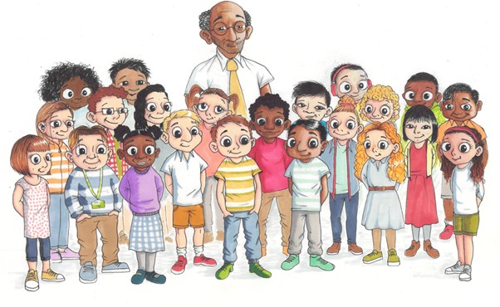

We’re at Bankwell Primary School. There are 30 of us in the class and lots of us have known each other since we started in Reception. We’re a good bunch really, but there have been some tricky situations as you might expect.
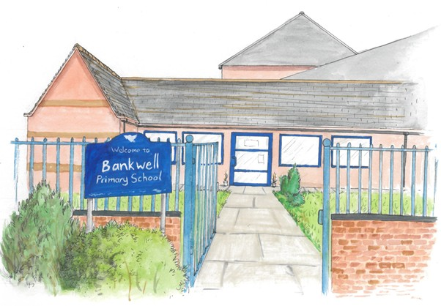
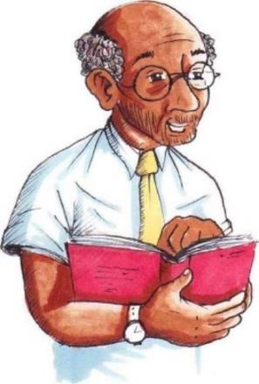
Our class teacher this year is Mr Vadar (we all call him Darth behind his back, but I don’t think he’s noticed) and he’s okay most of the time but sometimes can be a bit grumpy.
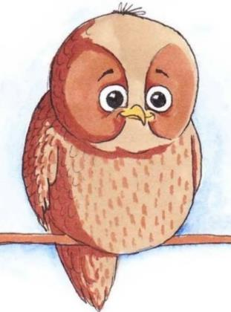
One thing you should know about our school – we have an owl. Ope is not just any owl either. He is a talking owl. The Head Teacher introduced Ope to us as our school pet and we get to talk to him when our teacher isn’t available. We’ve become very comfortable with Ope as he is a very good listener. We don’t see him all the time, he only appears when he thinks somebody needs help with something. You could say he’s a wise owl, but when you talk to him he doesn’t always know that much. He asks loads of questions though! He always means well, and we all like to hear what he has to say. His questions often help us to think through things in a different way. The teachers go and talk to him sometimes. The other kids don’t believe us when we tell them about Ope, but we know he exists.
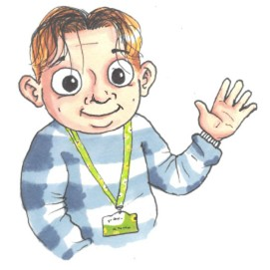
I’m Alex by the way. I’m going to tell you about some of the stuff that has been going on in our class.
It’s been quite eventful really – and not always for good reasons. The thing that sticks out most in my memory of this year so far is the changing relationships between everyone. Friends one minute, enemies the next, rumours, showing off, being popular and also being just plain mean….there have been so many dramas! Safe to say that some of the things that have gone on have caused upset to several people, but I guess it’s useful to talk about these things. Mr Vadar always says that we can learn from things that go wrong just as much (and maybe even more) than the good things.
The others in my class said it was okay for me to share their stories with you. Each chapter features a different person’s experience, and then there’s some things to do afterwards to think about what happened and consider how you might react in a similar situation. Your teacher will help you with this. Last term Mr Vadar organised some exercises in our class to help us work as a group and get along better. We didn’t want to do it at first (and some of it was pretty embarrassing to be honest) but I have to admit that it was good to get things out in the open and discuss stuff. I feel like I know more what to do and how to deal with friendship problems now – and there’s bound to be plenty of chances for me to practise!

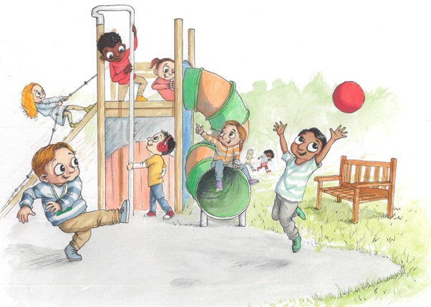

Resource 1a

Baseline activities

Possible ‘rules’ that could be shared with pupils and ask them to choose the ones that are important to them. You can add others as well that you think are relevant.

Wear the right school uniform.

Be kind to other people.

Sit on your chair not on the table.

Listen to what other people have to say.

Take turns when talking.

Share ideas and opinions with others.

Make sure that you bring your pencil case with all of the things you need to school.

Resource 1b

Our Class Agreement

Creating Our Class Agreement
You can use this spider diagram to make notes of the pupils’ responses within the session to help develop Our Class Agreement.

This is important because…
Insert the Key Word here
This is important because…
This is important because…
This is important because…

Lesson 2: Friendships Change (Tommy’s story)

Lesson 2 Overview: At a glance

- Activity | - Description | - Timing  (Total 60 mins)
- Discuss the ground rules for PSHE sessions | Discuss the agreed class ground rules for PSHE classes co-constructed in lesson 1. | 5 mins
- Baseline activity | Pupils demonstrate their understanding of what a friend is. | 5 mins
- Tommy’s story | Read Tommy’s story (or use pre-recorded video) which explores how friendships change. | 10 mins
- Friendship changes – pathways to friendship | Pupils explore steps to build stronger friends and manage friendship differences in a positive way through the Pathways to Friendship activity. | 15 mins
- How to maintain friendships during periods of change | Using a cartoon strip or role play activity where pupils can consider how the children in the story might maintain their friendship. | 20 mins
- Assessment of Learning - Plenary | Revisit what friendship means using an ‘explain to an alien’ activity. | 5 mins

Lesson 2 Session Plan

Before using this plan, we recommend you read the introductory material including how to use this resource.

  - Context
This is the second session in a series which is designed to provide your pupils with the understanding and tools to deal with some of the complexities of friendships. These will support Key Stage 2 pupils and will help them to understand the nature of friendships, the benefits to positive friendships, how friendships can change and what makes a good friendship. Friendships become increasingly important during middle childhood as young people move into adolescence. These lessons will provide pupils with positive ways of managing some of the varied aspects of friendships and equip them with the skills to make informed and constructive choices within their relationships with peers.
Tommy’s story forms the basis for the session. As per the guidance provided in How to use this resource, the story could be read before or outside of the lesson or could be split into parts or several chunks.
This lesson is planned for a one-hour session but can be broken down into two shorter sessions or adapted if needed.
  - Learning objective
> To learn how and why friendships can change over time.

  - Learning outcomes
Pupils will be able to:
> Describe some benefits and challenges of friendships.
> Explain how to manage changes in a friendship in a positive way.
> Identify how to manage a difficulty with a friend.

For this session, you will need…
> Story 2: Tommy’s story
> Flipchart/marker pen
> Resource 1a (optional)
> Resource 1b (optional)
> Resource 2c (for display)
> Resource 2d (optional)
> Paper and scissors for the pupils

  - Climate for learning
- As with all PSHE classes, this lesson should be taught in a non- judgemental environment with support provided.
- Pupils should be encouraged to reflect on the materials, but not discuss real-life incidents or other pupils within the class/school.
- Ground rules should be agreed at the start of the year (see Lesson 1 in this pack) and should be reiterated at the start of each class (these might be displayed around the classroom for example).

  - Key words
Friendships, changes, best friends

In class activities
NB: Please review this lesson before delivery and consider the needs and circumstances of pupils in your class. For example, character names or scenarios may need adapting if similarities are likely to cause distress to your own pupils.

  - Discuss the class ground rules for PSHE sessions Estimated time 5 minutes
At the start of the session, discuss the agreed class ground rules for PSHE classes (framed as the Our Class agreement) which will have been co-constructed with the class in Lesson 1.

  - Baseline activity Estimated time 5 minutes
This baseline will help you to assess pupils’ understanding about what a friend is. This will also help you to decide where teaching may need to be adapted.
Ask pupils to imagine that an alien has come to earth and wants to find out more about this thing called ‘friendship’. Ask pupils to explain to the alien: What is a friend? Why does someone have friends? What do friends do together? What are the features of a ‘good’ friend?’
Ask children to write their responses to the questions in their exercise books. These might include friends as people who are kind, friendly, share, make you laugh etc. The importance of friendships could include how they make you feel (make you feel good about yourself), instrumental support (such as having someone to talk to about problems) companionship, someone you can get an honest opinion from who won’t laugh at you, having an ally etc.
They can come back to their answers and add new learning about what a friend is at the end of the lesson.

  - Tommy’s Story Estimated time 10 minutes
Read Tommy’s Story to the pupils (they should have already heard the first story: Welcome to Our Class). There is a video on our website if you prefer to show this. Tommy’s Story describes the best friendship between Tommy and Stefan. The two boys have been friends forever, but during this year, they start to realise that they have different interests and begin to drift apart. This story explores how friendships can change over time and provides a context within which to discuss how children may manage this in a positive way. Potential questions you could ask to check understanding:
- How is Tommy and Stefan’s friendship changing?
- What challenges are they facing in their friendship?
- Why do you think their friendships are changing?
Potential responses from pupils may refer to friendships changing as interests change or that friends do not need to spend all of their time together.

  - Friendship changes – pathways to friendship Estimated time 15 minutes
This activity allows pupils to explore steps to build stronger friendships and manage friendship difficulties in a positive way.
Provide pupils with ‘pathways to friendship’ activity. Pupils in groups are asked to consider the following questions.
- What does Tommy want? e.g. to spend time doing active, outdoor activities like football; to have some choice in what he does; to feel comfortable and confident.
- What does Stefan want? e.g. to spend time together, particularly doing activities he enjoys (like gaming); to feel included and not left out; to keep the friendship close.
- Are their needs the same or different? e.g. they want to stay friends and spend time together, but they enjoy different activities and don’t always want the same things.
- What can Tommy and Stefan do? e.g. recognise that it can sometimes be tricky to balance different needs and find a compromise; tell each other how they are feeling; take turns to do different. activities; spend some time together and some time with other friends – remembering that everyone can have more than one friend; agree that it’s OK not to do everything together; find activities they both enjoy.
- Why might friendships change over time? What factors contribute to this? (ask pupils to consider going further than the Tommy and Stefan story – for example, when someone moves house/school, goes to secondary school etc…).
- From the story it looks like Tommy and Stefan both want to stay friends. In this case, what can they do to stay friends? (for example, have a conversation, arrange an activity together, share their feelings etc…).

- Provide groups of pupils (suggested 3-4 per group) with a pair of feet (see Resource 2a) or ask them to draw around their own feet.
- Ask them to write a reason why a friendship might change on one of the feet (this is the ‘challenge’ to friendship).
- Once they have done this, ask them to think about how the people in that situation could stay friends and write this on the other foot (this is the strategy to stay friends).
Encourage pupils to think about positive strategies for maintaining a friendship. Provide them with an example, such as:
One person joins an afterschool club and starts hanging out with other people and spending less time with their old friend. What should the old friend do if they want to maintain the friendship? Give the pupils a choice – a) arrange for them to come round to their house to do an activity that they both enjoy or b) buy them sweets to try to win them back? Get pupils to vote on these and then to discuss why a) might be better than b).
Once the pupils have completed the task in their group, ask them to share with the other pupils/another group. Ask them to set up their ‘feet’ and share each one-by-one. First the challenge and then the strategy.
It is possible that some of the strategies may still be less positive and when discussing with the wider group at the end, ask pupils to vote on their ‘best’ strategies which can then be written on the board.

  - How to maintain friendships during periods of change Estimated time 20 minutes
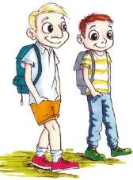
Tommy and Stefan want to stay friends, despite their different interests. Will they still be ‘best friends’ or do you think they can stay friends, but won’t be as close as before? What do you think Tommy and Stefan should say to each other on the way home?
- Display the cartoon strip provided (Resource 2c: What happens next?) showing the two boys walking home. Pupils could either fill in the thought/speech bubbles OR you could arrange the pupils into groups of two to role play either Stefan or Tommy.
- The endings might include Tommy and Stefan deciding to make an effort to stay best friends, or staying friends but not best friends. Given that Tommy and Stefan want to stay friends, encourage pupils to think about ways in which they might stay best friends or stay friendly but not necessarily best friends, rather than the friendship ending. We will look at ending unhealthy friendships later in the series.
- If using a role play activity, ensure that pupils are playing the characters of either Tommy or Stefan rather than role playing themselves, people they know, or situations they have been in. It should be made clear that participating in the role play is optional, and individuals can sit out and watch if they feel uncomfortable. Supervision is required to ensure that pupils are not role playing risky, dangerous or potentially upsetting scenarios e.g. bullying.
Share the activity outcomes (either the completed cartoons or sharing role play summaries) with the group and ask the pupils to explain their ending to the story. Give the pupils criteria on which feedback on the role play or cartoon activity should be fed back. These should be positive and constructive ways forward for the characters, rather than the drawing or acting displayed. For example, have they created a positive outcome for the characters, either with them staying 'best friends' or just friends? Have they suggested how Tommy and Stefan might stay friends? What else could they have included? The pupils can then be asked to reflect on whether they think that Stefan is sharing how he feels, or trying to control what Tommy should do? e.g. Stefan is expressing his feelings but is also suggesting that being friends means Tommy should always choose him, which may make Tommy feel pressured. They can then be prompted to consider, what could Stefan say instead that shows how he feels but still lets Tommy choose? e.g. “I feel a bit left out when we don’t spend time together, could we plan something soon?” or “I miss hanging out with you, do you want to do something together another day?”
Allow some time at the end of this activity for a debrief on what was learnt, and for pupils to get out of character before moving on.

  - Assessment of Learning - Plenary Estimated time 5 minutes
In the final part of the class, draw the whole class together to review the responses to the initial ‘explain to an alien’ activity. Ask them to add in any new learning or ideas in their books in a different coloured pen to show any progress/learning that has been made.
Within this session, try to tease out more psychological aspects of friendship, such as companionship, an ally, a sounding board, someone to help you and someone you can rely on. Suggested questions could include:
Why do people have friends? How should friendships make people feel? Can you describe what a good friend is like?
What should someone do if their friend is unhappy? What should someone do if their friend has a problem?

  - Support for learning
For the pathways to friendship activity, provide pupils with the feet pictures (Resource 2a) with friendship challenges on one side and three options for the friendship pair on the other which vary in how helpful they might be (Resource 2b). Ask pupils to identify which action the friends should take in order to maintain their friendship and think about how these might work out.

  - Challenge
For the activity on how to maintain friendships during periods of change, ask pupils to consider how the story might continue. What might happen the next day? Ask pupils to draw their own cartoons in small groups (to facilitate discussion and sharing of ideas) to develop the story further of how Stephan and Tommy might work out how to stay friends (even if they are not best friends anymore).

Further learning/Extension
Ask the pupils to draw a picture of themselves or find a photo of themselves and write what makes you a good friend (Resource 2d). This activity should be delivered as a personal reflection activity and does not need to be shared with the class.

Further support
At the end of each lesson, support should be signposted to pupils for those who may need it. This may include pastoral members of the school staff or adults at home, such as parents or carers, and external organisations such as ChildLine (0800 11 11).
How did it go? Please tell us what you think of the materials:

Story 2: Tommy’s story

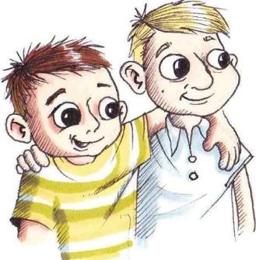
In this story I’m going to tell you about Tommy, and his friend Stefan.
Tommy and Stefan had been best mates forever.
However, recently it had been feeling a bit different between them. Tommy wasn’t sure why but being friends with Stefan seemed to be harder work than it used to be.
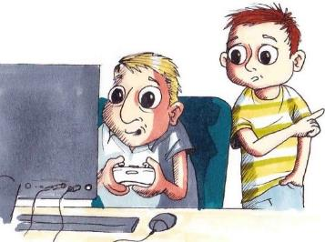
One evening, Tommy went over to Stefan’s after school. Stefan was playing on his computer. Tommy played along for a bit but then he got bored.
“Hey, do you fancy going outside?” Tommy asked.
Stefan barely looked up from the screen. “Not right now, I want to finish this level” he said.
Just then, Stefan’s older brother Marek stuck his head around the door.
“Stef, I’m going to the park to play some football, are you coming?” he asked. He glanced at Tommy and nodded “oh hey T.”
Stefan shook his head “No, I’m finishing this” he said. Marek looked at Tommy, “you?”
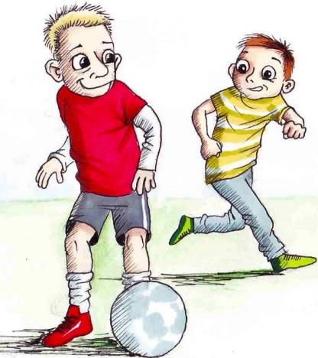
Tommy hesitated. He really fancied going outside, but he had come around to spend time with Stefan so felt a bit bad going off without him. Marek noticed his uncertainty.
“Stef, you wouldn’t mind if T came out with me, would you?”
Stefan glanced over and shrugged, then returned his attention to the screen.
Tommy followed Marek downstairs, and they headed out to the park.

When Tommy arrived back at Stefan’s house, he went to Stefan’s room quickly before he went home. Stefan was still playing on the computer.
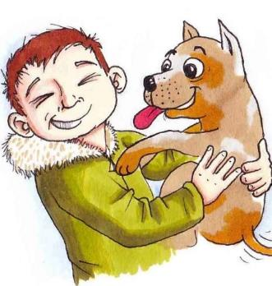
“Hey, I’ve just got back, but my mum’s coming now…I’ll see you tomorrow?”
Stefan glanced around “Yeah sure, see you T,” he raised his hand.
Tommy ran back down the stairs and grabbed his coat. Stefan’s dog Bug scampered over to him wagging his tail. Tommy crouched down to fuss him and Bug leapt up in excitement, trying to lick his face.
“Bye Stefan, bye Bug!” Tommy shouted, as he headed out of the front door.

The next day at school Tommy and Stefan sat together. Stefan was still talking about the computer game.
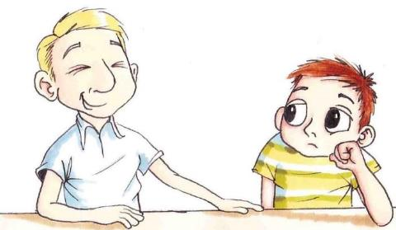
“I finished the level!” he laughed.
Tommy smiled. He could see how much Stefan enjoyed it, but he couldn’t understand why he’d want to spend so long playing the game. Tommy had been getting really into this science fiction series on live stream. He mentioned it to Stefan.
“You should really watch it Stef,” he said, “it’s so good!”
Stefan screwed up his face in disapproval. “Nah I’m not a fan” he shook his head, then looked away.
They sat quietly for a while. It felt awkward, which was weird. Topics of conversation didn’t come easily anymore. It was like they didn’t have much in common.
Just then, Ravi came over. “Hey, do you two want to play football at lunchtime?”
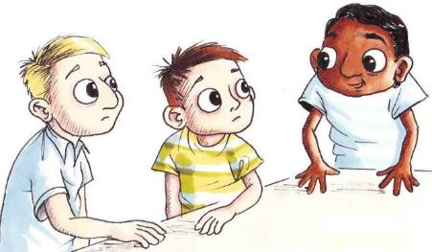
Tommy’s eyes lit up, and he looked over at Stefan. Stefan shook his head, “no thanks, we’re going to the computer room.”
This was the first Tommy had heard about it, but before he could say anything, Ravi said “Ok, no worries” and ran off.
Tommy turned to Stefan, “what’s this about the computer room?”
Tommy really didn’t fancy the sound of it. He got bored being on the computer for too long and preferred to play outside. He was a bit annoyed that Stefan had arranged it without asking him first. Still, he and Stefan always did stuff together, so he reluctantly went along with his friend.
Stefan got the computer started, whilst Tommy sat on the desk next to him.
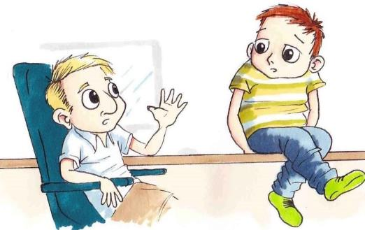
“Aren’t you going to join in?” Stefan asked
“Um, yeah okay, but you’ll need to show me” Tommy replied, hesitantly. He wasn’t as confident with computers. Stefan set up the computer next to him and explained it quickly to Tommy. The boys worked quietly alongside each other for a few minutes, but then Tommy got stuck. “Stef….can you show me?”
Stefan glanced over, looking a bit irritated. “Um yeah, like this” he said, demonstrating.
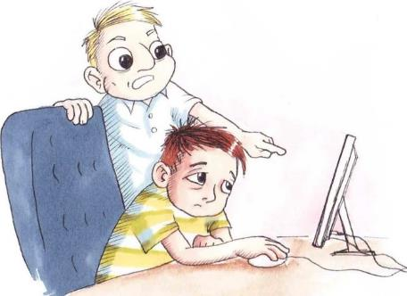
Tommy tried to follow, but he could feel Stefan watching him and it made him nervous. Tommy felt flustered, “I’m just not as good at this as you are.”
“But it’s not difficult T, I don’t understand why you can’t get it!” Stefan sounded frustrated.
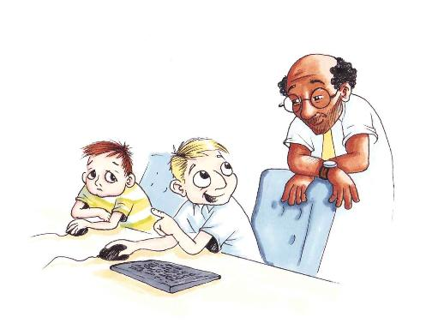
Tommy blushed with embarrassment. Stefan was making him feel stupid, which wasn’t helping his lack of confidence with IT things. Tommy was feeling fed up with Stefan’s lack of patience. They both worked in silence for a bit, but things between them felt tense. It was a relief when the bell went.
In class that afternoon, Mr Vadar came over to check on progress.
“How did you get on at lunchtime?” he asked.
“Okay” Stefan replied, and grinned over to Tommy. “Of course, Tommy was as much use as a chocolate teapot!” He laughed, shoving him gently on the shoulder. Tommy’s cheeks flushed. He knew that Stefan was attempting to be funny, but his comment made him feel ashamed.
Afterwards, Tommy was packing his bag when George came over. “Hey Tommy, a few of the lads are playing football after school if you want to join us?”
Tommy didn’t have any plans and was really pleased to be invited. “Yeah, sounds good.”
Stefan was finishing tidying things up on the desk. “Are you coming over to mine after school?” he asked.
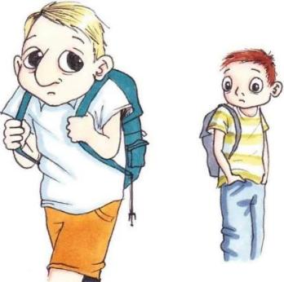
“Oh, no sorry I can’t tonight, I’m playing football.” Tommy replied.
Stefan looked disappointed, making Tommy feel guilty. “…you can come too if you want?” Tommy asked.
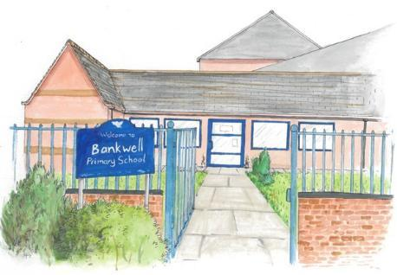
“No thanks,” Stefan replied, “not really my thing. See you tomorrow then I guess,” he said. Stefan shuffled off, looking sad, with Tommy wondering if he should go after him or not.

The next day, Tommy and Stefan walked to school together as usual. They chatted away and things seemed to be back to normal.

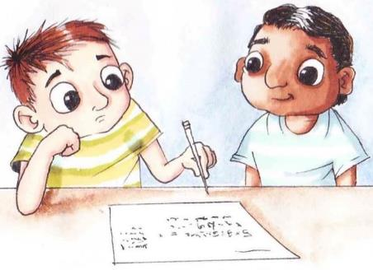
In class, Tommy worked with Ravi. They chatted about football and arranged to do some practice at lunchtime.
As they were about to head out to the playground, Stefan came over to Tommy.
“Are you coming to the computer room with me again?” he asked.
Tommy hesitated. “Oh, er, no sorry I’m playing football with Ravi.”
Stefan looked surprised. “Oh. But we always hang out together at lunchtime,” he said bluntly.
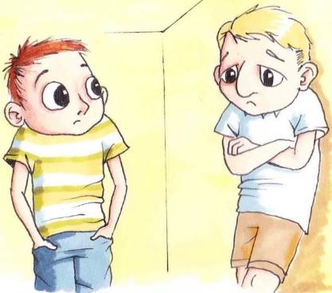
There was an awkward pause, and then he added “I thought we were supposed to be friends.”
Tommy felt a bit annoyed. “We are friends,” he answered, “but it doesn’t mean we have to spend all of our time together, does it?”
Stefan stomped off. Tommy watched him go, not sure what to do for the best.
He went into the playground and sat down on the bench, crossing his arms grumpily in front of him.
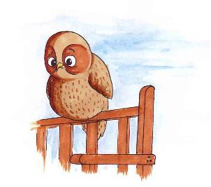
A few minutes later, there was a rustle, and a leaf dropped down beside him. Looking up, he saw Ope coming into land on the bench.
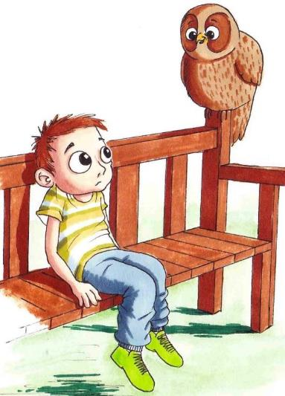
“Hi Ope!” Tommy grinned.
Ope waited for an appropriate moment to ask, “is everything okay?”
Tommy sighed “Not really”.
Ope fluffed out his chest. “What’s happened?”
Tommy replied. “It just feels like me and Stefan don’t have that much in common anymore.”
Tommy looked down, then continued. “Stef’s really into his computer stuff and although he tries to include me, he ends up getting annoyed with me….I’d rather be doing sporty stuff, but when I try to play with the others Stef gets upset and feels like I’m leaving him out.”
“Couldn’t you explain that to him?” Ope asked
Tommy thought “I guess…” his voice trailed off “….but I don’t want to upset him…”
Ope tilted his head. “How do you think he’s feeling?”
“I don’t know,” Tommy answered, “sometimes I think he feels like we’re drifting apart too, but then when I make other plans, he seems really hurt about it.”
“And how do you feel?”
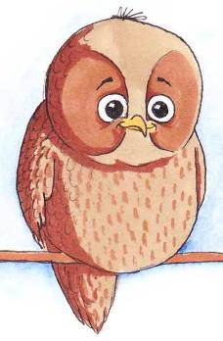
Tommy thought carefully. “I feel guilty if I spend time with others, but don’t want to be doing the same things as Stefan all the time, and when I do try and join in with his stuff sometimes he makes me feel stupid ‘cos I’m not as good as him.”

Ope listened carefully but didn’t interrupt. Tommy continued. “It’s like, we’ve been best friends for so long, but sometimes I fancy doing my own thing or hanging out with others.”
Ope turned to Tommy. “Does it have to be one or the other?”
Tommy looked up at him. “What do you mean?”
“Well, do you have to be either best friends or not friends at all?”
Tommy looked puzzled. “Well, no, that’s just silly. Just because you’re not best friends doesn’t mean you can’t still be friends.”
As he said it out loud, he started to realise what Ope meant.
“Maybe it’s okay that we’re not as close as we used to be, but we can still be friends.”
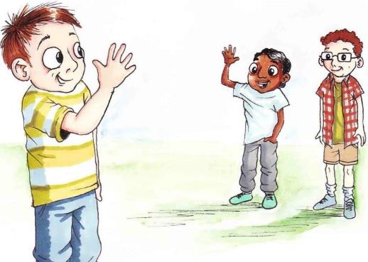
Ope nodded. They sat quietly whilst Tommy decided what to do.
“I need to have a chat with him about it, so he knows that we’re okay.”
At that point, Ravi beckoned over to him. “Are you playing?” he shouted. Tommy ran across the playground to where Ravi and George were playing football.

Back in the computer room, Stefan was trying to concentrate but his mind kept going back to Tommy. He hated falling out with him, so he decided to go and find him.
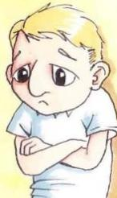
He looked around the playground for a while, then saw Tommy with Ravi and George. They were kicking the ball around and laughing. Stefan noticed how happy Tommy looked. He sat on the bench and watched them for a bit. He was surprised how left out and alone he felt.
He heard a squawk, shortly followed by a flapping sound. Sure enough, there was Ope sitting on the bench next to him.
“Hello Ope. Not seen you for a while!”
Ope hopped onto the back of the bench.
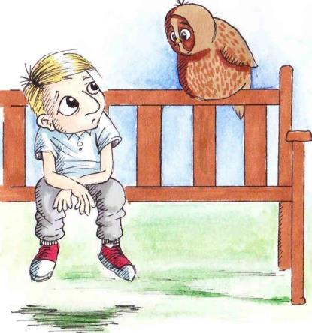
“Everything okay between you two?” Ope asked, looking over towards Tommy.
Stefan shrugged. “Well, if I’m honest, things feel a bit different between us at the moment,” he admitted. “He doesn’t seem to want to hang out with me anymore and it feels like I’m losing him.”
The words sat heavily.
“What do you mean ‘losing him’?” Ope asked.
Stefan folded his arms and looked at his shoes. “We’re best friends,” he said “but it’s awkward between us right now. We don’t seem to want to do the same stuff together. I don’t think he wants to be friends with me anymore. He has been hanging around with those other lads.”
Ope waited a few moments before asking, “do friends always have to spend their time together?”
Stefan thought about this. “No, not necessarily….but we’ve always done everything together, we’re best friends.”
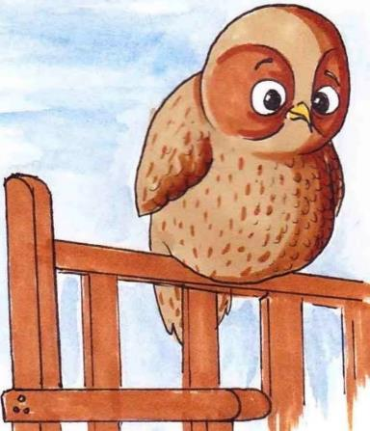
Ope asked. “Does that mean only being friends with each other?”
Ope continued, “What do you like most about Tommy?”
Stefan took a deep breath. “Well, he knows me very well, understands me, I trust him, I can rely on him, he makes me laugh…..we’ve grown up together….”
“You and Tommy have known each other for a long time,” Ope chipped in, “and you have a special bond. Nobody can change that.”
Stefan thought about this. “I guess it’s okay for our interests to change as we get older, and for us to get to know other people.”
Ope nodded. “But you can still be friends.”
Stefan continued “I think I’ve been trying to get things back to how they were which is not the best thing for either of us”. He stood up. “I need to talk to him about it,” he said, putting his bag over his shoulder, “thanks Ope!”.
Tommy and Stefan were in different groups for class that afternoon, which worked out well as they each got chance to think over what they wanted to say. When everyone was making their way to the cloakroom to collect their things, Tommy caught up with Stefan.
“Hey, fancy walking home together?”
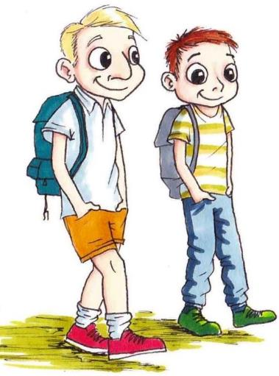
Stefan smiled. “Yeah, sure,” he said.

Resource 2a

Activity Sheet (Tommy’s story): Pathways to Friendship


One strategy is….
One challenge is…..


Resource 2b

Pathways to Friendship – support for the activity

Challenge | Choice of Action
Friend A moves to a different school to Friend B. | a) Friend B could ask to move schools too.
 | b) Friend B could get angry and tell them they can’t be friends any more.
 | c) Friend B could speak to carers/parents to see if they can meet up at weekends.
Friend A likes football, and Friend B doesn’t. | a) Friend B could ask Friend A not to play.
 | b) The friends could do some separate activities, but also joint ones.
 | c) Friend B could join in football even though they don’t like it.
Friend A always wants to watch  the same tv programme when they come round, but Friend B doesn’t like it. | a) Friend B could put up with it and watch it anyway.
 | b) Friend B could tell them not to come round anymore if they won’t watch something else.
 | c) The friends could take it turns to watch the programmes they like.
Friend A has made friends with someone new to the school and is spending all their time with them rather than with Friend B. | a) Friend B could tell Friend A that they won’t stay friends with them if they keep ignoring them.
 | b) Friend B could make other friends.
 | c) Friend B could join in and make friends with the new person as well.

Resource 2c

Activity Sheet (Tommy’s story): What happens next?
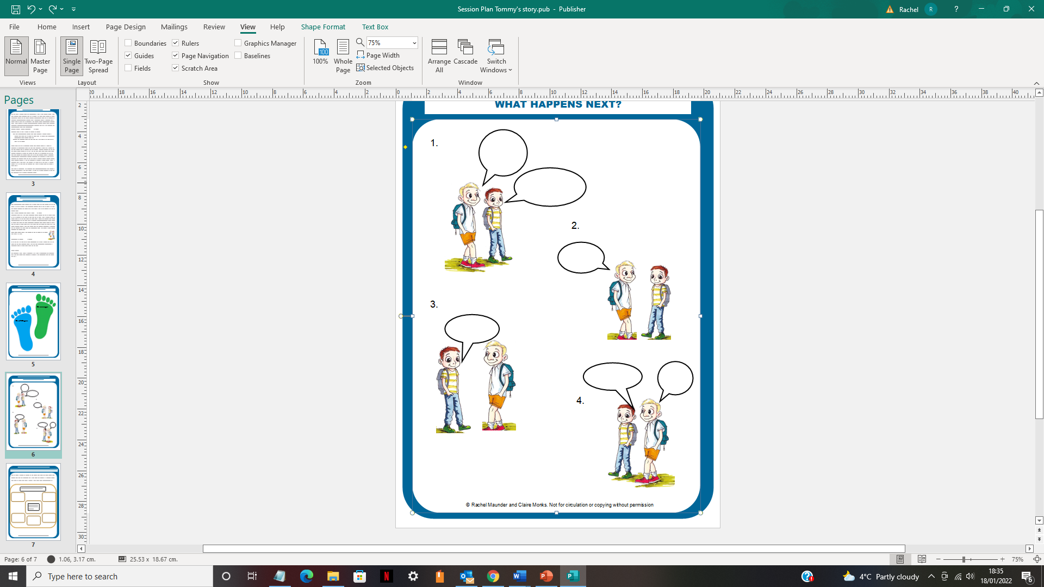

Resource 2d

Activity Sheet (Tommy’s story): Further learning

Draw or stick a picture of yourself in the middle, then using the boxes around your picture write what you think makes you a good friend. Try to think of 5 different things. This could be things like ‘I listen to others’, ‘I think about other people’s feelings’ etc.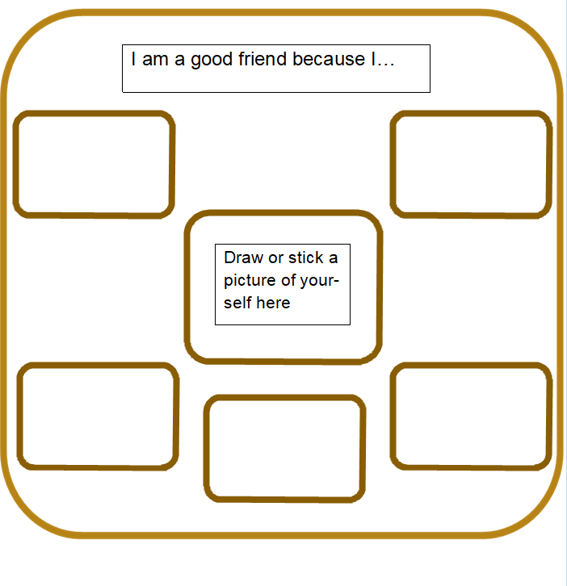

Lesson 3: When should you keep a secret and what makes a good friendship? (Halina’s story)

Lesson 3 Overview: At a glance

- Activity | - Description | - Timing  - (60 mins)
- Discuss the class ground rules for PSHE sessions | Discuss the agreed class ground rules for PSHE classes co-constructed in lesson 1. | 5 mins
- Baseline activity | Pupils demonstrate their understanding of how to handle a difficult friendship scenario. | 5 mins
- Halina’s story | Read Halina’s story (or use pre-recorded video) which explores what makes a good friendship. | 10 mins
- When is a secret, secret | Pupils will look at secrets, when to keep them, when to tell, and who to tell using the ‘Secret Agent Game’. | 15 mins
- Heads, Hearts, Hands | Pupils to consider what a child in the story could do when someone is being unkind about another child. They will consider what they are thinking and feeling and what they could do. | 20 mins
- Assessment of Learning - Plenary | Pupils reflect on their responses to the baseline activity in light of their learning. | 5 mins

Lesson 3: Session plan

Before using this plan, we recommend you read the introductory material including how to use this resource.

  - Context
This is the third session in a series which is designed to provide your pupils with the understanding and tools to deal with some of the complexities of friendships. These will support Key Stage 2 pupils and will help them to understand the nature of friendships, the benefits to positive friendships, how friendships can change and what makes a good friendship. Friendships become increasingly important during middle childhood as young people move into adolescence. These lessons will provide pupils with positive ways of managing some of the varied aspects of friendships and equip them with the skills to make informed and constructive choices within their relationships with peers.
Halina’s story forms the basis for the session. As per the guidance provided in How to use this resource, the story could be read before or outside of the lesson or could be split into parts or several chunks.
This lesson is planned for a one-hour session but can be broken down into two shorter sessions or adapted if needed.

Learning objective
> To learn how to manage challenges within friendships

Learning outcomes
Pupils will be able to
> Describe what makes a good friendship and explain why
> Identify strategies to help manage challenges within friendships
> Identify adults to talk to if someone has worries or concerns about their friendships

  - For this session, you will need…
> Story 3: Halina’s Story
> Flipchart/marker pen
> small pieces of paper for each child
> box/postbox into which pupils can post these notes
> Resource 3a: Secret agent game
> Resource 3b: Cartoon (for display) (optional)
> Resource 3c: Further learning (optional)

  - Climate for learning
- As with all PSHE classes, this lesson should be taught in a non-judgemental environment with support provided.
- Pupils should be encouraged to reflect on the materials, but not discuss real-life incidents, personal experiences or other pupils within the class/school.
- Ground rules should be agreed at the start of the year (see Lesson 1 in this pack) and should be reiterated at the start of each class (these might be displayed around the classroom for example).

  - Key words
Friendships, trust, making friends

In class activities
NB: Please review this lesson before delivery and consider the needs and circumstances of pupils in your class. For example, character names or scenarios may need adapting if similarities are likely to cause distress to your own pupils.

  - Discuss the class ground rules for PSHE sessions Estimated time 5 minutes
At the start of the session, discuss the agreed class ground rules for PSHE classes (framed as the Our Class agreement) which will have been co-constructed with the class in Lesson 1.

  - Baseline activity Estimated time 5 minutes
Part of this session will look at challenging situations pupils may face in their friendships. This baseline will help you assess pupils’ current understanding of how to handle a difficult friendship scenario. This assessment may also help you to adapt teaching where necessary.
Ask pupils to imagine that they have overheard the conversation below:
Person A: “Sam said Jessica wasn’t very nice to him yesterday”
Person B: “What did you do?”
Person A: “I…”
Ask pupils to write down the rest of Person A's sentence on a small piece of paper (without their name), outlining what they think Person A might have said or done in response to Sam's comment. These can be collected in the box.
We will then come back to this at the end of the session. Whilst pupils complete this task, walk around the room to gauge pupils’ understanding and take feedback from some pupils.

  - Halina’s Story Estimated time 10 minutes
Read Halina’s Story to the pupils (they should have already heard the first story: Welcome to Our Class). There is a video on our website if you prefer to show this. Halina’s Story describes the friendship between Halina, Isabel, Molly and Kim. Halina tells Isabel a secret that she then shares with Molly and Kim, and the girls start to treat Halina differently. Molly and Kim then try to get Halina to join in when they are excluding Isabel. This story explores what makes a ‘good’ friendship and provides a context within which to discuss how children may manage this in a positive way. Then, ask pupils:
- How do you think Halina feels at different points in the story?
They might say:
- worried when talking about difficulties at home.
- hurt when she discovers Isabel has told others about the secret.
- What could Halina do to address the other girls’ behaviour?
They might say:
- talk to Isabel about how she was upset about her telling her secret.
- think about whether she wants to remain friends with the group or if she would prefer to spend time with Nia and Zoe.
- Are the others being good friends to Halina?
They might say:
-not really, because part of being a good friend means that you can trust each other and Isabel told the others Halina’s secret– this may then lead to discussions which will come in the next activity (when is a secret, secret) about when to tell a secret and when to keep a secret.
- good friends are kind to each other. The girls were trying to get Halina to exclude Isabel which isn’t a sign of a good friendship.

  - When is a secret, secret? Estimated time 15 minutes
Halina trusted Isabel with a secret, but Isabel then went and told Molly and Kim. The three of them were then quite unkind to Halina as a result.
Often friends tell other friends things about themselves that they want to keep secret. It could be something that happened that was embarrassing (e.g. the time they poured orange juice on their cereal instead of milk), or about someone they have a crush on, or something private that is happening in their family, like in Halina's case.
It is good for someone to talk about things that are upsetting them, and it can often feel better to share these things with a friend, bringing two people closer. So, when a friend tells other people someone's secrets it can be very upsetting.
However, some secrets shouldn’t be kept. But how does someone know when they should tell their friend's secret or not? And how do they know who to tell?
In this section, we will look at secrets, when to keep them, when to tell and who to tell…

Secret Agent Game – using the materials provided, give pupils a list of different secrets that they need to place in one of three piles – keep the secret, tell the secret, don’t know. They should work in small groups to put them into piles on the table (using the cards in Resource 3a). With the cards that they have put into ‘tell the secret’, they then need to decide WHO the person should tell – they are given several options, an adult, a teacher, a police officer, another friend.
Then, as a group, discuss why they have chosen for the person to tell some secrets and not others, talk about the importance of telling when they are worried that someone is getting hurt or if something serious is happening that is upsetting them. Often a good rule is that secrets that are meant to be kept for a long time are not secrets that should be kept and if someone is worried at all about another person, it is better to seek help from a trusted adult. Get them to think about who the best person would be to tell – e.g. a trusted adult rather than another child. You may want to consider having another adult in the room with you (e.g. teaching assistant) to support this activity. We also recommend you consult with the designated safeguarding lead so that you are familiar with the school procedures and can provide appropriate advice to pupils, and have a clear referral route should any disclosures be made.

  - What could Halina do when Molly and Kim were being unkind about Isabel (Heads, Hearts, Hands?) – Estimated time 20 minutes
At several points in the story, Molly and Kim were trying to get Halina to exclude Isabel or join in saying unkind things about her. Halina didn’t say or do anything in the situation. Do you think she did the right thing?
Using the picture provided (Resource 3b) showing Halina and Kim, ask pupils to complete a ‘Head, Hearts Hands’ activity. For this, pupils should work in small groups to consider what the characters might be thinking (head) and feeling (heart) and what they could do (hands) about the situation they are in.
Actions might include Halina confronting Molly and Kim about being unkind to Isabel. This should be in a positive, constructive way rather than starting an argument. Some pupils might think Halina should tell Isabel that Molly and Kim are being unkind about her. Also, ask pupils to consider how others in the situation might be feeling, for example, what might Molly/Kim be feeling? How might they help Molly/Kim to think about their behaviour in a kinder way?
Next, the class should focus on Halina and, on the whiteboard, brainstorm pupils' ideas about what Halina could do next (the 'hands' part), creating a whole class list of strategies. Finally, independently, they should write advice to Halina about what she should do, by evaluating which strategy they think would be most effective and explaining why.
Share the activity outcomes with the group and ask the pupils to explain their responses. What do they think might happen afterwards?

  - Assessment of Learning - Plenary – Estimated time 5 minutes
In the final part of the class, draw the whole class together and have a look through some of the suggestions in the box that pupils made in the baseline activity. Ask pupils to write an alternative response/sentence based on what they have learnt in the lesson. The sentence should start “I think Sam should….”. Read some of these out to the class and ask pupils which ones they would now recommend others to do if they found themselves in a similar situation to Halina. Remind them about safeguarding and when a trusted adult should be informed.

  - Support for learning
For the activity looking at secrets, provide pupils with the worked examples (in red on the sheet) to give them a starting point. You may want to talk through these examples as to why someone should/shouldn’t tell in these situations before they move on to the next examples.

  - Challenge
For the activity looking at what Halina could do when Molly and Kim were being unkind about Isabel, ask pupils to consider several different things that Halina could do in this situation and discuss which one they prefer and why. This will help them to appreciate that there are often different ways of responding to challenging situations, along with the pros and cons of these approaches.

Further learning/Extension
Ask the pupils to think about what someone should look for in a friend. What makes a friendship a good one? Ask them to think about things beyond the practical ones (e.g. a good friend is someone to play football with), and more about the psychological aspects of friendship (including trust, caring, support, sharing). Ask pupils to complete the activity (Resource 3c) by drawing a picture of themselves in the centre and identifying key things that they look for in a good friendship around them.

Further support
At the end of each lesson, support should be signposted to pupils for those who may need it. This may include pastoral members of the school staff or adults at home, such as parents or carers, and external organisations such as ChildLine (0800 11 11).
How did it go? Please tell us what you think of the materials.

Story 3: Halina’s story

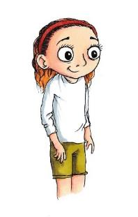
In this story I’m going to tell you about Halina. Halina thought she had friends she could rely on, but this was tested when she trusted one of them with a secret. She realised that perhaps they weren’t the friends she thought they were after all.
Halina, Isabel, Molly and Kim tended to hang around as a group of four. They had been friends for a while and were quite a tight group.
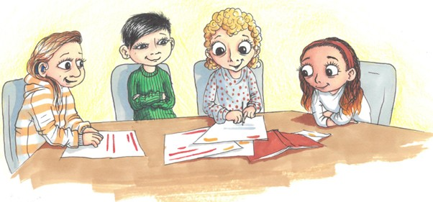
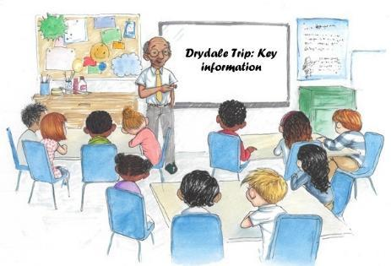
The big news of the moment was the forthcoming class residential visit. Two nights away at Drydale Adventure Centre, doing lots of exciting stuff like abseiling, climbing, and orienteering. It sounded like so much fun! It was only a few weeks away and everyone in the class was getting excited. There had been much debate in school that day about who was going to share rooms, and who could stay up the latest without getting caught.
Halina had tried to join in, but it was difficult knowing that she probably wasn’t going to be able to go on the trip. Her dad had promised her he would try his best to get the money together in time, but she didn’t want to put more pressure on him. Things were difficult enough for the family at the moment.
That evening, Halina went over to Isabel’s after school.
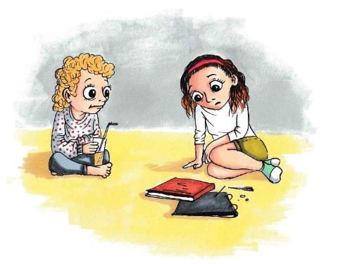
Halina was quiet and Isabel sensed something was bothering her.
“Is everything okay?” she asked, taking a slurp of juice.
Halina sighed. “I guess…..” her voice trailed off, “things are just really stressful at home at the moment.”
“Why? What’s going on?” she asked. There was a pause before Halina replied.
“I shouldn’t really say, mum and dad want to keep it private within the family.”
Isabel nudged her shoulder. “But we’re friends Hal, you can tell me stuff, I won’t tell anyone.”
“Do you promise?” Halina brought her knees up to her chest.
“Of course.”
“Well, my dad has lost his job,” Halina said glumly, “we’re really struggling with money.”
Isabel looked concerned. Halina continued, “mum said I might not be able to go on the school trip ‘cos we can’t afford it. Please don’t tell anyone, Isabel.”
“Of course I won’t, Hal. That’s rough, I really hope you can go.” Isabel replied.
Halina shrugged. She was gutted that she might not be able to go, but she was trying to put on a brave face so that her mum and dad didn’t feel bad. She tried to change the subject and take her mind off it.

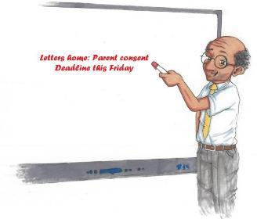
In school the next morning, Mr Vadar was passing out some letters about the school trip.

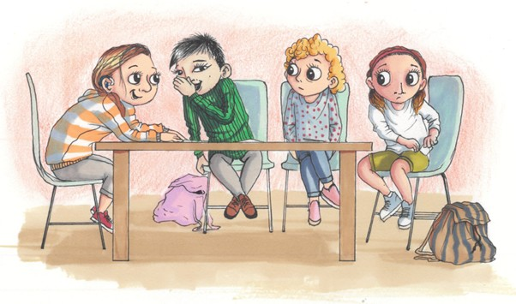
There was a buzz of excitement around the class. Halina quickly folded up the letter and shoved it in her pocket. She noticed the other girls watching her.
Kim whispered something to Molly. They both laughed. Then Kim jotted something down on her paper and showed Isabel.
“What are you talking about?” Halina asked.
Kim looked knowingly at the others, then said “Oh nothing – it’s just about the trip – so it doesn’t apply to you if you’re not going.”
Halina’s eyes widened in disbelief, and she turned to Isabel. Isabel looked down, guiltily.
“You told them?” Halina gasped. “How could you? You promised!”
Isabel’s cheeks flushed, but she didn’t say anything.
“Hey, look it’s okay,” said Molly, “you should’ve told us yourself anyway, we’re friends remember.”
“…but I’m not supposed to have told anyone. It’s private to our family.” Halina pleaded.
“Well, it won’t go beyond us” Kim added, trying to make light of it. Halina didn’t know what to say. She felt very hurt that Isabel had not kept her secret, but she was relieved that it was just the four of them who knew. Perhaps Isabel had been trying to help by telling the others?

At lunchtime, Halina spotted the other 3 girls sitting at one of the far tables. As she started walking towards them, she saw them glance over at her and then whisper to each other. She felt like they were talking about her. When she reached their table, they fell quiet. She smiled and got her lunchbox out of her bag, but she was feeling uncomfortable. She tried to act normally; in case she was just being overly sensitive.
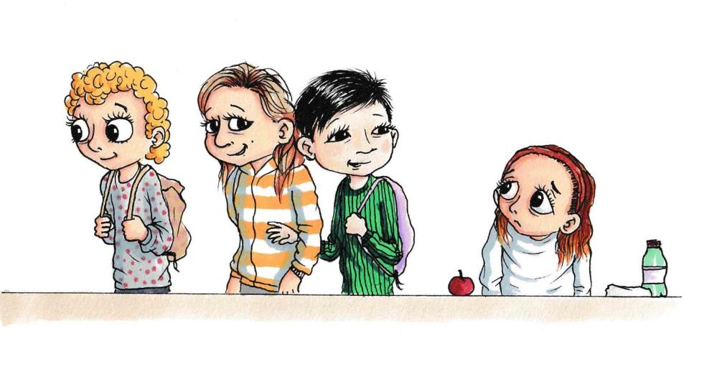
Before Halina had finished eating, the others started to pack away their things and stand up ready to go outside. “Where are you going?” Halina asked, wondering why they were leaving her behind.
“Outside.” Molly said, bluntly.
“Aren’t you going to wait for me?” Halina asked.
“We’re making plans for the school trip,” Kim said, “so you don’t need to be part of it.” She gave a sarcastic grin, turned her back to Halina and walked away – linking arms with Molly as she went.
Halina sat there with her cheeks burning. She could feel her eyes well up with tears and she swallowed hard. She glanced at Isabel, hoping for support, but Isabel looked away and followed Molly and Kim to the playground. Halina sat on her own finishing her lunch, not sure why she was being left out of the group.

Later that afternoon, Halina glanced over at Molly, Kim and Isabel as Mr Vadar was organising groups. They had already teamed up, and she could see them all smiling and giggling together, and she felt jealous.
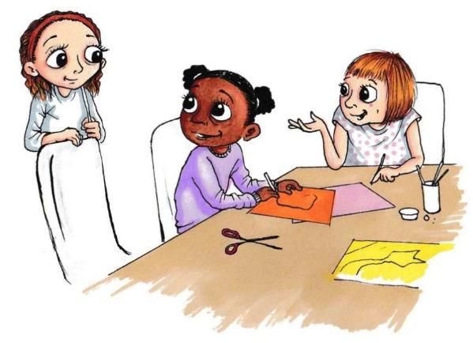
“Hey, do you want to join our group?” Zoe asked. “I’m working with Nia.”
Halina was grateful to be invited and followed Zoe over to the table where Nia was already working.
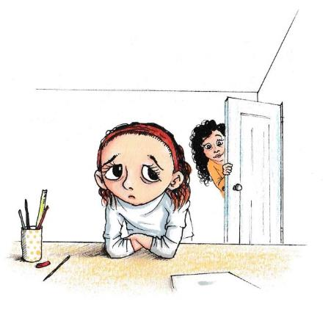
It was good working with Zoe and Nia, and Halina was glad to be away from the tension for a bit. When everyone was getting ready to go home, Isabel said bye to Halina as if nothing had happened, and Molly and Kim both turned to wave to her on the way out. Halina couldn’t work out what was going on, and whether they were being friends with her or not.
She felt really upset about it that evening at home. She went over things in her head, trying to work out why they were being funny with her, and if she had done anything to cause it. Could she trust them not to tell anyone else about her dad’s job? What had they been saying about her? Maybe they weren’t talking about her at all?
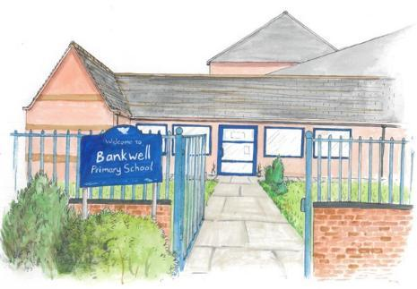
Halina felt nervous as she arrived at school the following morning wondering if the others were going to be nice to her today or not.
Molly and Kim came over. “Hi Hal, how are you?” they said, in a friendly tone. Halina was immediately relieved that both girls seemed to be being talking to her.
“Yeah, fine,” she replied, acting as normally as she could. “Did you finish your Maths homework?”
“Just about,” Molly replied. “It was really hard though.”
Kim laughed. “Yeah, I bet Isabel could do it though, she’s a bit of a swot isn’t she?” Kim said. Halina wasn’t sure whether she was joking or not.
As they approached the classroom, Halina could see that Isabel was already sitting at their table. Kim glanced towards her.
“Is everything okay between you two then?” she asked.
Halina looked at her. “What do you mean?”
“Well, after yesterday, about the school trip,” Kim added. Halina shrugged. Molly chipped in “You’re right though Halina, Isabel shouldn’t have told us your secret,” she said.
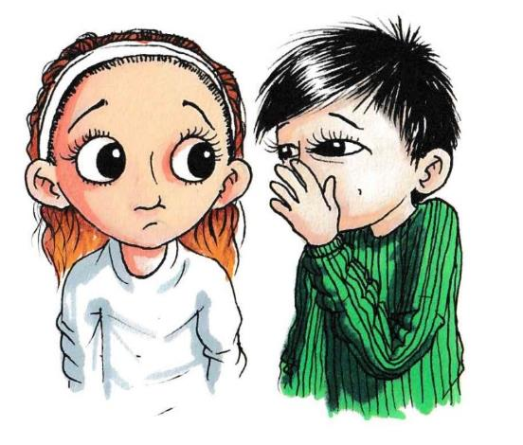
“Yeah, it wasn’t very nice of her to break your trust” Kim folded her arms “I’m not surprised though, it’s the sort of thing she does.”
As they approached the table, Molly whispered towards her “Yeah, she’s just doing it for attention. She so wants to be popular. She’s been sucking up to us loads. She’s been telling us other stuff about you too”
“Yeah, I think she’s trying to turn us against you,” Kim added.
Halina wasn’t sure what to say.
Molly leant in towards Halina and whispered, “Hey, do you want to come with us at lunchtime? We weren’t going to invite Isabel as we fancied a bit of space from her…she’s been a bit intense lately, hasn’t she?”
Halina hesitated – not wanting to speak out of turn about Isabel. “Um, yeah, maybe, not sure what I’m doing yet.”
Molly looked put out. “Oh right, well, whatever, do what you want, we’ll be there if you want to join us.”
Halina went over to her table, where Isabel was looking a bit glum. As Halina took her seat, Isabel asked her directly, “Is it me or are they being funny with me?”
Molly and Kim were out of ear shot, but Halina wasn’t comfortable passing on what they had said. She didn’t know who to trust, or what to do for the best. She just shrugged and sat down, trying to avoid the question.
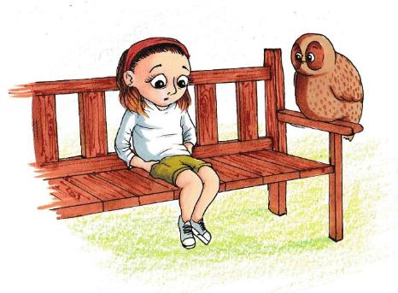
At lunchtime Halina shuffled over to the benches and sat down. Just then, she caught sight of Ope peering down at her from the branch above.
“Hello, Ope,” she smiled “are you coming down to see me?”
Ope stretched out his wings and swooped down from the tree onto the arm of the bench.
“Hello!” he said, “and how are you today?”
Halina fiddled with her hair “Oh I’m alright I suppose” she said, “things are not that great at the moment though.”
“Really? What’s the problem?” he asked, turning towards her.
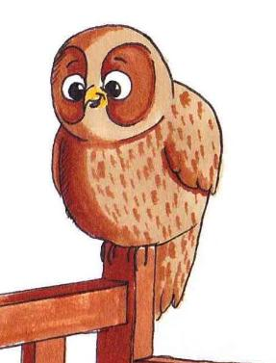
Halina sat up in the seat. “My dad’s lost his job, so we’re really struggling for money. I’m not going to be able to go on the residential trip.”
“Oh, that’s a shame. I’m sorry to hear that.” Ope replied, showing concern.
“Yeah, and I told my friend Isabel about it, but then she went and told my other friends Kim and Molly. Now they’re all being funny with me. Earlier Molly and Kim told me that Isabel’s been talking about me behind my back….and now they’re being funny with her and trying to get me to join in…”
“And these are your friends?” Ope asked, slowly.
“Um…well when you say it like that….maybe they’re not….” Halina replied.
“What do you value most about being friends with someone?” he asked.
Halina thought carefully and started to list a few things. “I like having someone to talk to about things, having someone to spend time with, who you feel comfortable with and can be yourself with….”
Ope sat and let her continue.
“…who makes you happy….makes you feel good about yourself…”
“And are these girls making you happy?” Ope asked. “Do you feel relaxed around them? Do you trust them?”
Halina thought back to the earlier conversation with Molly and Kim, and the way Isabel had been with her yesterday.
“Well, I guess not, but-” she hesitated “but it wasn’t like this before, it was all fine, they were good friends, I just want it to be back how it was with us all having fun together.”
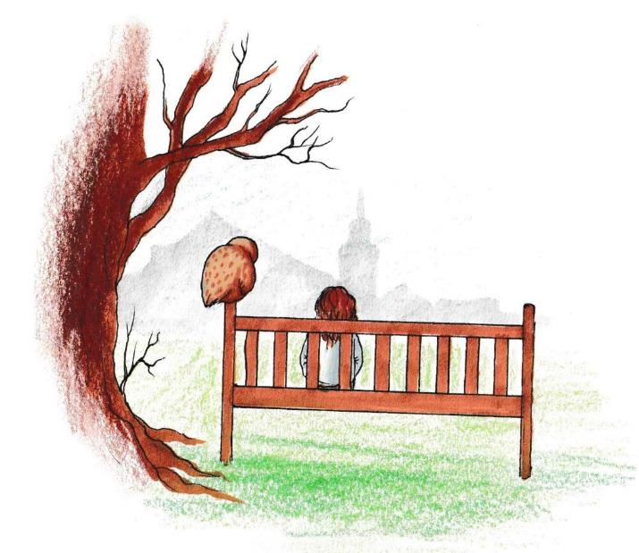
“Hmm, but you don’t seem happy at the moment, and from what you’ve said it doesn’t sound like they are being the kind of friends that you want,” Ope replied.
Halina said nothing.
“Things change, friendships don’t always last forever…. think about what’s important to you and what feels right.”
Halina sat in silence. She knew Ope was right, but it was difficult to accept, and she didn’t know how to deal with it.
“But I don’t want to be on my own Ope.”
He rustled his feathers.
“Are they your only friends?”
She thought for a minute “Er, sort of, I mean, they are the ones I hang out with the most……but I suppose there are others in the class I could spend more time with.”
Ope nodded “Okay. So how might you go about that?”
Halina could tell that Ope was encouraging her to take control of the situation.
“Well, Zoe had asked me if I wanted to join their group yesterday.”
“Great!”
“And I’ve always got on quite well with Nia too.”
Ope nodded. “There you go you see….that wasn’t too hard….one step at a time.”
Halina realised that she would need to be the one to change things and look for opportunities to move away from the group that was making her unhappy.
She heard the bell ring to signal the end of break time, so started to stand up.
“Ope, thank you, you’ve been a great help,” she said.
Halina jogged across the playground towards the line waiting to go back into the classroom. She saw that Zoe was chatting to the new girl, Ruby, so went over to join them.
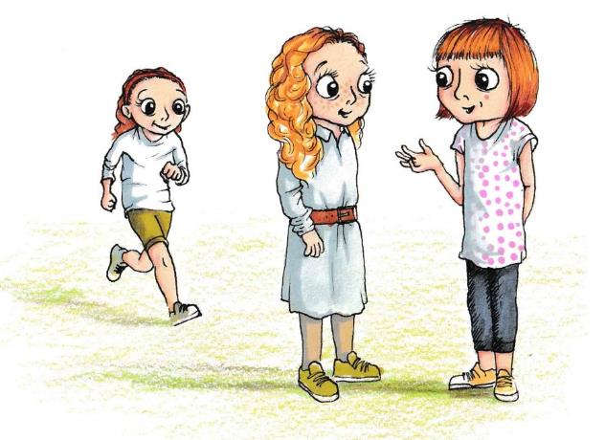

Resource 3a

When is a Secret, secret? Secret Agent Game

If someone told their friend one of these ‘secrets’, what should they do – should they keep the secret or tell someone? Sort the cards into ‘tell’, ‘don’t tell’, or ‘not sure’. For any you think are ‘tell’, decide who you think someone should tell, for example, ‘a friend’, ‘an adult’, ‘a police officer’, ‘a teacher’.

My mum has planned a surprise for my brother’s party, but it’s a secret. | Someone hit me and told me not to tell.
Someone stole my football and told me not to tell. | We’ve got the teacher a surprise present for the end of the school year, but don’t tell them.
I didn’t really like the present I got for my birthday, but don’t tell them as I don’t want to hurt their feelings. | I got my big brother to do my homework for me because it was too hard, but don’t tell anyone.
I don’t really like the cake my mum made for my packed lunch, but don’t tell her as she took ages making it. | I told Molly that I liked her cat, but I really prefer dogs, don’t tell her.
I told my aunty that I liked the hankies she bought me for a present, but I don’t really like them, but don’t tell her. | I’ve got a crush on someone at school, but don’t tell them.
I wish we could play something different at break, but Nia always wants to play football and I think she’d be upset if I said I was sick of football. | I saw someone steal my neighbour’s bike, but they told me that they would ‘get me’ if I told.
My brother is always going on his phone at bedtime, even when mum has told him not to, he said he’d give me £5 if I didn’t tell her. | My sister took some sweets from the local shop without paying, she told me I could have some if I didn’t tell mum.

Some worked examples that can be used if needed:
‘Secrets’
‘My mum has planned a surprise for my brother’s party, but it’s a secret’. Don’t tell
‘Someone hit me and told me not to tell’. Do tell – an adult/teacher
‘Someone stole my football and told me not to tell’. Do tell – an adult/teacher

Resource 3b

Activity sheet: Heads, hearts, hands

Kim
Head: What is she thinking?

Heart: What is she feeling?

Hands: What could she do?
Halina
Head: What is she thinking?

Heart: What is she feeling?

Hands: What could she do?

Resource 3c

Further learning worksheet

What do you look for in a good friend? Draw a picture of yourself in the middle and then use the squares around you to identify what you would like your friends to be like. This might include things like ‘someone I can trust’, for example.
Someone I can trust
Draw a picture of yourself here

I want my friends to be……

Lesson 4: Making new friendships (Ruby’s story)

Lesson 4 Overview: At a glance

- Activity | - Description | - Timing  - (60 mins)
- Discuss the class ground rules for PSHE sessions | Discuss the agreed class ground rules for PSHE classes co-constructed in lesson 1. | 5 mins
- Baseline activity | Pupils consider how they manage situations of loneliness, how to recognise loneliness in others, and how to support them. | 5 mins
- Ruby’s story | Read Ruby’s story (or use pre-recorded video) which explores challenges in making friendships in a new environment. | 10 mins
- What could the rest of the class do to help Ruby settle in? | Pupils consider how a child might notice that someone is feeling upset or left out and consider strategies they can use to help. | 15 mins
- How can I make new friends? | Pupils consider what the characters might feel and what they can do if they feel lonely and provide advice to Ruby. | 20 mins
- Assessment of Learning - Plenary | Pupils reflect on their initial responses during the baseline activity and add to these based on their learning. | 5 mins

Lesson 4: Session Plan

Before using this plan, we recommend you read the introductory material including how to use this resource.

  - Context
This is the fourth session in a series which is designed to provide your pupils with the understanding and tools to deal with some of the complexities of friendships. These will support Key Stage 2 pupils and will help them to understand the nature of friendships, the benefits to positive friendships, how friendships can change and what makes a good friendship. Friendships become increasingly important during middle childhood as young people move into adolescence. These lessons will provide pupils with positive ways of managing some of the varied aspects of friendships and equip them with the skills to make informed and constructive choices within their relationships with peers.
Ruby’s story forms the basis for the session. As per the guidance provided in How to use this resource, the story could be read before or outside of the lesson or could be split into parts or several chunks.
This lesson is planned for a one-hour session but can be broken down into two shorter sessions or adapted if needed.

  - Learning objective
> To learn about the important role friendship plays in someone’s wellbeing.

  - Learning outcomes
Pupils will be able to
> Describe the characteristics of friendships and what makes them special.
> Explain how to look out for people who feel left out or lonely.
> Analyse ways to manage feelings of loneliness.

  - For this session, you will need…
> Story 4: Ruby’s Story
> Flipchart/marker pen
> Post-it notes
> Pens/paper/computers (optional)
> Resource 4a: What makes friendship so special? (optional)

  - Climate for learning
- As with all PSHE classes, this lesson should be taught in a non- judgemental environment with support provided
- Pupils should be encouraged to reflect on the materials, but not discuss real-life incidents or other pupils within the class/school
- Ground rules should be agreed at the start of the year (see Lesson 1 in this pack) and should be reiterated at the start of each class (these might be displayed around the classroom for example).

Key words
Friendships, loneliness, making friends

In class activities
NB: Please review this lesson before delivery and consider the needs and circumstances of pupils in your class. For example, character names or scenarios may need adapting if similarities are likely to cause distress to your own pupils.

  - Discuss the class ground rules for PSHE sessions Estimated time 5 minutes
At the start of the session, discuss the agreed class ground rules for PSHE classes (framed as the Our Class agreement) which will have been co-constructed with the class in Lesson 1.

  - Baseline activity Estimated time 5 minutes
This baseline will assess how pupils manage situations where they might feel lonely or recognise someone else feeling lonely and how to support them. This will help you to adapt teaching where necessary, for example by spending more or less time on certain activities.
Ask the pupils to think about a time when they were new (perhaps when they joined a new club for example). Allow pupils time to reflect on these questions privately without sharing with the rest of the class.
As a class, then ask them to make suggestions about what advice could be given to someone about making new friends in a new situation. Pupils should record their ideas about how to help on graffiti walls - each focusing on a different example. Each scenario above could be written on large sheet of paper and placed around the room where pupils can add their ideas. This can be straight onto the paper or on sticky notes which are arranged onto each piece. This will help organise their ideas and make it easier to add to at the end of the lesson The below are examples you could use:
- A new person from a different school.
- A new person from a refugee country and can’t speak English fluently.
- Working with a new group of people.
Prompt them with questions such as ‘How might this situation make someone feel?’, ‘What might they do?’, ‘How could others help?’

  - Ruby’s Story Estimated time 10 minutes
Read Ruby’s Story to the pupils (they should have already heard the first story: Welcome to Our Class). There is a video on our website if you prefer. This chapter tells the story of Ruby who has recently moved from a different country and joins Bankwell Primary School. It explores the challenges she faces making new friends, even in a very friendly environment. It provides a context within which to discuss how pupils may manage situations where they might feel lonely or how to support others who may feeling lonely in a positive way. Then, ask pupils:
- What might be Ruby’s thoughts and feelings starting a new school?
They might say:
- she might be feeling excited, nervous, afraid, missing her old friends, lonely, feeling a bit left out, a bit lost…
- How do the other children’s behaviours make Ruby feel?
They might say:
- they are trying to include her, so she is feeling welcomed.
- when they are talking about other people that she doesn’t know or things she hasn’t been involved in she might be feeling a bit left out and it might remind her of her friend Jessie, who she is missing.
- Why does Ruby feel lonely even though she is making new friends?
They might say:
- it can take time to make close friendships.
- people are being friendly, but she still missing her close friends from where she used to live.
  - What makes friendship special? Estimated time 5 minutes
In the story Ruby is missing her friend Jessie. As a class, ask pupils to consider:
- what was so special about Ruby and Jessie’s friendship?
- Why was it so important to Ruby?’
After their discussion, organise pupils into small groups or pairs to write key words/phrases in a mind map describing what made the friendship special for Ruby.

What could the rest of the class do to help Ruby settle in? – 15 minutes
As we’ve seen from the stories, the pupils in the class are very friendly and kind. However, they don’t seem to realise at first that Ruby is feeling lonely and left out! In this part of the session, pupils will be looking at how they might be able to notice if someone is feeling left out, and what they might be able to do to help. In the story there were several situations where Ruby felt left out. For example, when she was sitting on the bus, when the others were talking about the sleepover and during the class activity.
- Ask the pupils to think about how the other children might be able to notice that she was feeling upset or left out? Ask them to describe how Ruby might have looked in these situations, her face, her body language and what she might have said. Ruby might have looked sad, she may have been looking at the ground, not standing up straight etc. She might have given an ‘it’s okay’ smile, but not a proper smile. She might have said it was alright, but her voice might have given it away…
- Then, ask the pupils to consider how these situations might have been different – how could the class have helped Ruby to feel included? This doesn’t mean that the children have to stop talking about other people who Ruby doesn’t know, for example. But, it might mean, explaining who they are to her, so that she starts feeling part of things. It might also not mean inviting her to the sleepover straight away as she’d only just joined the class, but being aware that she wasn’t coming, the girls might have been a bit more tactful talking about it in front of her.
- As a group, then come together to share these ideas and discuss/compare the different answers groups might have given to the different scenarios, showing that there are often different ways to behave that can still help.

  - How can I make new friends? Estimated time 20 minutes
Ruby was missing her friends at her old school and, even though the children at Bankwell Primary School were friendly, she felt left out. It can take time to make new friends who are as close as she was to Jessie in Ireland, as Ruby realises from her chat with Ope. There are times when we all feel a bit ‘out of place’.
Managing feelings and making friends
In this activity, the purpose is to help pupils think about what being lonely feels like, and what characters at Bankwell School can do if they feel lonely. Using resource 4a, organise the pupils into groups and ask them to fill in the thought bubbles considering how the characters feel if they are lonely (e.g. they feel sad, or alone), and what they can do (e.g. they could join in with a game at playtime when they don’t have anyone to play with). Pupils should work together in groups to identify the ways the characters manage being lonely or what they do when they want to make new friends. This can then be fed back to the class and used to help pupils complete the following task.
Advice to Ruby
Ask pupils to provide advice to Ruby on how to make friends by pretending to be Jessie, her friend in Ireland. Ask them to imagine that they are Jessie (Ruby’s best friend in Ireland), and Ruby has sent them an email telling them how lonely she is feeling after moving to a new country. She asks what she should do to make new friends. Ask pupils to compose an email as Jessie to send to Ruby giving her kind, helpful advice on how she might go about making new friends (as well as keeping her old friends too). Pupils can carry this task out in small groups or pairs to promote discussion of what she could do. Alternatively, you could ask pupils to role play a phone/video call between Ruby and Jessie where Jessie gives her friend advice.
Then, as a group, ask the pupils to share some of the advice that they have given to Ruby. This could be things such as understanding that it might take time to make new close friendships, but that the pupils at Bankwell Primary sound very friendly and nice. Pupils might also suggest practical advice, such as joining in when others invite you, asking people to join you, and taking part in clubs (especially as Ruby indicated that she liked sports and there were lots of sports clubs at Bankwell where she might meet other children who like similar things to her). Others might also advise her to keep in touch with her friends in Ireland too. They might also suggest that she speaks to her mum who might be able to help by talking things through with Ruby and doing fun things together while Ruby is settling in. When pupils are mentioning these, it is important to help them to understand that being lonely isn’t something that they should be embarrassed or ashamed of and that most people will feel lonely at some point or other, but that there are lots of things that you can do in these situations.
- If using a role play activity, ensure that pupils are playing the characters of either Ruby or Jessie rather than role playing themselves, people they know or situations they have been in. It should be made clear that participating in the role play is optional, and individuals can sit out and watch if they feel uncomfortable. Supervision is required to ensure that pupils are not role playing risky, dangerous or potentially upsetting scenarios e.g. bullying.
Share the activity outcomes (either the e-mail or sharing role play summaries) with the group and ask the pupils to explain their responses. Give the pupils criteria on which feedback on the role play or e-mail activity should be fed back (e.g. positive and constructive ways forward for the characters, rather than the writing or acting displayed). For example, have they been supportive in the advice they have given? Have they suggested practical ideas about what Ruby might do and how these might help her? What else could they have included? Allow some time at the end of this activity for a debrief on what was learnt, and for pupils to get out of character before moving on.

  - Assessment of Learning - Plenary – Estimated time 5 minutes
In the final part of the class, draw the whole class together and ask them to look back at the graffiti walls they produced at the start of the lesson. Pupils should add their new ideas and learning in different coloured sticky notes or pens. To ensure all pupils participate, ask them to write at least two new things they have learnt this lesson on a post-it note or in their books. You can then summarise the new learning for the class.

  - Support for learning
Using some of the examples in the ‘Advice for Ruby’ section, provide some overall guidance to pupils through prompts – these could be displayed on the board. This may be in the form of ‘What could Ruby do? Who could she talk to if she felt sad or lonely? How could she find people who she might have shared interests with to make friends? Who in the story might make a good new friend and why?

  - Challenge
Ask the pupils to work in pairs to produce a ‘how to’ top tips guide for new people joining the class, as well as existing class members, to ensure everyone feels welcome. These could then form part of a display on how to support friends.

Further learning/Extension

  - What would Ope say?
Ask the pupils to use resource 4b to consider what Ope would say to someone who was feeling lonely. They can fill in the speech bubbles with their questions and advice. These could be displayed around the classroom.

Further support
At the end of each lesson, support should be signposted to pupils for those who may need it. This may include pastoral members of the school staff or adults at home, such as parents or carers, and external organisations such as ChildLine (0800 11 11).

How did it go? Please tell us what you think of the materials:

Story 4: Ruby’s story

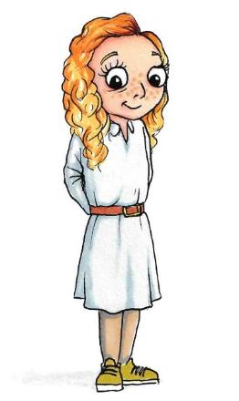
In this story, I’m going to tell you about Ruby. Ruby only recently started at our school.
Ruby was originally from Ireland and had been going to school over there. Ruby’s mum got a new job here, so they moved over to England during the holidays. Ruby said she was sad to leave Ireland, and she had a lot of family and friends there.
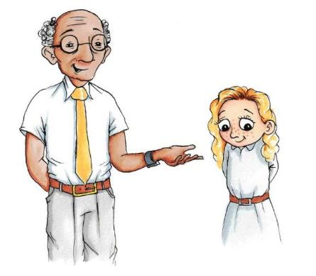
On Ruby’s first day, Mr Vadar introduced her to the class. She looked a bit shy and unsure – which is understandable being faced with us lot for the first time. Mr Vadar put her on a table with Lilly, Zuri, Nia and Grace. I thought that was a good move as they’re a welcoming and fun group.
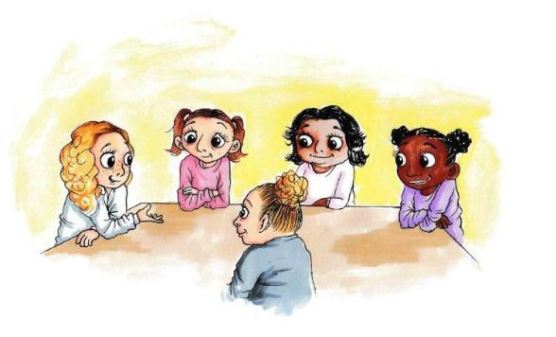Ruby sat down and said hello to the other girls. They all smiled at her.
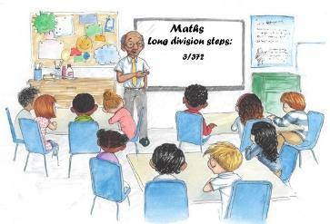
During class, Ruby tried to follow what was going on, but they were doing different things to what she had been doing at her old school, and she got quite confused. Mr Vadar offered to go over things with her afterwards, and Nia was helpful explaining some of the questions.
“Hey, do you want to come with us at break time?” Lilly asked.
Ruby felt immediately relieved that they seemed friendly.
Ruby spent the rest of the day with the 4 other girls. She was so pleased to have found some classmates she got on with so quickly, and suddenly being at a new school didn’t feel quite so scary anymore.
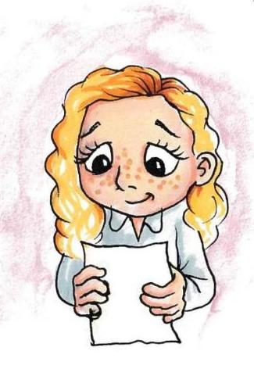
When Ruby got home, there was a letter waiting for her. She recognised Jessie’s writing on the envelope. Jessie was her best friend back in Ireland, and she was missing her so much. Still, at least she had some people to talk to at her new school.

The next day, our class went swimming. Everyone piled on the coach with their bags.
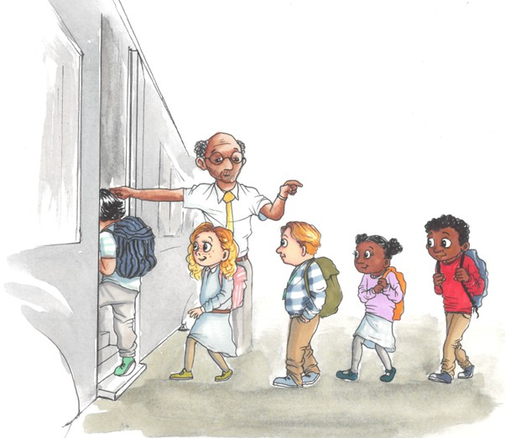
Ruby climbed on with the others and looked to find a seat. Grace and Zuri were sitting together, and Lilly and Nia were on the seat in front. The other seats were taken, so Mr Vadar quickly ushered Ruby on to the seat at the front of the coach next to him. She looked a bit embarrassed, but nobody else seemed bothered.
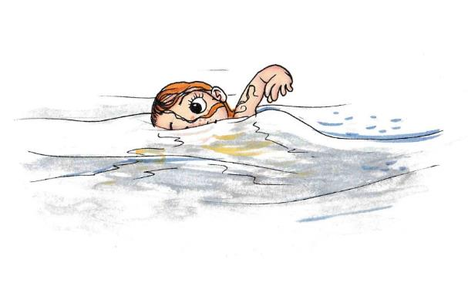
Swimming was good fun and Ruby surprised herself. Nia was really impressed. “Wow you’re really good at swimming!”
“Thanks!” Ruby replied, “I really like sport.”
“Oh that’s good,” Nia said, “Bankwell does a lot of sports activities, you’ll love it!”
Grace chipped in. “Do you remember that time at sports day last year when Tommy fell over in the hurdles? Oh, it was so funny.”
Nia laughed. “Yeah, and then Benson tripped over his foot, just as he was in the lead.”
Lilly joined in. “And you were going on about how unfair it was ‘cos he should’ve won…it was so obvious that you fancied him!”
“Shhhhh! I do not,” blushed Nia, smiling.
“You SO do!” Zuri giggled.
Ruby wasn’t sure who Tommy or Benson were, but she laughed along with the others anyway. She thought back to her old school and the ‘in jokes’ she had with Jessie.
On the coach back to school, Grace showed the others the bracelets she had been making that weekend.
“They look really good.” Ruby commented.
“Thanks!” Grace smiled.
Zuri looked up from the bracelet on Grace’s wrist. “Hey, Grace, are you still coming over after school?”
“Yes if that’s still okay?”
“Yeah great. And don’t forget about my sleepover on Saturday!”
“I won’t,” Grace added, “I can’t wait!”
“Me neither!” Nia and Lilly added in unison.
Ruby wasn’t sure what she’d be doing at the weekend. It had been quiet since she moved and didn’t know anyone locally. Last weekend it had been Owen’s birthday party back in Ireland and loads of her old classmates had gone bowling together. The photos Jessie had sent her looked so funny and she enjoyed seeing everyone having fun, but she also felt jealous at the same time, and sad to have missed it.
In class that afternoon, Mr Vadar set up an activity where everyone had to get into pairs.
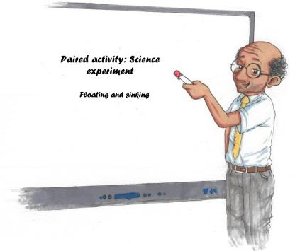
Ruby looked around. She saw that Nia and Grace had joined up, and Lilly and Zuri were already sitting together. Ruby wasn’t sure what to do, so Mr Vadar paired her up with another girl called Zoe.
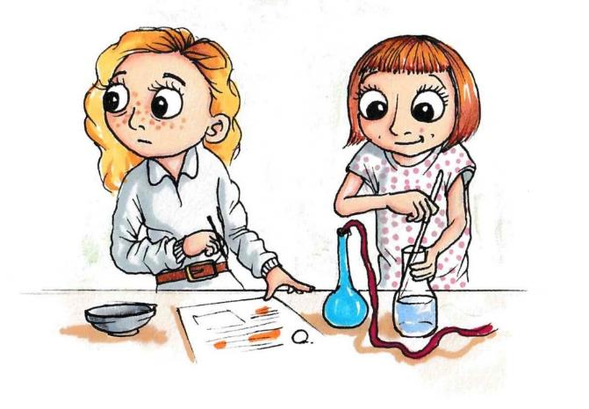
Her and Zoe worked together, but Ruby kept glancing over at Lilly, Zuri, Grace and Nia. She could see that they had a strong bond between them. She thought back to all the times she used to work with Jessie at her old school, and she felt very alone.

At the end of class, she saw the four girls run out to the playground together for lunch break. Zuri called over just as they were leaving.. “Are you coming Ruby?”
Ruby hesitated, then shook her head and looked away. She didn’t feel like going with them. She felt like she’d been an afterthought, and that they’d probably prefer to stick to their foursome. She was grateful that they were being nice to her but didn’t want to intrude in their group.

Outside, Zuri plopped down on the bench next to Lilly. Grace and Nia came over to join them.
Nia looked around. “Hey, where’s Ruby?”
Zuri shrugged. “I asked her if she wanted to come out with us, but she said no. It was a bit off to be honest.”
Nia looked surprised. “That doesn’t sound like her, what do you think is up?”
Lilly shook her head. “I’m not sure. She was okay this morning but seemed to go quiet after class.”
“Who was she working with?”
“I think Mr Vadar paired her up with Zoe.”
“Do you reckon they had a fight or something?”
“I’d be surprised. Zoe’s cool and she wouldn’t normally fall out with people.”
The four girls sat quietly together. They were feeling really confused about Ruby’s change in behaviour towards them. There was a rustle in the trees above. Ope appeared on one of the branches.
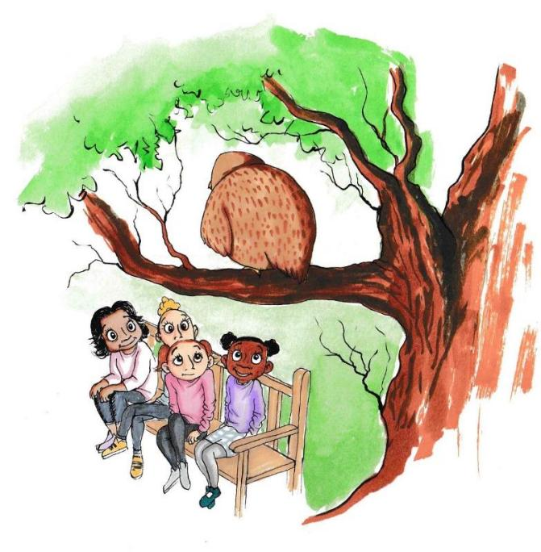
“You look concerned,” he squawked.

Nia looked up “Oh hi Ope,” she smiled. “Yeah, we’re just trying to work out what’s upset Ruby.”
“Who’s Ruby?” he asked.
“Oh, she’s a new girl who’s joined our class,” Zuri added “she’s been hanging out with us.”
Nia said “but she’s gone really quiet and seems a bit funny with us. Maybe she doesn’t want to hang out with us anymore.”
Ope shuffled on his branch. “What happened before she went quiet?”
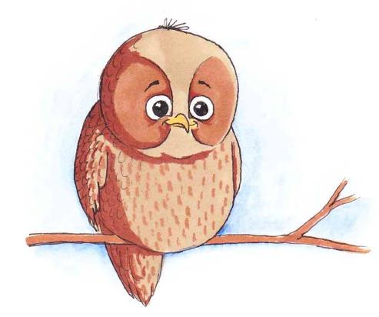
Nia retraced the events.
“Well, I was working with Grace, and Lilly was working with Zuri, then Mr Vadar paired Ruby up with Zoe…”
Lilly chipped in “Yeah, so she wasn’t on her own…” She hesitated and looked at Nia. “Do you think that might be it?”
“But why would she be upset about that?” Nia frowned, “we didn’t deliberately leave her out or anything.”
Lilly thought. “Well no,” she added, “but it doesn’t mean she wasn’t upset about it.”
“Oh yeah, and do you remember earlier on the bus there weren’t enough seats, so she had to sit with Mr Vadar?” Zuri added.
Grace nodded “She’s bound to be feeling a bit left out still being new here, and we’ve all known each other for ages.”
Lilly agreed. “We just automatically pair up….I feel bad now ‘cos I hadn’t thought about how she must be feeling.”
Nia said, “Yeah but the four of us are close friends, we’re a group, we do stuff together. We shouldn’t feel bad about that.”
The girls sat quietly for a moment. Ope broke the silence.
“Can friendships be shared?” he asked.
“What do you mean Ope?” Grace asked.
“Well, does the fact that you are friends mean that you can’t be friends with others?” he replied.
Grace sniggered. “No Ope! Of course not. We can have lots of friends.”
“Maybe we can make more of an effort to include her in things?” Lilly suggested.
“But we have been already.” Nia chipped in, looking surprised.
“Yes, but maybe she needs to know that we want to get to know her more,” Lilly added.
“Yeah, involving her doesn’t mean our friendships have to change – we can include her too.” Zuri added.
“Okay, fair enough,” Nia added. “I can see how she might have felt left out even if we didn’t mean it to come across like that.”
All four girls got up from the bench and headed back towards the school building.
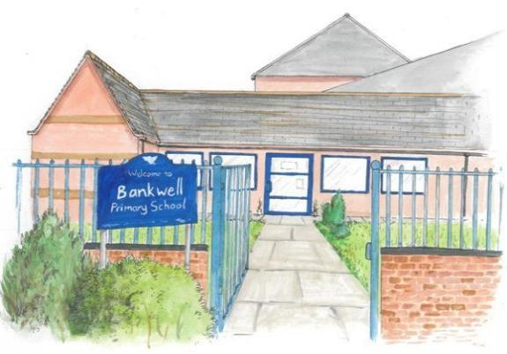

Ruby had been wandering around the playground feeling glum. She looked over at all the children playing in groups with their friends. Everyone she had met so far had been friendly, but she felt on the outside of things. She wasn’t used to feeling like this, and it made her feel terribly lonely. She wandered over to the benches and sat down by herself. A few minutes passed, and then she heard a rustle.
Ope swooped down from the tree and perched on the arm of the bench next to her.
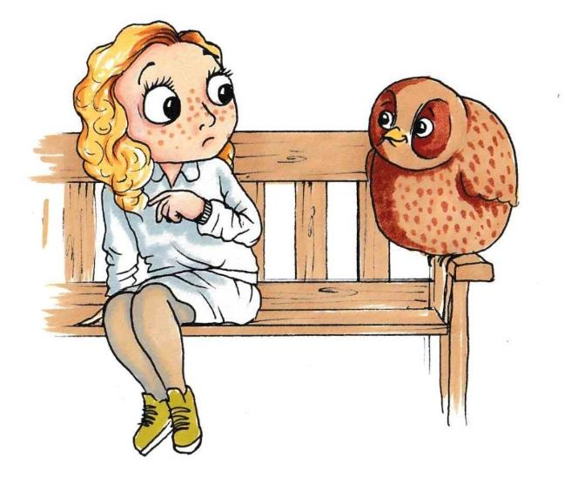
Ruby looked at him in surprise. She’d never been this close to an owl before and wasn’t sure what to do.
“Hello?” she said, cautiously.
“Are you okay?” he asked.
Ruby shrugged. “I guess.”
Ruby thought for a moment before admitting, “I’m new here. Everybody’s nice” she said, “but I feel lonely and left out.”
“Why’s that?” Ope enquired.
“Well, when I started here, I was worried I wouldn’t know anyone, and I’d be on my own.” She said, “I’ve got people to hang out with, but I don’t feel like I have any real friends.”
Ope pecked at his wing. “What is a real friend then?” he asked, inquisitively.
Ruby thought for a moment. “Friends make you feel special,” she said, “they are by your side, they have your back.”
“Do the classmates you’ve been spending time with not make you feel that way?” he asked.
Ruby shook her head. “They’ve already got their friends,” she said. “They partner up for things and do stuff together out of school…” her voice trailed off.
Ope looked surprised. “Is there a limit to how many friends you can have then?”
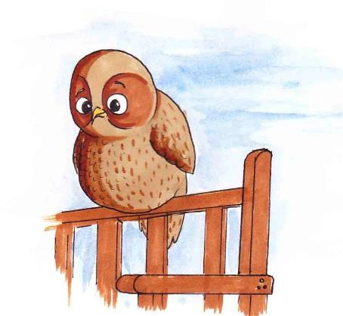
She smiled “No Ope.....but I’m not their first choice. Their other friends are closer, so they choose them first over me.” She swung her feet and looked down at the floor. “When I was in Ireland, me and Jessie would always do stuff together and we would always sit next to each other and work together in class. It’s not like that here. I miss her.”
“I’m sure she misses you too,” Ope replied. “How long were you friends?”
“Oh ages” Ruby said, perking up as she thought about Jessie. “We started in Year 1 together and have been best friends ever since.”
Ope thought about what Ruby had said.
“So, you knew each other for a while then before you became close?”
She nodded.
“I guess I can’t expect too much too soon” she said. “I’ve only been here a short time, and becoming true friends doesn’t happen overnight.”
Ope rustled his feathers. Ruby looked over to the playground and saw some of her classmates playing together. “I’d better go” she said, standing up and straightening her skirt. “Thanks, Ope” and off she went. Ope fluffed out his chest and watched as Ruby ran over to join them.
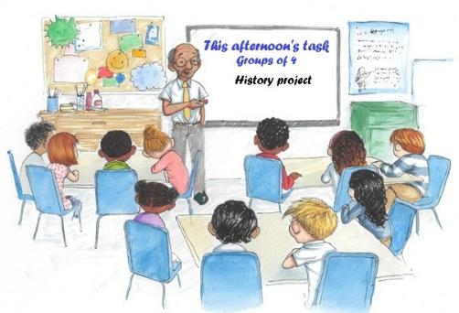
In class that afternoon, My Vadar explained that everyone needed to get into groups of 4.
Nia, Grace, Zuri and Lilly looked at each other and then glanced over at Ruby who was looking down at the floor. Lilly put up her hand. “Sir, can we work as a 5 please?” she asked. Ruby smiled.
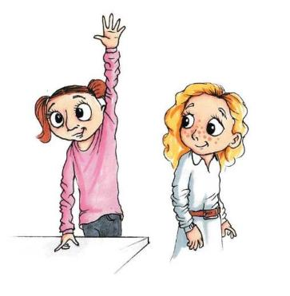

Resource 4a

Feeling lonely and making friends

There are lots of times when people are in situations where they might feel a bit lonely. What does it feel like to be lonely? What can members of the class at Bankwell School do if they are feeling lonely?
Bei

If someone is lonely they can…..

Being lonely feels……

Resource 4b

Activity sheet: What would Ope say?

Imagine someone at Bankwell School is feeling lonely at lunchtime. They go and sit on the bench, and Ope comes down to talk to them. What do you think Ope will say? What will he ask? What advice will he give?

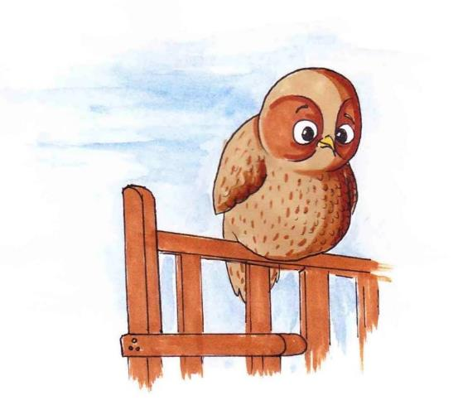

Lesson 5: Recognising healthy and unhealthy friendships, and handling tricky situations (Benson’s story)

Lesson 5 Overview: At a glance

- Activity | - Description | - Timing  - (70 mins)
- Discuss the class ground rules for PSHE sessions | Discuss the agreed class ground rules for PSHE classes co-constructed in lesson 1. | 5 mins
- Baseline activity | Pupils consider what they value in a friendship and what a healthy/unhealthy friendship looks like. | 5 mins
- Benson’s story | Read Benson’s story (or use pre-recorded video) which explores what makes healthy friendships. | 10 mins
- Being true to yourself | Pupils consider how friends should make each other feel and how they should NOT make each other feel. | 10 mins
- Pause, rewind and replay | Using this activity, pupils are able to pause the story and discuss what the characters might be thinking/feeling and what they could do differently. | 10 mins
- Mini plenary feedback | Consider strategies that the main character could use in difficult situations. | 5 mins
- Righting wrongs | Pupils consider how to apologise when they’ve done something wrong and what makes a good apology. | 5 mins
- What happens next? | Pupils consider strategies that avoid creating more problems, being honest and respectful of all. | 15 mins
- Assessment of Learning - Plenary | Pupils revisit their responses in the baseline activity and add to these based on their learning. | 5 mins

Lesson 5: Session Plan

Before using this plan, we recommend you read the introductory material including how to use this resource.

  - Context
This is the fifth session in a series which is designed to provide your pupils with the understanding and tools to deal with some of the complexities of friendships. These will support Key Stage 2 pupils and will help them to understand the nature of friendships, the benefits to positive friendships, how friendships can change and what makes a good friendship. Friendships become increasingly important during middle childhood as young people move into adolescence. These lessons will provide pupils with positive ways of managing some of the varied aspects of friendships and equip them with the skills to make informed and constructive choices within their relationships with peers.
Benson’s story forms the basis for the session. As per the guidance provided in How to use this resource, the story could be read before or outside of the lesson or could be split into parts or several chunks.
This lesson (without the story) is planned for a 60-minute session but can be broken down into two shorter sessions or adapted if needed. If you are reading the story as part of the class, we suggest allowing 70 mins.

  - Learning objective
> To learn about healthy friendships and how to manage conflict in friendships.

  - Learning outcomes
Pupils will be able to
> Describe the features of a healthy friendship.
> Identify the different types of friendships people can have.
> Analyse strategies to manage conflict in friendships.

  - For this session, you will need…
> Story 5: Benson’s Story
> Flipchart/marker pen
> Resource 5a: Pause, rewind and replay
> Resource 5b: What if? Scenario cards
  - Climate for learning
- As with all PSHE classes, this lesson should be taught in a non-judgemental environment with support provided.
- Pupils should be encouraged to reflect on the materials, but not discuss real-life incidents or other pupils within the class/school.
- Ground rules should be agreed at the start of the year (see Lesson 1 in this pack) and should be reiterated at the start of each class (these might be displayed around the classroom for example).

  - Key words
Recognising healthy and unhealthy relationships; how to deal with tricky situations and bullying.

In class activities
NB: Please review this lesson before delivery and consider the needs and circumstances of pupils in your class. For example, character names or scenarios may need adapting if similarities are likely to cause distress to your own pupils.

  - Discuss the class ground rules for PSHE sessions Estimated time 5 minutes
At the start of the session, discuss the agreed class ground rules for PSHE classes (framed as the Our Class agreement) which will have been co-constructed with the class in Lesson 1.

  - Baseline Activity Estimated time 5 minutes
This baseline will assess what pupils value in a friendship and their ideas about what makes a good friend. As pupils complete the activity, circulate the room to gauge their responses. This will allow you to adapt teaching where necessary, in order to address or correct any misconceptions.
Ask pupils to draw what a healthy friendship looks like and write, around the picture, words, phrases and/or sentences to describe what a healthy friendship is in further detail (kindness, sharing, caring, trustworthy, reliability etc.) They could then discuss features that are not present in unhealthy friendships (i.e. what makes a friendship unhealthy?).
It is worth discussing that nobody is perfect and everyone may also show some of these traits occasionally, but that the point is that they shouldn’t be the norm within a friendship.

  - Benson’s Story Estimated time 10 minutes
Read Story 5: Benson’s Story. There is a video on our website if you prefer. Benson’s Story describes the new friendship between Benson and Chen. Benson looks up to Chen because she is popular, but when they start spending time together, she does some things that make him uncomfortable – including picking on his friend George. Benson feels torn between keeping in with Chen’s group and loyalty to his long-standing friend. This story explores what makes healthy friendships and provides a context within which to discuss how children can manage difficult situations with peers. Then, ask pupils:
- Why does Benson want to be friends with Chen?
They might say:
- Benson thinks that Chen is cool.
- he thinks that she is popular and wants to be part of her group.
- How do you think Benson’s behaviour makes George feel?
They might say:
- George might feel upset that Benson didn’t stick up for him.
- George might wonder if Benson is a real friend to him.
- Why do you think Chen behaves this way?
They might say:
- Chen might think that this is the only way to make people like her.
- Chen might think that this makes her look more important than other people.

  - Being true to yourself – Estimated time 10 minutes
In the story, Benson wanted to become friends with Chen, and when he started hanging around with her, he really enjoyed being part of the group. However, there were several occasions when she did things that made him feel uncomfortable.
Discussion questions:
- What did Chen do that made Benson feel uncomfortable?
- What did ‘uncomfortable’ feel like for Benson? (thoughts, emotions, physical feelings)
- Why do you think he felt uncomfortable about these things?
Ope encourages Benson to think about whether Chen is his friend. Lead a class discussion about ‘how friends should make each other feel’. Use the whiteboard to generate 2 lists based on pupils’ contributions.
- Friends should make each other feel
- Friends should NOT make each other feel
Key points to emphasise:
Sometimes friends can do things that others don’t agree with or try to get their friends to do things they don’t want to do. It is important that people make their own decisions and do what they think is right. No one should feel like they have to go along with something just to keep a friendship. If someone is making others feel pressured or uncomfortable, they are not being a good friend.

  - Pause, Rewind and Replay: – 10 minutes (Pairs)
When Chen was being mean to George in the cloakroom, Benson stood and watched. Using the ‘Pause Rewind and Replay’ Activity sheet (Resource 5a), organise the pupils into pairs or 3s to revisit this scene in the story. Ask them to firstly ‘pause’ at the moment when Benson watched Chen trampling on George’s coat and think about what might have been going through his mind at the time. Why did he not say or do anything?
This is a useful opportunity to discuss with pupils how it can take courage to make a stand when someone is doing something they don’t like. Someone might be worried about another person turning against them or making the situation worse. It’s worth highlighting that it’s okay to feel like this, but that it can help to plan out some strategies that can be used if someone finds themselves in similar situations, so they know what to do and say. Imagine George’s situation – what might he want his friends to do to help?
Next ask them to re-play the scene, but this time with Benson reacting to Chen’s actions.
What do you think he could have done differently? How could he have shown Chen that he was not ok with the way she was talking to George?
Share the activity outcomes with the group and ask the pupils to explain their responses. Give the pupils criteria to feedback on each other’s ideas. For example, have they created a positive outcome for the characters? Have they given an example of a positive response? Is there anything else they could have included?

  - Mini plenary feedback Estimated time 5 mins
Discuss with the group the ideas they had for Benson to say or do differently.
Examples to consider:
Change the subject/distraction; Walk away; He could have stayed with George to see if he was okay rather than following Chen outside.
He could have said things like “ah don’t do that, shall we go outside?”; “that’s harsh, there’s nothing wrong with his coat”; “hey Chen, George is my friend, no need to be like that”; He could have said something to Chen “was that really necessary?”
The key message to draw out is that it is possible to speak up in a way that makes the point without being mean and avoids creating more problems for themselves. Highlight that if someone doesn't think it's safe for them to speak out, they should find a trusted adult and speak to them instead.
- Encourage the pupils to reflect independently (without sharing it with the class) on which of these strategies they could you use if they found themselves in a similar situation

  - Righting wrongs - Estimated time 5 minutes
It can be hard for people to admit when they have done something wrong, and say sorry, but doing this is an important part of being a good friend. It's about people taking responsibility when they have done something wrong in a relationship and trying to make it right.
Revisit that part of the story and encourage the pupils to identify things Benson did well in the extract.
What makes a good apology? – admitting what they did wrong (taking responsibility), saying sorry (expressing regret), explaining what they will do differently (change) and showing that they want be friends (desire to repair the relationship).
Also, being willing to forgive others is important too. In the story, George is honest with Benson about how he felt and how Benson hurt him but listens to his apology and shows signs that he is willing to move on from it.

  - What happens next? – Estimated time 15 minutes
Benson was brave to stand up to Chen and defend George at the end of the story, but what will happen next?
Split the class into groups and allocate one of the ‘what if?’ scenario cards (Resource 5b) to each group. The aim is for them to think about the situation from the perspective of each character and run through how they might react in the situation.
Plenary discussion:
Guide students where needed to help them recognise:
- Using strategies to avoid creating more problems, being honest and respectful, seeking to maintain harmony between everyone.
- There are two sides to every story. Chen’s actions in the story do not mean she is a bad person. Everyone makes mistakes, and she may not be making the best choices. There is the opportunity here to provide a good example for treating others well that she can learn from. Why might she be behaving in this way and how can we help her to think about her behaviour in a kinder way?
- If a friendship doesn’t work out, someone can distance themselves, but still be polite and friendly towards them.
- Even if people aren’t friends, it's good to try and maintain positive relations with peers
- Some friendships end, others change; someone can have different types of relationships with people they know. Difference between friends and acquaintances – circles/layers of closeness – lead into further learning activity.

  - Assessment of Learning - Plenary – Estimated time 5 minutes
In the final part of the class, draw the whole class together and ask them to revisit the baseline ‘draw and write’ activity from the start of the session. Pupils should add in any new ideas and learning they have acquired during the course of the lesson using a different coloured pen. This will allow you to see the progress pupils have made, as well as anything that needs following up on or revisiting in future lessons.

  - Support for learning
For the ‘what happens next’ activity, some pupils might need some guidance on what the protagonists might do or say in these situations. Some examples to get them started are included here, and they can be directed to consider which strategies they think would work better than others.

“I’m sorry” | “I still want to be friends” | “Your behaviour upset me”
“I didn’t like how you treated George” | “I feel guilty” | “We can still hang out”
“I feel hurt” | “I didn’t mean it” | “George is my friend”

  - Challenge
Ask pupils to look at each of the situations described in the activity focussed on what happens next. Get the pupils to look at the situations from the different aspects of those involved to try to get a fuller appreciation of the complexities of relationships and how to manage challenging situations in a constructive way.

Further learning/Extension
This story and lesson plan is the final one in the ‘Caring Friendships’ series. As a way of consolidating learning from across the sessions, there are some Optional Extension Activities provided at the end of the pack.

Further support
At the end of each lesson, support should be signposted to pupils for those who may need it. This may include pastoral members of the school staff or adults at home, such as parents or carers, and external organisations such as ChildLine (0800 11 11).


How did it go? Please tell us what you think of the materials:

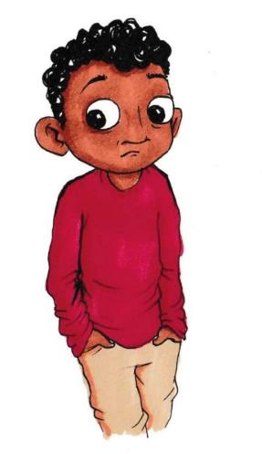
Story 5: Benson’s story

Benson and George have been friends for ages, but things got a bit tricky last term when he started hanging out with Chen.
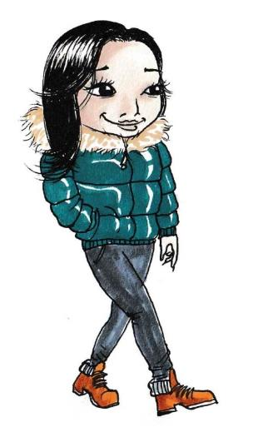
Chen is one of those kids in class that everyone wants to be like. Her hair is always perfect; her clothes are always the latest fashion and she’s funny too. She always knows the right answer to questions in class and doesn’t seem to have to try hard with her schoolwork. On top of that, she’s popular. Chen’s not the sort of person you’d ever see sitting alone or being left out of things.
Benson thought Chen was amazing. He watched her from afar and admired her. He longed to spend time with her and be her friend. Although she’d say hello to him sometimes, she didn’t really pay attention to him. Benson wished he had the guts to talk to her more, and get to know her, but he felt shy around her.
“I don’t know why you like her so much,” George said to him one day as they were walking home from school. Benson and George were best mates and spent most of their time together. They could talk to each other about everything, and they knew each other very well.
“She’s actually not that nice you know.”
Benson shrugged. “What makes you say that?”
“Just stuff I’ve heard,” George replied.
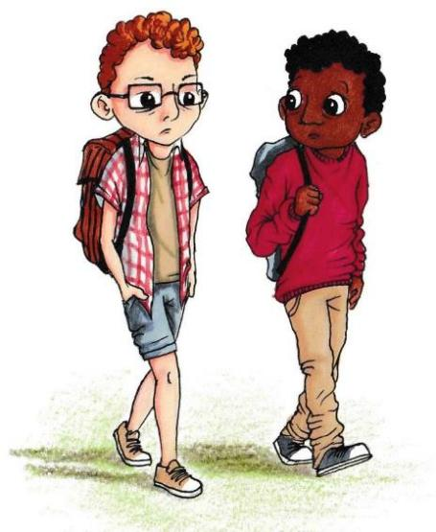
Benson shook his head. “I don’t reckon that’s true. She’s got loads of friends.”
“That’s not the same thing,” George said. They walked quietly for a bit. Benson was a bit annoyed with him for speaking out of turn about Chen when he knew how much he liked her.

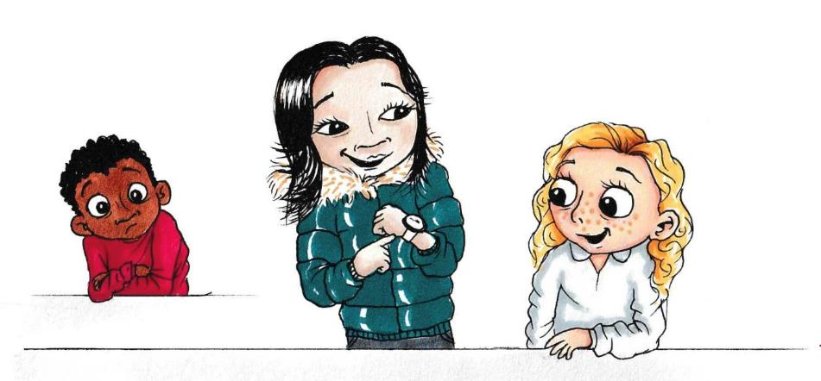
The next morning, Chen arrived in class and she was showing off a new watch that she’d got that weekend. Several kids from class were standing around admiring it. Benson watched from another table, feeling jealous. He’d been wanting that watch for ages. He’d seen it online and begged his mum to buy it, but she said she couldn’t afford it and he’d have to wait. Now that Chen had the watch he wanted, he liked her even more.
At lunchtime, Benson was on his way to the playground when he spotted Chen in the cloakroom. She was sitting on the bench desperately fiddling with her watch. Her face was red, and she seemed really stressed. Benson wanted to go over but felt nervous.
“Er hi,” he muttered, “is everything okay?”
Chen looked up. “It’s my watch,” she said, looking worried, “the screen’s frozen and none of the buttons are working. My dad’s going to kill me!”
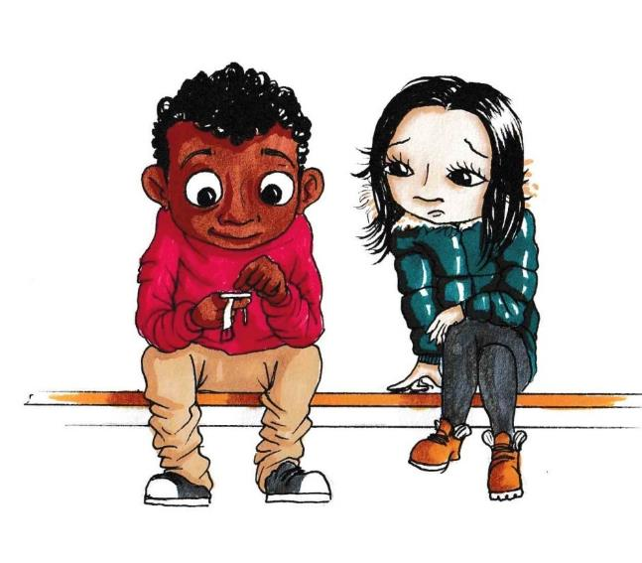
Benson looked over her shoulder at the watch. “Here, let me have a look, I might know how to fix it.”
She looked surprised. “Do you know how they work then?” she asked, handing him the watch.
“A bit,” he said, trying to sound confident.
Benson looked at the watch and turned it over. “Ah, yeah, here you go,” he said, “you need this reset button here.” He showed her what to do, and sure enough the screen went blank and then sprung back into action. Chen was visibly relieved. “Thank you so much!” she said.
Benson blushed. “No worries, happy to help.”
After that, Chen acknowledged Benson more frequently at school. Benson was full of pride and excitement, wondering if they might start to become friends after all.
Later that week, Benson was in the playground with George, and he noticed Chen and Nicole from his class talking to a younger boy. The younger boy was red in the face and looked unhappy, but the girls were laughing. Chen looked over and saw Benson.
“Hey Benson!” she called, “come over here.”
Benson’s heart skipped in delight that she had noticed him, and he immediately went over to see what she wanted.
“You’ve got to look at this,” she said, grabbing the younger boy’s wrist and pushing it in Benson’s face.
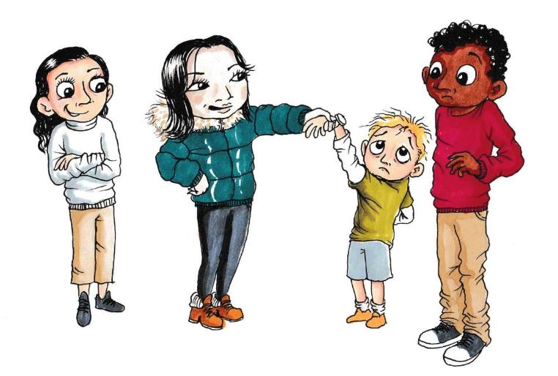
“Look at the state of this!” she said, gesturing towards the boy’s watch. “Isn’t it the ugliest thing you’ve ever seen?”
Benson saw that the watch was a plastic copy of the one Chen had. The younger boy had tears in his eyes. “My mum bought it for me!” he whimpered.
“But it’s not even real!” Chen squealed, “it just looks rubbish.”
Nicole nodded and laughed along. “Total embarrassment,” she added.
Chen looked directly at him, gesturing with her eyes for him to respond, “don’t you reckon Benson?”
Benson hesitated, not sure what to say. “Er yeah, it’s nowhere near as good as the proper one,” he said.
The younger boy’s head lowered in shame, and he walked off. Benson felt guilty. Chen smiled. “I couldn’t believe it when I saw it. I knew you’d agree!” she said, “want to hang out with us?”
Benson couldn’t believe his luck. “Yeah, sure” he said, happily.

Benson started hanging out with Chen and her friends more often. He was loving it. He’d never been mixing with the popular lot before, and it made him feel more confident. He still saw George, but they didn’t talk as much as they used to. Benson had been hoping George might join in with things more, but George had made it clear that he didn’t think much of Chen, and that he didn’t want to be part of her group.

One lunch time, Benson was with Chen and her friends in the cloakroom.
George came over to get his coat. Chen was standing in the way.
“Excuse me,” George said politely, “could you move please so I can get my coat?”
Chen turned to look at his coat peg. She lifted his coat up and showed it to him. “What? You want to wear this? Really?” she said, sarcastically.
George looked annoyed. “Yes, give it here please” he said defiantly. Chen turned and held it up to show the others. “Look at the state of this!” she announced, “one of the jumble sale’s finest collection!”
Nicole sniggered.
“Oh look, and his mummy has even stitched his name inside it!” she jeered.
George blushed and glanced nervously at Benson – hoping his friend would help. Benson bit his lip.
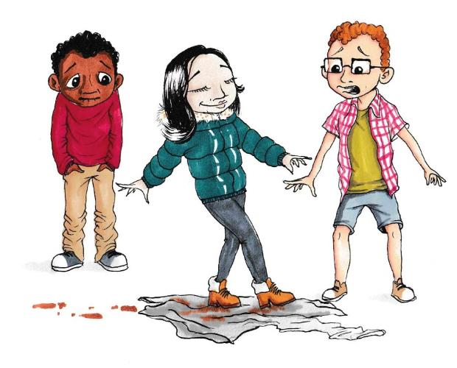
Chen tossed the coat to Nicole, and Nicole caught it and threw it up in the air. When it landed on the floor, Chen walked across it deliberately with her dirty shoes. George looked horrified. She then kicked it towards George, and he hurriedly grabbed it and ran off. Chen, Nicole, and her other friends laughed and headed outside. Benson watched in shock but said nothing. He reluctantly followed them out to the playground – passing George who was sitting glumly on his own.
Benson felt very uncomfortable. His tummy was knotted, and he felt hot, but he tried to shrug it off as he headed over to join Chen and the others.

Later, he decided to go and have a sit down on the benches in the playground. He sat there looking down at the floor, thinking about what had happened and how George must be feeling. He also thought about the younger boy with the watch, alongside all the fun he’d been having with his new friends. A few minutes passed, and there was a flutter in the trees above. He looked up and saw Ope swooping down and perching on the bench next to him.
“Hi Ope,” Benson said, “good to see you”
Ope cleared his throat. “You looked a bit sad, so I thought I’d see if you needed anything.”
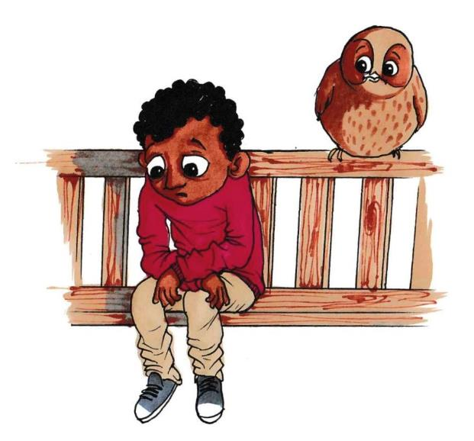
Benson said nothing and carried on staring at the floor. A few moments passed with them both sitting in silence. Then Benson sighed.
“I think I’ve really messed up, Ope.”
Ope turned to him. “What makes you say that?”
Benson tried to explain.
“Well, I’ve been wanting to be friends with Chen for ages. George warned me about her, but I didn’t listen.”
“What’s happened?” Ope asked.
“She’s mean to people.” Benson replied, shutting his eyes as he said it out loud.
Ope thought for a moment before he asked, “and how do you feel about that?”
Benson fell quiet again as he considered Ope’s question. Eventually he admitted,
“I feel bad. I don’t want to be mean to people. I joined in but I didn’t like it, and now I feel awful about it”
Ope asked, “so, why did you join in then?”
Benson thought hard before he responded. He’d been asking himself the same question and saying it to Ope made him feel even worse.
“It felt like the right thing to do. Everyone was joining in, and having a laugh together, and I wanted to be part of the group”.
Ope nodded slowly to show he understood.
“Do you think her liking you depends on how you treat others?” Ope asked.
“If I don’t join in, I don’t think she would like me any more…and I have been really enjoying hanging out with her and her friends.” Benson admitted. “I feel popular for once and its great”. Benson blushed, feeling embarrassed.
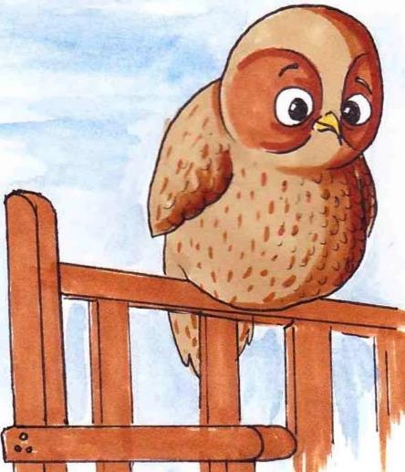
Ope turned to Benson and asked “Hmmm…is Chen your friend?”
Benson thought about this. “I guess so….”
“You don’t sound so sure?”
“Well, I like spending time with her and stuff but I’m not sure it feels quite right”.
Ope tilted his head. “How are friends supposed to make you feel?”
The first thing that came to Benson’s mind was his friendship with George and all the things he liked about him. He thought about how he felt when he was with George.
“They should make you feel good about yourself, bring out the best in you, stick by you, treat you well,” he explained.
“And does Chen do those things?” Ope asked.
“Er….” He hesitated, “not really. If I’m honest, I feel like I’m trying to be someone I’m not.”
Ope nodded slowly. He turned to Benson, “and what about George?” he enquired.
Benson put his hand in his pockets nervously. “He’s my friend, we’ve been friends for years, I can always rely on him…” his voice trailed off.
“I didn’t do anything Ope.” He shook his head. “I just watched when Chen was picking on him.” Benson paused for a moment thinking about what he’d just said, “I’m such a rubbish friend.”
He closed his eyes and sighed heavily.
“What do you think you should have done?” Ope asked.
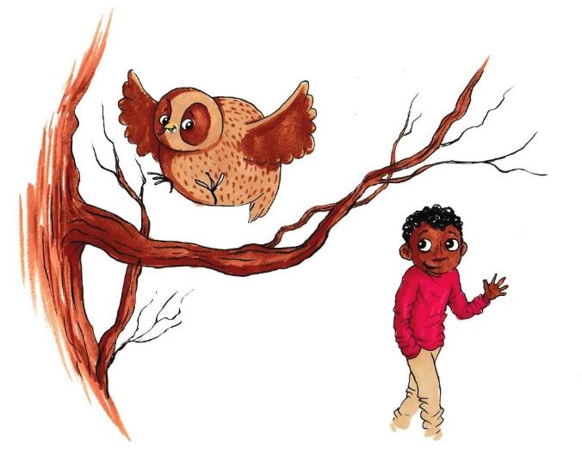
“I should have said something, I should have stuck up for him. He would never have let anyone treat me like that.”
They both sat together for a few minutes, looking out over the playground.
“This is not who I am.” Benson said, “I need to make this right”. He stood up and headed back towards the school building. “Thanks, Ope!” he called, as Ope flew back into the tree.

Benson went to find George in the classroom. George was reading a book on his own, so Benson went over to sit next to him. George looked up at him and then turned away.
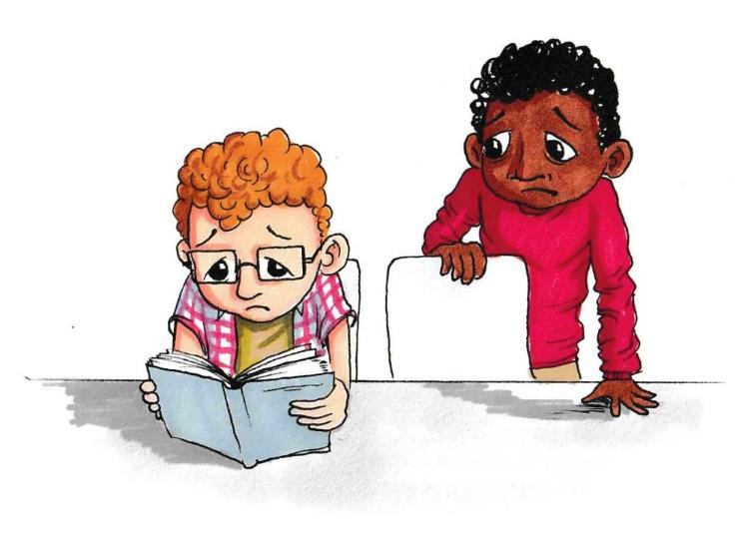
“Look George, I’m really sorry about earlier,” Benson said. George didn’t say anything.
“I didn’t know Chen was like that, and I’m not going to hang out with her anymore”. He waited for George to reply. There was a long pause, and George eventually said
“I was really hurt Benson. I needed you and you let her treat me like that.”
Benson hung his head. “I know, I should have done something. I feel awful. It won’t happen again. Can we be mates again like we used to be? I want to make it up to you.”
Just then, Chen came over. “Benson, what are you doing talking to him?” she nodded towards George and laughed. “Got any more jumble sale bargains lately, eh?”
Benson stood up and took a deep breath. He knew what he had to do, but his heart was thumping through his chest as he tried to summon the courage. “Actually Chen, George’s coat is the new trend. Everyone at secondary school has this style.”
“You what?” She scoffed. Benson stood firm, even though his legs were like jelly.
“Yeah, I really want the same one,” he added “and by the way, I think you should apologise to George for earlier.”
George grinned at him.
Chen’s eyes widened in horror. “Whatever” she said and turned away.

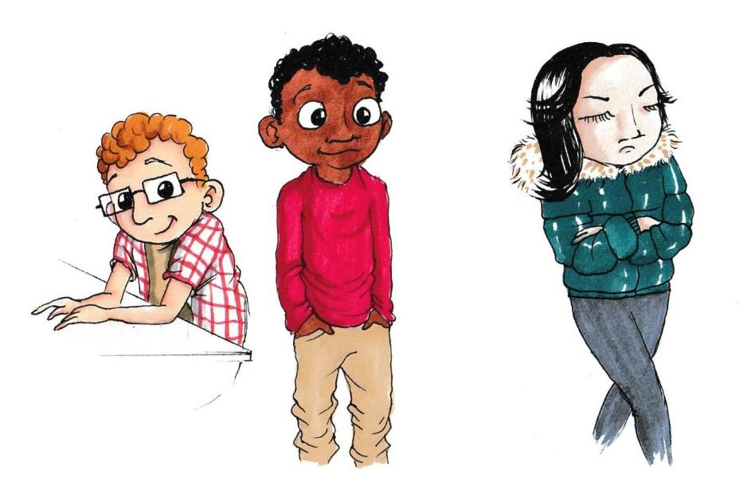

Resource 5a

Pause, rewind and replay

When Chen was being mean to George in the cloakroom, Benson stood and watched.

- Pause:
Why do you think Benson acted the way he did? What was going through his mind at the time?
In the picture below, add in things that Benson might have been thinking.

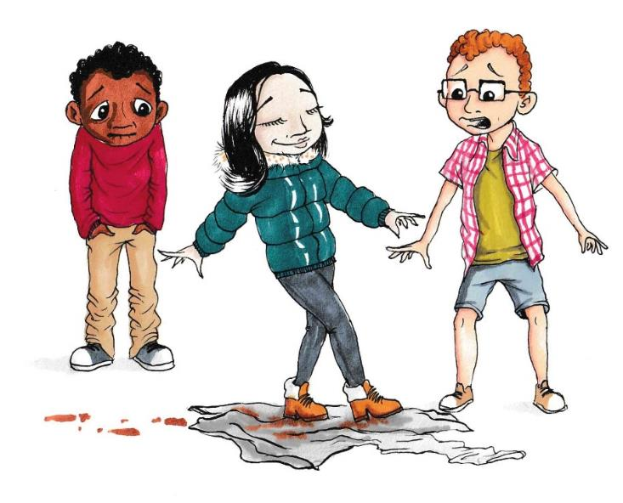
- Rewind and replay:
Afterwards, Benson felt guilty about how he responded to the situation.
What do you think he could have done differently? How could he have shown Chen that he was not okay with the way she was talking to George?
In the picture below:
- Write one thing that he could have said
- Suggest one thing that he could have done

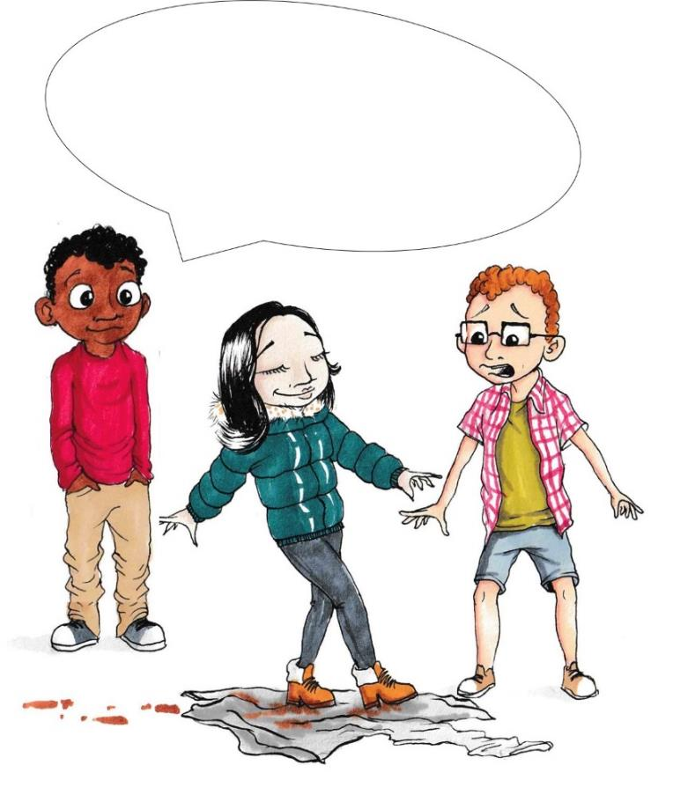

Resource 5b

What if? Scenario Cards
---------------------------------------------------------------------------------------------
Chen meets Ope
Let’s imagine that Chen storms out of the classroom following her meeting with Benson and George, and goes into the playground. Whilst sitting on the bench looking upset, Ope appears. How do you think their conversation might play out?
- What questions might Ope ask Chen?
- How might she answer his questions?
- What might Chen be thinking or feeling?

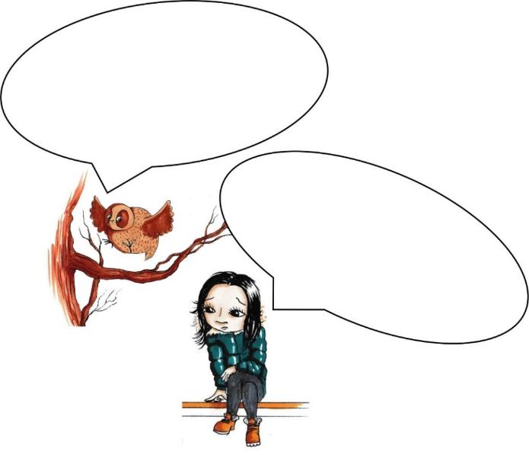

--------------------------------------------------------------------------------------------
Facing the fallout
Let’s imagine that the next time Benson sees Chen, she glares at him and stomps over.
“Thanks very much for embarrassing me in front of George,” she says sarcastically “what were you playing at back there? That was not cool.”
- How might you explain Chen’s response?
- What could Benson say to her?
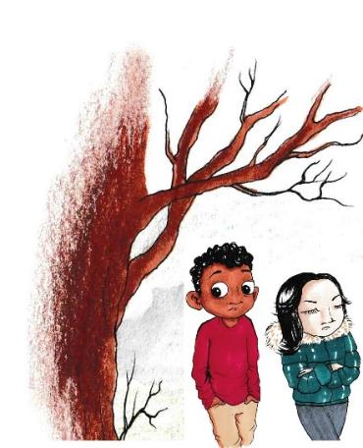

-----------------------------------------------------------------------------------------
Carrying on as usual?
Let’s imagine that next time Benson sees Chen, she bounces over to him. “You were being well weird earlier,” she grins. “Anyway, do you want to hang out later?”.

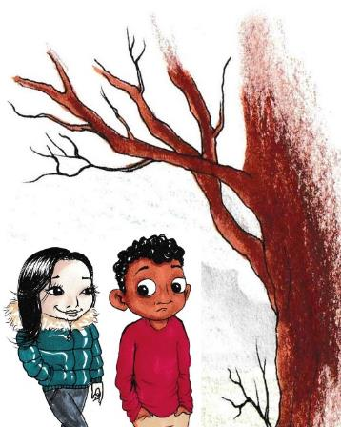

- How might you explain Chen’s response?
- What could he say to her?

---------------------------------------------------------------------------------------------------------------------------

Optional Extension Activities

If all or several of the stories have been covered by the class, it is good to review learning and share this with others at the end of the programme. This can be done in a variety of different ways, enabling pupils to review what they have learnt and also to share this learning with other pupils within the school and with important people at home. We suggest a number of different approaches below that you may want to consider.

Working wall
Have a wall display where pupils’ work on the topic of Caring Friendships can be shared. Some of the activities that pupils have undertaken as part of the programme (excluding private reflection activities) can be displayed. These can then be revisited at various points in the school year.

What would Ope say?
Ask pupils to create their own Opes to be displayed around the classroom as a reminder of the way they should question things and think about how they and others are feeling – asking ‘What would Ope say?’. This could be using drawings, collages, paper mâché sculptures or computer-generated images.

Explaining friendship to an alien
Ask pupils to think about how Ope would explain what does and doesn’t make a good friendship to an alien who had just landed in the playground of Bankwell Primary School. Pupils could do this through a short play, a song, a rap, a poem, a cartoon or story.

Our Class Assembly
Ask pupils to choose their favourite Our Class story and create a play based on this. They can present this to other pupils at school as well as important people from home. As part of the story, it might be good to include a ‘hit the pause button’ at key points in the story where other pupils come in and explain what has happened here or why this might be a problem or what the protagonists could do differently.

Video-recording/Photo montage
Ask pupils to create a video or photo montage of what good friendship means to them. They will need guidance on how to do this, in terms of asking the permission of anyone they want to record or photograph, and that this would only be shared within the school. This could then be shared in an assembly or on a wall in the classroom or more public area of the school.

My social circle
Using the ‘My Social circle’ activity (Resource 6c), pupils can think about the kinds of relationships they have with people they know. The purpose of this is for pupils to distinguish between types of relationships (best friends, friends, acquaintances etc) and recognise the different features that characterise these relationships. This should be a private activity only as it is very personal.

Further support
Remember that support should be signposted to pupils for those who may need it. This may include pastoral members of the school staff or adults at home, such as parents or carers, and external organisations such as ChildLine (0800 11 11).



How did it go? Please tell us what you think of the materials:

Resource 6c

My social circle

For this activity, think about all the people you like to spend time with. Make a list of friends and peers around your age who you know and who you interact with.

Write your name in the middle circle. You can draw yourself if you want!

From the list, organise them into the circles (1, 2 and 3) based on the type of relationship you have with them.

Inner circle (1) – people you are closest to, who you feel the most comfortable with and who make you happy. You know each other very well
Second circle (2) – people who you like spending time with, who you regard as friends, but are not as close.
Third circle (3) – people you know and are friendly and polite to, and who you see sometimes.

From the list below, think about which circle they should go in to reflect the type of relationship you expect to have with people in each group. Each characteristic could go in one, two or all of the circles.

- Trust
- Generosity
- Loyalty
- Kindness
- Friendly
- Helping with problems
- Talking about personal things
- Having things in common
- Know lots about them
- Feel comfortable with them
- Enjoy spending time together
- Sharing things
- Doing things together
Try to add some more characteristics of your own to put in the relevant circles.



