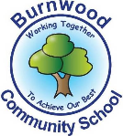
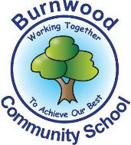
Year 1 Home Learning Week Beginning Monday 13th April
Theme: Where in the World

Literacy
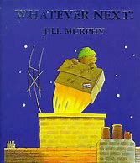
Reading:
This week our story focus is… What Ever Next!
To listen to the story follow this link:

https://www.youtube.com/watch?v=Nn73STXrPP0

Other stories to read: (search on YouTube if you don’t have a copy)
Aliens Love Underpants, How To Catch A Star, Rocky’s Space Adventure- YouTube.

Writing:
- Write sentences using adjectives about - the moon, the clock, space boots, helmet, rocket etc.
-Extension can you use ‘and’ or ‘because’ in a sentence?
-You could write a list of food that he took on his journey.
- In your garden retell the story- Use a box, a colander, wellies and a bear.

Maths
Songs and videos for a starter/maths warm up:
Count to 100: https://www.youtube.com/watch?v=bGetqbqDVaA
Counting in 2s: https://www.youtube.com/watch?v=GvTcpfSnOMQ
Counting in 5s: https://www.youtube.com/watch?v=EemjeA2Djjw
Counting in 10s: https://www.youtube.com/watch?v=Ftati8iGQcs
Number bonds: https://www.youtube.com/watch?v=lD9tjBUiXs0

This week our maths focus is: counting in steps of 2, 5 or 10

Can your child…
- Count in 2’s, 5’s and 10’s- can you order the numbers 2, 4, 6 etc.?
- Can you find missing numbers from the sequence? Can you say them forwards and backwards?

You could watch the video for lesson 2 and do the activity-
https://whiterosemaths.com/homelearning/year-1/

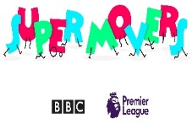
- Watch the counting video with Jack Hartman or SUPERMOVERS
https://www.youtube.com/watch?v=q_yUC1NCFkE
https://www.bbc.co.uk/teach/supermovers

- Can you splat the all the numbers that would be in a pattern of 2, 5 or 10?
https://www.topmarks.co.uk/learning-to-count/paint-the-squares

- Can you count out 5p’s, 2p’s and 10p’s? How much would four 5p’s, five 2ps, or six 10p’s be? Can you count pairs of socks?

Extra Ideas
Order the days of the week and spell them. What day is it today? What day is it tomorrow? How many days in a week?
Say the months in order. How many months in a year? What year are we in?

If you complete these tasks, there are plenty of other links and games on the Year 1 class page.
Science
Seasons
- Can you name the seasons? Spring, Summer, Autumn, Winter
Which season is your birthday in? Which is your favourite season? Why?
Can you draw pictures of things you might see in each season? Can you draw a tree in each season? What happens to the trees? What would you wear?
Topic
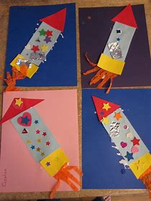
- You could look at google maps, can you find Stoke? Chell Heath or your house?
- Press – (zoom out) until you can see the whole world, click the compass to see an aerial view, look at the North and South Pole, Can you see the snow? Do the same for the jungle and the desert.
- Can you name all the countries in the UK and their capital cities?

- Use available resources to draw or make your own rocket. You could use different shapes or Lego.

PE: Please also try to enjoy some daily exercise (remember Joe Wicks is doing PE videos every morning!).

Don’t worry if you can’t complete all these activities, the most important thing is for you to stay safe and have fun learning at home.

We hope to see you very soon,
Mrs Lowell, Mrs Ellis, Mrs Reynolds and Mrs Fox

