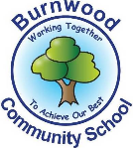
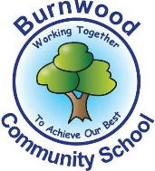
Year 1 Home Learning Week Beginning Monday 22nd June
Theme: Under the Sea

Literacy
Phonics:
This week we are focusing on the igh family. Play games on phonicsplay
Mrs Ellis’ group: igh, ie, i-e, i, y
Mrs Reynolds’ group: igh, ie, i-e
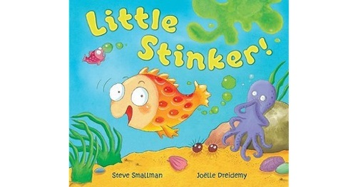
Mrs Lowell’s group: igh

Reading:
This week our story focus is… Little Stinker
To listen to the story, follow this link:
https://www.youtube.com/watch?v=oeFSqF6CA-0

- What was Percy’s special talent? How did the other fish try to teach him a lesson? How did Percy end up saving the day?

Other stories to read: (search on YouTube if you don’t have a copy)
What the Ladybird Heard at the Seaside

Writing:
Make a Little Stinker book – Choose 5 or 6 pictures from the story and draw the pictures for yourself then write one or 2 simple sentences to match each picture. Can you remember capital letters and full stops? Now read your story to someone in your family.

Maths
Songs and videos for a starter/maths warm up:
Count to 100: https://www.youtube.com/watch?v=bGetqbqDVaA
Number bonds: https://www.youtube.com/watch?v=lD9tjBUiXs0
2D Shape song: https://www.youtube.com/watch?v=WTeqUejf3D0
3D Shape song: https://www.youtube.com/watch?v=2cg-Uc556-Q

This week our maths focus is: Time

- Talk about the story Little Stinker. Using the language before, after, next, then, talk about the order that things happen. E.g. does Little Stinker cheat in the race before or after he gets Penny Pufferfish into trouble?
- Write or draw pictures to make a timetable for your day. Using o’clock and half past times, can you write the time that you do each activity? Keep an eye on the clock or a watch throughout the day to see if you stick to the times!
- Using a stop watch time yourself or your family completing activities such as jumping, hopping, or skipping. How many of each can you do in 30 seconds? 1 minute? 2 minutes?

If you complete these tasks, there are plenty of other links and games in the Year 1 class page.
Science
Can you draw and label the parts of a fish?
Labels to include:
- dorsal fin - pectoral fin
- gills - mouth
- eye - tail
- scales
(If you have access to a printer there are labelling worksheets in Twinkl)

Topic
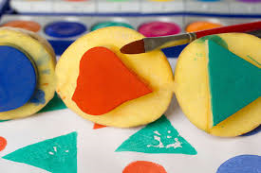
Fishy crafts and painting
Paint some fish to be in Percy’s class – use different colours, different shapes and different patterns. You could use a printing technique e.g. dip a celery stick in paint to make scale shapes on your fish or a potato with a shape cut into it then print in different colours.

PE: Please also try to enjoy some daily exercise (Joe Wickes PE, Cosmic Kids Yoga, Go Noodle dances).

Don’t worry if you can’t complete all these activities, the most important thing is for you to stay safe and have fun learning at home.

We hope to see you very soon,

Mrs Lowell, Mrs Ellis, Mrs Reynolds and Mrs Fox

