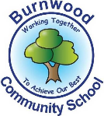
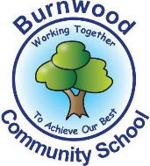
Year 1 Home Learning Week Beginning Monday 13th July
Theme: Under the Sea

Literacy
Phonics:
This week we are focusing on Tricky Words. Play games on phonicsplay or search for videos on YouTube.
Mrs Ellis’ group: Phase 5 tricky words
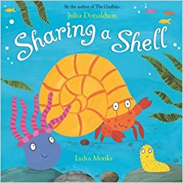
Mrs Reynolds’ group: Phase 4 tricky words
Mrs Lowell’s group: Phase 3 tricky words

Reading:
This week our story focus is… Sharing a Shell
To listen to the story, follow this link:
https://www.youtube.com/watch?v=6KuSl9eXgpk

- How many creatures share the shell? How did they help each other? What did they do when they got too big for the shell? How did they get a new shell?

Other stories to read: (search on YouTube if you don’t have a copy)
Tiddler the Storytelling Fish

Writing:
Sharing a Shell Reading Comprehension
- Why did the crab need to find a shell quickly?
- How did the anemone scare the big fish away?
- What does the bristle worm love to do?
- Why did crab not want to hang out with the anemone anymore?
- What words are used to describe the storm?
- Bristle worm uses the word ‘whelkome’, this is a pun. These are often used in jokes. Can you think of another example of a pun?
Does it teach us anything? Think about people who help you. What do they do? What can you do to help them?
Design and make a poster about how you can be kind to your friends
Maths
Songs and videos for a starter/maths warm up:
Count to 100: https://www.youtube.com/watch?v=bGetqbqDVaA
Counting in 2s: https://www.youtube.com/watch?v=GvTcpfSnOMQ
Counting in 5s: https://www.youtube.com/watch?v=EemjeA2Djjw
Counting in 10s: https://www.youtube.com/watch?v=Ftati8iGQcs

This week our maths focus is: Fractions and Sharing

- Collect 20 coins/pasta shapes/counters. Use hoops or mats to represent your friends. Can you share them between 5 friends? 20 shared between 5 equals ____
Can you share them between 2 friends? 20 shared between 2 equals ____
Can you share them between 10 friends? 20 shared between 10 equals ____
- Can we share them equally between 3 friends?
- Listen to the story about making half. Practise using the vocabulary whole and half.
https://www.youtube.com/watch?v=hVaxiJB6Fls

If you complete these tasks, there are plenty of other links and games on the Year 1 class page.
Science
Throughout the year we have looking at the different seasons by watching how the trees in our school grounds have changed. The last season for us to look at is summer.

- Watch the season song. What is the weather like in each season? What should we wear?
https://www.youtube.com/watch?v=_BkkzF9z4-g

- Go for a walk in your local area to look for trees, or just have a look in your back garden. What do they look like in the summer? Take some photos of the trees and talk about the different parts of the tree. How is it different to the winter tree that we saw?

- Draw and label your summer tree. Can you label the trunk? Branches? Leaves?

Topic
Look on a map and find the location of your nearest beach. How would you get there? How long would the journey take?

Design (and build) a new home for the three creatures to share

PE: Please also try to enjoy some daily exercise (Joe Wickes PE, Cosmic Kids Yoga, Go Noodle dances).

Don’t worry if you can’t complete all these activities, the most important thing is for you to stay safe and have fun learning at home.

We hope to see you very soon,

Mrs Lowell, Mrs Ellis, Mrs Reynolds and Mrs Fox

