Monday | Tuesday | Wednesday | Thursday | Friday
Phonics Focus- NG | Phonics Focus- AI | Phonics Focus- EE | Phonics Focus- IGH | Tricky Words
Phonics play https://www.phonicsplay.co.uk  Recap sounds- Flash Card Speed Trial-Phase 2/3 | Phonics play https://www.phonicsplay.co.uk  Recap sounds- Flash Card Speed Trial-Phase 2/3 | Phonics play https://www.phonicsplay.co.uk  Recap sounds- Flash Card Speed Trial-Phase 2/3 | Phonics play https://www.phonicsplay.co.uk  Recap sounds- Flash Card Speed Trial-Phase 2/3 | Play the tricky word songs  https://www.youtube.com/watch?v=TvMyssfAUx0  https://www.youtube.com/watch?v=ri4u0TjAZ38
Search ‘Geraldine the Giraffe learns the /NG/ sound’ on YouTube  Diagraph – 2 letters 1 sound- You find this diagraph at the end of a word | Search ‘Geraldine the Giraffe learns the /AI/ sound’ on YouTube  Diagraph – 2 letters 1 sound- You find this diagraph at the end of a word | Search ‘Geraldine the Giraffe learns the /EE/ sound’ on YouTube  Diagraph – 2 letters 1 sound | Search ‘Geraldine the Giraffe learns the /IGH/ sound’ on YouTube  TRIGRAPH – 3 letters 1 sound | Tricky Words Phase 2/3 –  Play game on Phonics Play  Tricky Word Trucks
Have a go at writing some words that have the NG sound e.g.  Ring, wing, sing, long, song, king  Now choose a word and write a sentence e.g.  I can sing. | Have a go at writing some words that have the AI sound e.g.  Spain, pain, train, rain, main, laid, paid, raid, hail, snail, sail  Now choose a word and write a sentence e.g.  The snail can sail. | Write the words-  Seed, feed, reed, feet, sweet, sheep, teeth, met, sleep, keep  Get an adult to stick them up around the room and run to the words  Now choose a word and write a sentence e.g.  I can feed the sheep. | Write the words  Night, fight, right, tight, light, fright, bright  on some paper.  Cut them up and get the children to put them back together.  Now choose a word and write a sentence e.g.  I put the light on at night. | Matching pairs Write some of tricky words on paper (duplicate).  Put them face down on the table and play the matching pair game.
Play the NG game on Education City- Free Trial | Play the AI game on Education City- Free Trial | Play the EE game on Education City- Free Trial | Play the IGH game on Education City- Free Trial | Play the tricky word game on Education City- Free Trial

Access to Education City.
Type Education City into Google.
Click on find content by subject
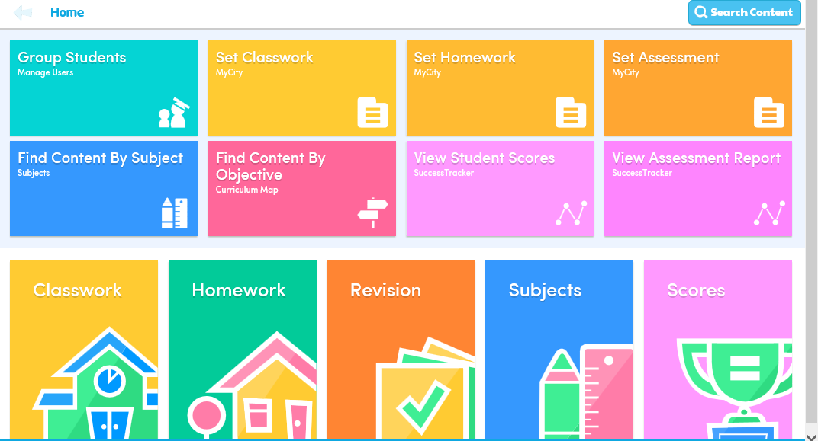
Click on English
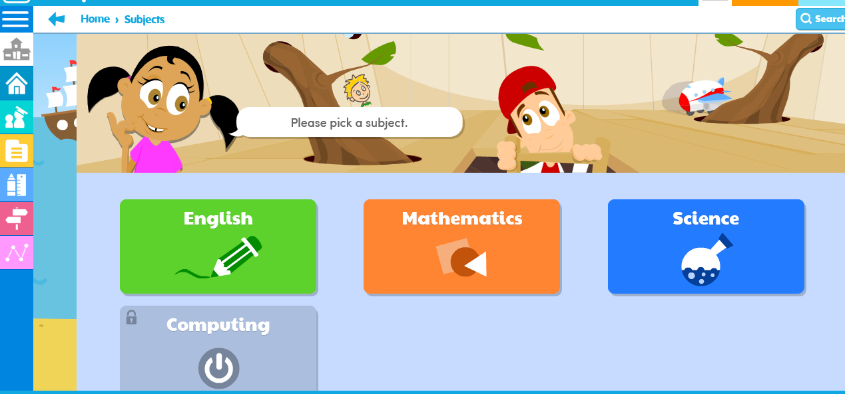
Click on EYFS
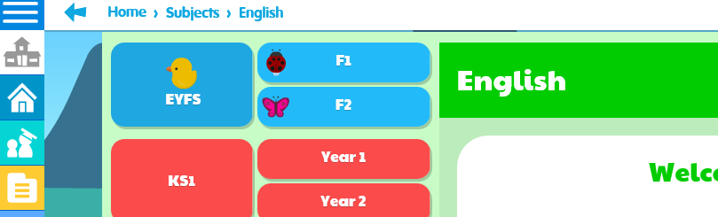

Click on Letters and Sounds

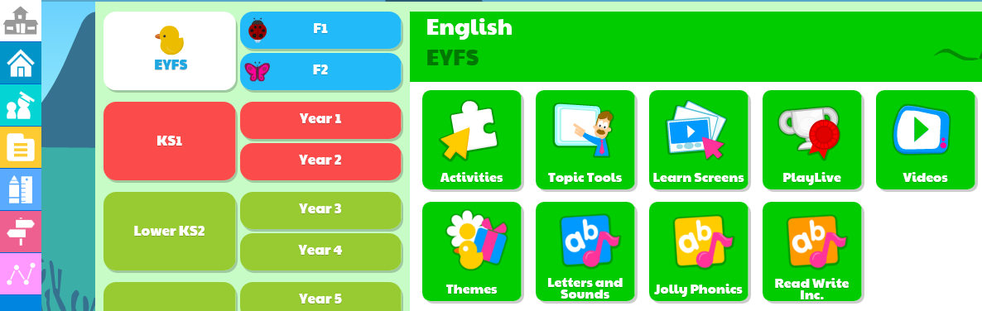
Click on Phase 2 or 3 (depending on which group your child is working in) then click on the sound you child is working on.


