Monday | Tuesday | Wednesday | Thursday | Friday
Phonics Focus- s | Phonics Focus- a | Phonics Focus- t | Phonics Focus- p | Tricky Words
Children - Say the phase 2 sounds that we have learnt in school.  Adult - You can point to them in random order or in the order on the sound mat.  See and use sound mat below  Children – read the phase 2 tricky words and the pre phase 2 words  Adult –show the children a word at a time. Remember the tricky words are sight words and you cannot segment and blend them.  See and use the word lists below | Children - Say the phase 2 sounds that we have learnt in school.  Adult - You can point to them in random order or in the order on the sound mat.  See and use sound mat below  Children – read the phase 2 tricky words and the pre phase 2 words  Adult –show the children a word at a time. Remember the tricky words are sight words and you cannot segment and blend them.  See and use the word lists below | Children - Say the phase 2 sounds that we have learnt in school.  Adult - You can point to them in random order or in the order on the sound mat.  See and use sound mat below  Children – read the phase 2 tricky words and the pre phase 2 words  Adult –show the children a word at a time. Remember the tricky words are sight words and you cannot segment and blend them.  See and use the word lists below | Children - Say the phase 2 sounds that we have learnt in school.  Adult - You can point to them in random order or in the order on the sound mat.  See and use sound mat below  Children – read the phase 2 tricky words and the pre phase 2 words  Adult –show the children a word at a time. Remember the tricky words are sight words and you cannot segment and blend them.  See and use the word lists below | Play the tricky word song-phase 2  https://www.bing.com/search?q=tricky+words+song+phase+2&form=EDNTHT&mkt=en-gb&httpsmsn=1&msnews=1&plvar=0&refig=40eadad2dbc34571a3ab30ad92f94c13&sp=5&qs=SC&pq=tricky+words+sou&sk=PRES1SC3AS1&sc=8-16&cvid=40eadad2dbc34571a3ab30ad92f94c13&cc=GB&setlang=en-US  Children – read the phase 2 tricky words and the pre phase 2 words  Adult –show the children a word at a time. Remember the tricky words are sight words and you cannot segment and blend them.
Watch the video Mr Thorne does phonics sound ‘s’.  Google  Mr thorne does phonics episode s | Watch the video Mr Thorne does phonics sound ‘a’.  Google  Mr thorne does phonics episode a | Watch the video Mr Thorne does phonics sound ‘t’.  Google  Mr thorne does phonics episode t | Watch the video Mr Thorne does phonics sound ‘p’.  Google  Mr thorne does phonics episode p | Tricky Words Phase 2 –  Play game on Phonics Play  Tricky Word Trucks
Write the s sound on a piece of paper / in the air.  Collect some items beginning with s.  Children - Segment and blend these words  Adult if you write these words on a piece of paper the children can add sound buttons  Sat  Sock  Sit  Sun  Sad  sack | Write the a sound on a piece of paper / in the air.  Collect some items beginning with a.  Children - Segment and blend these words  Adult if you write these words on a piece of paper the children can add sound buttons  ant  fan  bag  bat  ran  gas | Write the t sound on a piece of paper / in the air.  Collect some items beginning with t.  Children - Segment and blend these words  Adult if you write these words on a piece of paper the children can add sound buttons  tap  top  tin  tip  tog | Write the p sound on a piece of paper / in the air.  Collect some items beginning with p.  Children - Segment and blend these words  Adult if you write these words on a piece of paper the children can add sound buttons  pin  pan  pip  sip  dip  pig | Matching pairs Write some of tricky words on paper (duplicate).  Put them face down on the table and play the matching pair game.  And / or  Adult  Show the child a tricky word. Ask the child to read it. Adult hide the word and  Say it.  children could have a go at writing it on a piece of paper.  Repeat with other tricky words.
adult say some / all of these words 1 at a time.  Segment and blend with actions.  Sat  Sock  Sit  Sun  Sad  Sack  When you have said 1 word – ask the child to segment it and write it. Use the actions we use in school when segmenting.  Repeat with the other words.  Children could use the phoneme frame to write the words on if they need to. | adult say some / all of these words 1 at a time.  Segment and blend with actions.  ant  fan  bag  bat  ran  gas  When you have said 1 word – ask the child to segment it and write it. Use the actions we use in school when segmenting.  Repeat with the other words.  Children could use the phoneme frame to write the words on if they need to. | adult say some / all of these words 1 at a time.  Segment and blend with actions.  tap  top  tin  tip  tog  When you have said 1 word – ask the child to segment it and write it. Use the actions we use in school when segmenting.  Repeat with the other words.  Children could use the phoneme frame to write the words on if they need to. | adult say some / all of these words 1 at a time.  Segment and blend with actions.  pin  pan  pip  sip  dip  pig  When you have said 1 word – ask the child to segment it and write it. Use the actions we use in school when segmenting.  Repeat with the other words.  Children could use the phoneme frame to write the words on if they need to. | Use an online timer /egg timer  How many tricky words can you read in a minute?

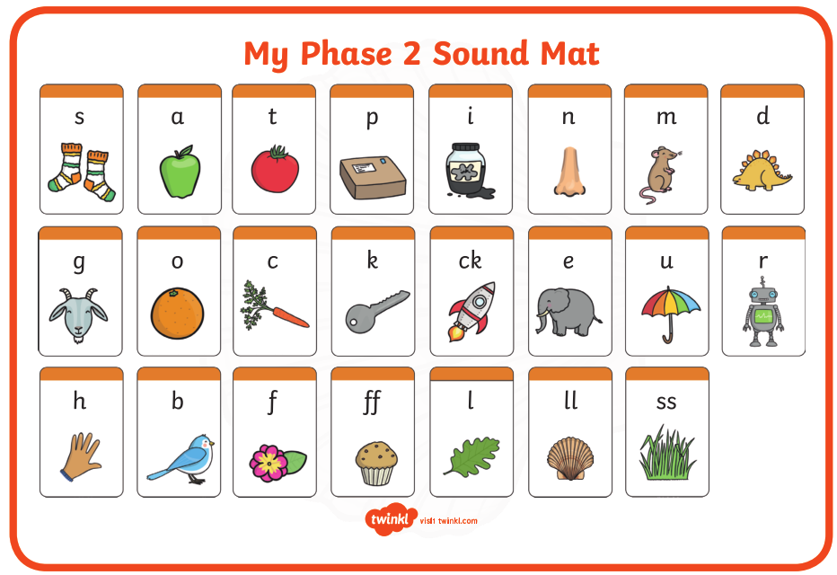

Pre phase 2 words

in | it | is
on | up | of
am | as | us

Phase 2 tricky words

I | no | the
into | go | to
and

Phoneme frames



