Monday | Tuesday | Wednesday | Thursday | Friday
Phonics Focus- segmenting and blending and  reading captions using phase 2 sounds | Phonics Focus- segmenting and blending and  reading captions using phase 2 sounds | Phonics Focus- segmenting and blending and  reading captions using phase 2 sounds | Phonics Focus- segmenting and blending and  reading captions using phase 2 sounds | Tricky Words
Children - Say the phase 2 sounds that we have learnt in school.  Adult - You can point to them in random order or in the order on the sound mat.  See and use sound mat below  Children – read the phase 2 tricky words and the pre phase 2 words  Adult –show the children a word at a time. Remember the tricky words are sight words and you cannot segment and blend them.  See and use the word lists below | Children - Say the phase 2 sounds that we have learnt in school.  Adult - You can point to them in random order or in the order on the sound mat.  See and use sound mat below  Children – read the phase 2 tricky words and the pre phase 2 words  Adult –show the children a word at a time. Remember the tricky words are sight words and you cannot segment and blend them.  See and use the word lists below | Children - Say the phase 2 sounds that we have learnt in school.  Adult - You can point to them in random order or in the order on the sound mat.  See and use sound mat below  Children – read the phase 2 tricky words and the pre phase 2 words  Adult –show the children a word at a time. Remember the tricky words are sight words and you cannot segment and blend them.  See and use the word lists below | Children - Say the phase 2 sounds that we have learnt in school.  Adult - You can point to them in random order or in the order on the sound mat.  See and use sound mat below  Children – read the phase 2 tricky words and the pre phase 2 words  Adult –show the children a word at a time. Remember the tricky words are sight words and you cannot segment and blend them.  See and use the word lists below | Play the tricky word song-phase 2  Google  Phase 2 tricky word song or use this  https://www.bing.com/search?q=tricky+words+song+phase+2&form=EDNTHT&mkt=en-gb&httpsmsn=1&msnews=1&plvar=0&refig=40eadad2dbc34571a3ab30ad92f94c13&sp=5&qs=SC&pq=tricky+words+sou&sk=PRES1SC3AS1&sc=8-16&cvid=40eadad2dbc34571a3ab30ad92f94c13&cc=GB&setlang=en-US  Children – read the phase 2 tricky words and the pre phase 2 words  Adult –show the children a word at a time. Remember the tricky words are sight words and you cannot segment and blend them.
Adult  Say some of the phase 2 sounds from the phase 2 sound mat below.  Children  Write the sounds as you say them.  Play this game online  Use the link or the details below  https://www.phonicsplay.co.uk/member-only/MatchingPh2Wk13.html  Phonics play.co.uk  Phase 2  Interactive resources  Make a match  s a t p  i n m d  g o c k | Adult  Say some of the phase 2 sounds from the phase 2 sound mat below.  Children  Write the sounds as you say them.  Play this game online  Use the link or the details below  https://www.phonicsplay.co.uk/member-only/MatchingPh2Wk4.html?  Phonics play.co.uk  Phase 2  Interactive resources  Make a match  ck e u r | Adult  Say some of the phase 2 sounds from the phase 2 sound mat below.  Children  Write the sounds as you say them.  Play this game online  Use the link or the details below  https://www.phonicsplay.co.uk/member-only/MatchingPh2Wk5.html  Phonics play.co.uk  Phase 2  Interactive resources  Make a match  h b f l  ff ll ss | Adult  Say some of the phase 2 sounds from the phase 2 sound mat below.  Children  Write the sounds as you say them.  Play this game online  Use the link or the details below  https://www.phonicsplay.co.uk/member-only/BuriedTreasure2.html  Phonics play.co.uk  Phase 2  Interactive resources  Buried Treasure  Click on the yellow rectangle that says  Revise all phase 2  Get the children to explain what the real words are or you explain what they are. | Play the game  Tricky Words Phase 2 –  Play game on Phonics Play  Tricky Word Trucks
Adult  Say some CVC words  e.g.  hat sat cat  fat bat cog  bog fog  For each of the words ask the child these questions  1. What is the initial sound?  2. What is the end sound?  3. What is the middle sound?  4. Do any of these words rhyme?  If you need to write the words on a piece of paper to help the child answer the questions. | Adult  Say some CVC words  e.g.  back run sack rack red pack peck heck  For each of the words ask the child these questions  1. What is the initial sound?  2. What is the end sound?  3. What is the middle sound?  4. Do any of these words rhyme? (which ones)  If you need to write the words on a piece of paper to help the child answer the questions. | Adult  Say some CVC words  e.g.  huff full bill  puff pull pill  pass kiss  For each of the words ask the child these questions  1. What is the initial sound?  2. What is the end sound?  3. What is the middle sound?  4. Do any of these words rhyme? (which ones)  If you need to write the words on a piece of paper to help the child answer the questions. | Adult  Say some CVC words  e.g.  tip hit pot  hot hip sit  loss  For each of the words ask the child these questions  1. What is the initial sound?  2. What is the end sound?  3. What is the middle sound?  4. Do any of these words rhyme? (which ones)  If you need to write the words on a piece of paper to help the child answer the questions. | Play Tricky word Bingo  Adult  Write all of the phase 2 tricky words on a piece of paper. Say a word one at a time. Children will cross off the word when you say it.
Adult segment and blend these words one at a time.  Children try to write each word on a piece of paper.  Use the phase 2 sound mat to help  hat sat cat  fat bat cog  bog fog  Children could use the phoneme frame (below) to write the words on if they need to.  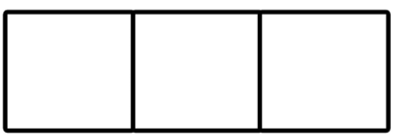  Children  Have a go at this.  Read this caption  a big cat  and/or  Read this sentence?  Go and pat a cat  Children  Have a go at writing the cation and or sentence as the adult says them.  Use the phoneme frame to help. | Adult segment and blend these words one at a time.  Children try to write each word on a piece of paper.  Use the phase 2 sound mat to help  back run sack rack red pack peck heck  Children could use the phoneme frame to write the words  Children  Have a go at this.  Read this caption  a doll in a hat  and/or  Read this sentence?  I put a hat on a doll  Children  Have a go at writing the cation and / or sentence as the adult says them.  Use the phoneme frame to help. | Adult segment and blend these words one at a time.  Children try to write each word on a piece of paper.  Use the phase 2 sound mat to help  huff full bill  puff pull pill  pass kiss  Children could use the phoneme frame to write the words on if they need to.  Children  Have a go at this.  Read this caption  a hot sun  and/or  Read this sentence?  It is not hot.  Children  Have a go at writing the cation and / or sentence as the adult says them.  Use the phoneme frame to help. | Adult segment and blend these words one at a time.  Children try to write each word on a piece of paper.  Use the phase 2 sound mat to help  tip hit pot  hot hip sit  loss  Children could use the phoneme frame to write the words on if they need to.  Children  Have a go at this.  Read this caption  a big mess  and/or  Read this sentence?  It is a big mess.  Children  Have a go at writing the cation and / or sentence as the adult says them.  Use the phoneme frame to help. | Adult  Show the children the phase 2 tricky words.  See below.  Use an online timer /egg timer  How many tricky words can the child read in a minute?  Can you beat last weeks score?

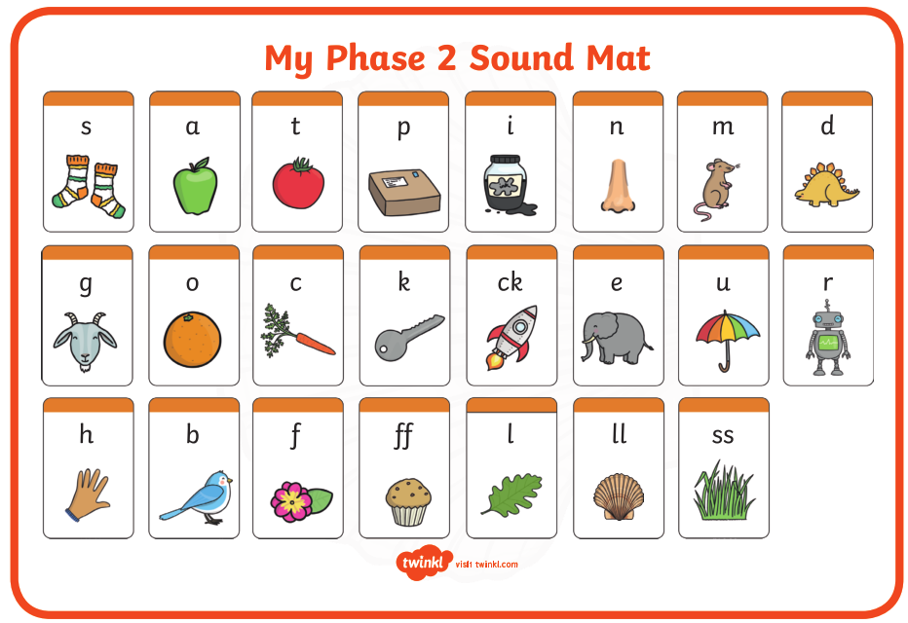

Pre phase 2 words

in | it | is
on | up | of
am | as | us

Phase 2 tricky words

I | no | the
into | go | to
and

Phoneme frames

