Monday | Tuesday | Wednesday | Thursday | Friday
Phonics Focus- segmenting and blending and  reading captions using phase 2 sounds  real or fake words | Phonics Focus- segmenting and blending and  reading captions using phase 2 sounds  real or fake words | Phonics Focus- segmenting and blending and  reading captions using phase 2 sounds  real or fake words | Phonics Focus- segmenting and blending and  reading captions using phase 2 sounds  real or fake words | Tricky Words
Children - Say the phase 2 sounds that we have learnt in school.  Adult - You can point to them in random order or in the order on the sound mat.  See and use sound mat below  Children – read the phase 2 tricky words and the pre phase 2 words  Adult –show the children a word at a time. Remember the tricky words are sight words and you cannot segment and blend them.  See and use the word lists below  And or  Play this game online  Use the link or the details below  Phonics play  Phase 2  Flash cards  Speed trial  https://www.phonicsplay.co.uk/member-only/Flashcards.html | Children - Say the phase 2 sounds that we have learnt in school.  Adult - You can point to them in random order or in the order on the sound mat.  See and use sound mat below  Children – read the phase 2 tricky words and the pre phase 2 words  Adult –show the children a word at a time. Remember the tricky words are sight words and you cannot segment and blend them.  See and use the word lists below  And or  Play this game online  Use the link or the details below  Phonics play  Phase 2  Flash cards  Speed trial  https://www.phonicsplay.co.uk/member-only/Flashcards.html | Children - Say the phase 2 sounds that we have learnt in school.  Adult - You can point to them in random order or in the order on the sound mat.  See and use sound mat below  Children – read the phase 2 tricky words and the pre phase 2 words  Adult –show the children a word at a time. Remember the tricky words are sight words and you cannot segment and blend them.  See and use the word lists below  And or  Play this game online  Use the link or the details below  Phonics play  Phase 2  Flash cards  Speed trial  https://www.phonicsplay.co.uk/member-only/Flashcards.html | Children - Say the phase 2 sounds that we have learnt in school.  Adult - You can point to them in random order or in the order on the sound mat.  See and use sound mat below  Children – read the phase 2 tricky words and the pre phase 2 words  Adult –show the children a word at a time. Remember the tricky words are sight words and you cannot segment and blend them.  See and use the word lists below  And or  Play this game online  Use the link or the details below  Phonics play  Phase 2  Flash cards  Speed trial  https://www.phonicsplay.co.uk/member-only/Flashcards.html | Play the tricky word song-phase 2  Google  Phase 2 tricky word song or use this  https://www.bing.com/search?q=tricky+words+song+phase+2&form=EDNTHT&mkt=en-gb&httpsmsn=1&msnews=1&plvar=0&refig=40eadad2dbc34571a3ab30ad92f94c13&sp=5&qs=SC&pq=tricky+words+sou&sk=PRES1SC3AS1&sc=8-16&cvid=40eadad2dbc34571a3ab30ad92f94c13&cc=GB&setlang=en-US  Children – read the phase 2 tricky words and the pre phase 2 words  Adult –show the children a word at a time. Remember the tricky words are sight words and you cannot segment and blend them.
Adult  Say some of the phase 2 sounds from the phase 2 sound mat below.  Children  Write the sounds as you say them.  Phonics play.co.uk  Phase 2  Interactive resources  Buried Treasure  Phase 2  Set 1 (satp) plus set 2  +i | Adult  Say some of the phase 2 sounds from the phase 2 sound mat below.  Children  Write the sounds as you say them.  Play this game online  Phonics play.co.uk  Phase 2  Interactive resources  Buried Treasure  Phase 2  Set 1 (satp) plus set 2  +n | Adult  Say some of the phase 2 sounds from the phase 2 sound mat below.  Children  Write the sounds as you say them.  Play this game online  Phonics play.co.uk  Phase 2  Interactive resources  Buried Treasure  Phase 2  Set 1 (satp) plus set 2  +m | Adult  Say some of the phase 2 sounds from the phase 2 sound mat below.  Children  Write the sounds as you say them.  Play this game online  Phonics play.co.uk  Phase 2  Interactive resources  Buried Treasure  Phase 2  Set 1 (satp) plus set 2  +d | Play the game  Tricky Words Phase 2 –  Play game on Phonics Play  Tricky Word Trucks
Adult  Write these words on pieces of paper  sat ip ti tis  tas tip pit it  Place them face down  Child  Choose one and segment and blend it.  Adult ask-is it a real or fake word? | Adult  Write these words on pieces of paper  an tin tan san  ni nap nis in  Place them face down  Child  Choose one and segment and blend it.  Adult ask-is it a real or fake word? | Adult  Write these words on pieces of paper  pim man nim mam nam mat map mip mim am  Place them face down  Child  Choose one and segment and blend it.  Adult ask-is it a real or fake word? | Adult  Write these words on pieces of paper  dip dad dis pid das tid sad nad dit dat  Place them face down  Child  Choose one and segment and blend it.  Adult ask-is it a real or fake word? | Play Tricky – matching pairs  Matching pairs Write some of tricky words on paper (duplicate).  Put them face down on the table and play the matching pair game.
Adult segment and blend these words one at a time.  ask  Is this word real or fake?  Children try to write each word on a piece of paper.  Use the phase 2 sound mat to help  sat ip ti tis  tas tip pit it  Children could use the phoneme frame (below) to write the words on if they need to.  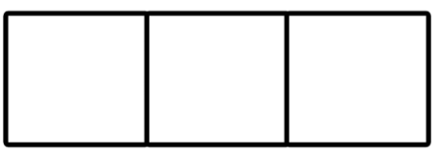  Children  Read this sentence  It is a pit.  and/or  Read this caption?  Sat on a mat  Children  Have a go at writing the cation and or sentence above as the adult says them.  Use the phoneme frame to help. | Adult segment and blend these words one at a time.  ask  Is this word real or fake?  Children try to write each word on a piece of paper.  Use the phase 2 sound mat to help  an tin tan san  ni nap nis in  Children could use the phoneme frame to write the words  Children  Read this caption  a tan  and/or  Read this sentence?  It is a tin.  Children  Have a go at writing the cation and / or sentence above as the adult says them.  Use the phoneme frame to help. | Adult segment and blend these words one at a time.  ask  Is this word real or fake?  Children try to write each word on a piece of paper.  Use the phase 2 sound mat to help  pim man nim mam nam mat map mip  Children could use the phoneme frame to write the words on if they need to.  Children  Have a go at this.  Read this caption  map on a mat  and/or  Read this sentence?  It is a big mat  Children  Have a go at writing the cation and / or sentence above as the adult says them.  Use the phoneme frame to help. | Adult segment and blend these words one at a time.  ask  Is this word real or fake?  Children try to write each word on a piece of paper.  Use the phase 2 sound mat to help  dip dad dis pid das tid sad nad dit dat  Children could use the phoneme frame to write the words on if they need to.  Children  Read this caption  a dad  and/or  Read this sentence?  I am a sad dad.  Children  Have a go at writing the cation and / or sentence above as the adult says them.  Use the phoneme frame to help. | Adult  Show the children the phase 2 tricky words.  See below.  Use an online timer /egg timer  How many tricky words can the child read in a minute?  Can you beat last weeks score?

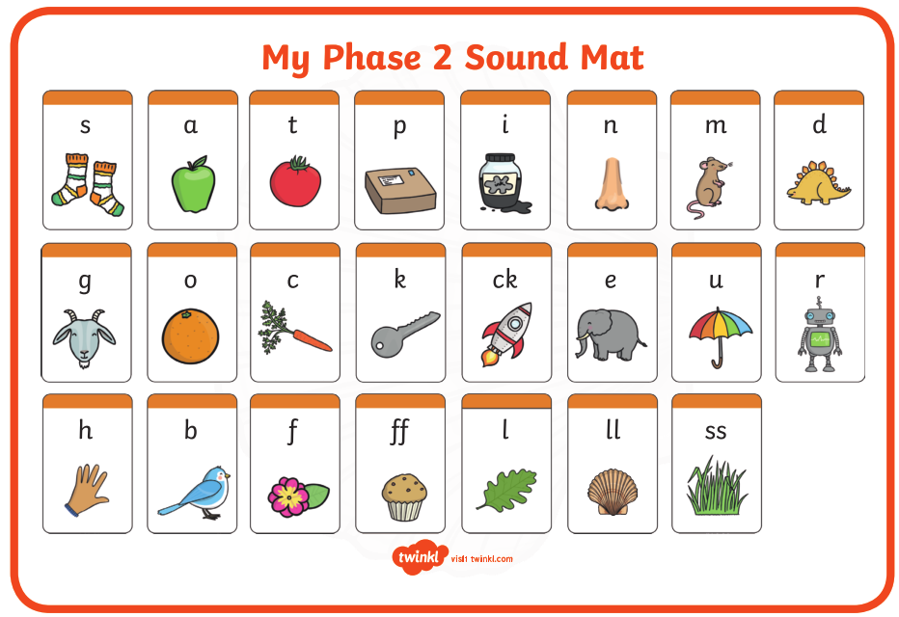

Pre phase 2 words

in | it | is
on | up | of
am | as | us

Phase 2 tricky words

I | no | the
into | go | to
and

Phoneme frames

