Monday | Tuesday | Wednesday | Thursday | Friday
Segmenting blending phase 2 sounds | Segmenting blending phase 2 sounds | Segmenting blending phase 2 sounds | Segmenting blending phase 2 sounds | Segmenting blending phase 2 sounds
Phonics play https://www.phonicsplay.co.uk  Recap sounds- Flash Card Speed Trial-Phase 2 | Read the sounds on the board, pre teach phase 2 words and the phase 2 tricky words  See below | Phonics play https://www.phonicsplay.co.uk  Recap sounds- Flash Card Speed Trial-Phase 2 | Adult read the sounds on the phase 2 sound board or the tricky words one at a time.  Child – write the sound or the word as it is said. | Read the tricky words and the pre teach words  See below
Phonics play – phase 2  Dragons Den  Set 1 (satp) plus +i +m +n +d | Phonics play – phase 2  Dragons Den  Set 1 and 2 plus set 3 +g +o +c +k | Phonics play – phase 2  Dragons Den  Set 1-3 plus set 4 +ck +e +u +r | Phonics play – phase 2  Dragons Den  Set 1-4 plus set 5 +h +b +f/ff +l/ll +ss | Phonics Play Phase 2  Play - Train your brain
Look at the picture. Write an initial sound, CVC word and /or sentence about the picture.  Use the tricky and the pre teach words.   | Look at the picture. Write an initial sound, CVC word and /or sentence about the picture. Use the tricky and the pre teach words.   | Look at the picture. Write an initial sound, CVC word and /or sentence about the picture. Use the tricky and the pre teach words.   | Look at the picture. Write an initial sound, CVC word and /or sentence about the picture. Use the tricky and the pre teach words.  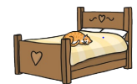 | Matching pairs Write some of tricky words on paper (duplicate).  Put them face down on the table and play the matching pair game.  Then  Write the tricky words as an adults says them to you?  How many did you get correct?
Read this caption  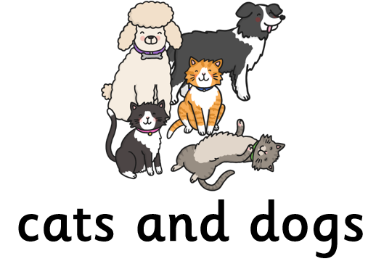 | Read this caption  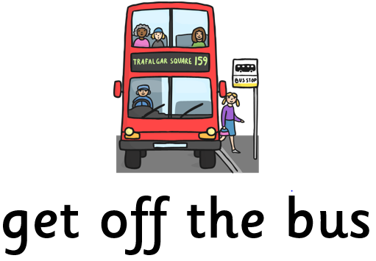 | Read this caption  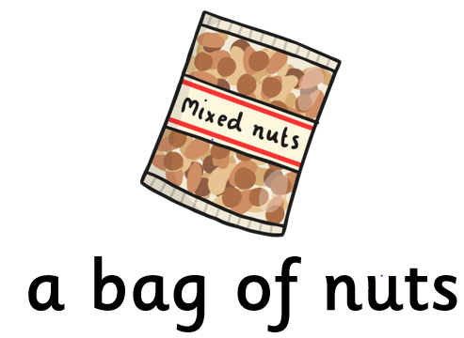 | Read this caption  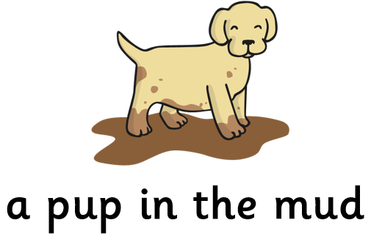 | Use an online timer. How many tricky words can you read in a minute?

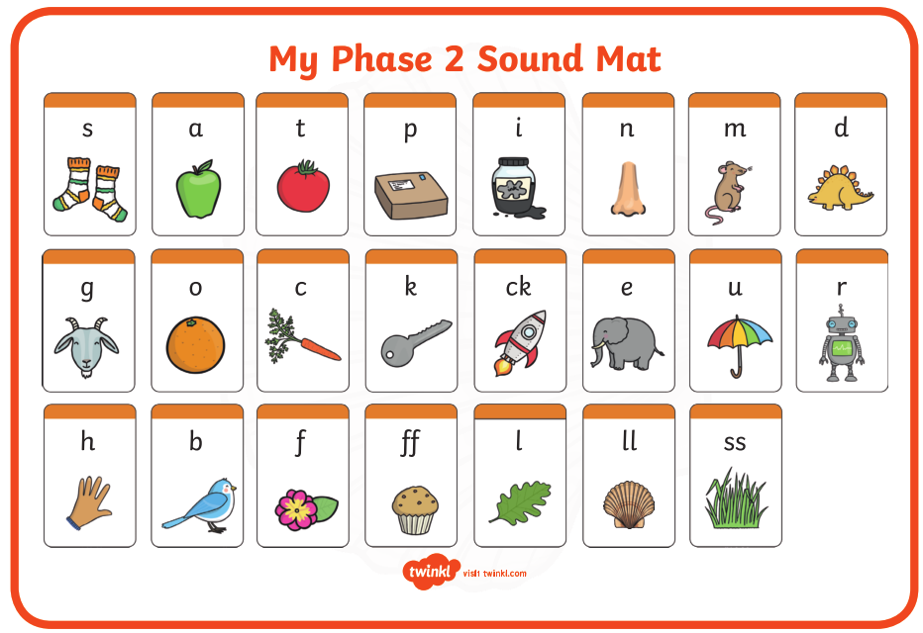

Pre phase 2 words

in | it | is
on | up | of
am | as | us

Phase 2 tricky words

I | no | the
into | go | to
and

Phoneme frames



