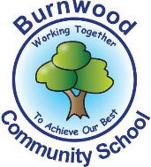
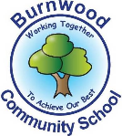
Nursery Home Learning WB: 20.04.20
Theme: Brown Bear, Brown Bear What Do You See?
I hope you have all had a wonder Easter and have had fun completing the different challenges set on our Easter Bingo game. Below are some
Phonics, English and Maths activities for you to do this week. Remember they do not all need to be completed at once. Take your time and enjoy doing different things together as a family.
I am really enjoying looking at the different pictures people are uploading to our Facebook page. If you do not want to put them up yourself you can privately send them to the Facebook account and Miss Watson or Mr Colclough will email them to me. Hopefully we will all see each other soon! Stay Safe. Mrs Jukes-Thornton
Phonics | English | Maths
Watch the ‘Mr Thorne Does Phonics’ Episode for a.  https://www.youtube.com/watch?v=vMEvxTGvi4c  Once you’ve watched the episode go around your house and identify the objects which start with a. | Our story this week is ‘Brown Bear, Brown Bear What Do You See?’ written by Bill Martin Jr  Read it together if you have a copy of the story. If not here is the link to a YouTube version.  https://www.youtube.com/watch?v=WST-B8zQleM  After you have read or listened to the story. Talk about the different animals in the story. Which is your favourite? | This week’s number of the week is 6.  Practice counting out 6 different objects from round your home.  Find 6 big objects, 5 small objects, 6 flat objects, 6 different foods and 6 toys in your house. Put them in a line and touch count each object make sure you are careful when you are counting saying one number name at a time.
On Page 2 you will see the formation rhyme for s.  ‘Round the apple, down the leaf.’  Have a go at writing your own a.  A grown up can write one for you which you can trace over if needed. | Read the story of ‘Bear Brown’ again and talk about the different animals, are the all the same or different?  If you have any animal toys in your house you could gathered them and create your own story using the same characters. | Ask a grown up to play penny drop with you.  The grown up holds the tin and the coins, you close your eyes whilst the grown up drops pennies one at a time into the tin. Make sure your eyes are closed and listen to how many pennies you hear drop into the tin. You can play with lots of different numbers.
Write a big s on 1 piece of paper and a big a on another and stick them up on 2 different sides of a room. Get a grown up to say one of the sounds and you run to the correct letter shape. | Create a picture of your favourite animals using different materials from around the house.  Don’t forget to upload a picture to our school Facebook page. | Go on a shape hunt around your house. On page 3 there is a tick sheet you can use to see how many different shapes you can find.

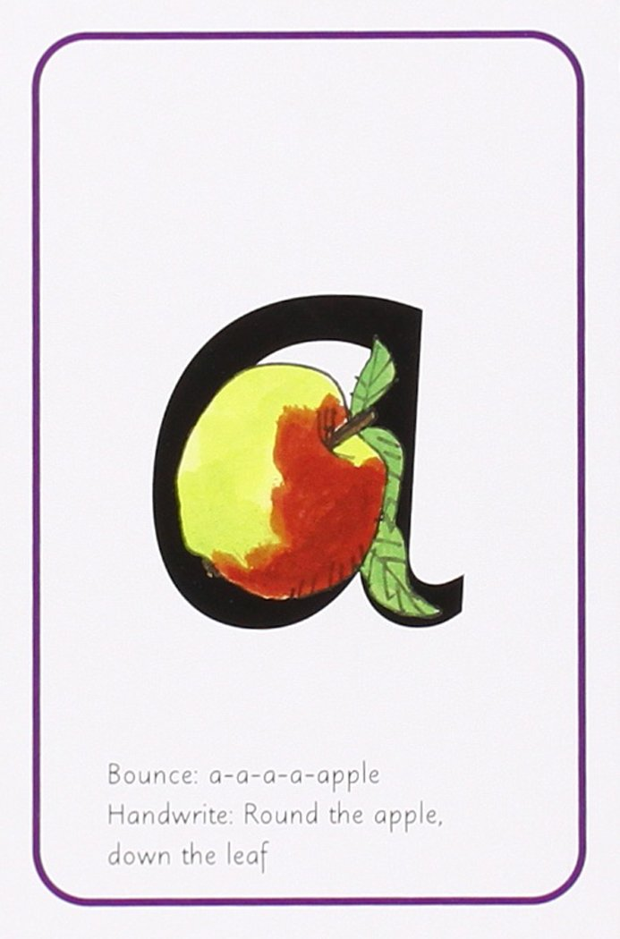
SHAPE HUNT
How many of each shape can you find?
Rectangle |  | Circle
Triangle |  | Square

